Executive Summary

ES-05 Executive Summary - 24 CFR 91.200(c), 91.220(b)
1. Introduction
Cherokee County is required to submit to the United States Department of Housing and Urban Development (HUD) a Consolidated Plan for 2019-2023 and an Annual Action Plan for 2019. The Consolidated Plan and Annual Action Plan are submitted as a prerequisite to receiving Community Development Block Grant (CDBG) program funds.
The Five-Year Plan includes a Needs Assessment, Market Analysis, and Identification of Priority Needs and Long-term Strategies. An Annual Action Plan implements the strategies and provides a basis for allocating CDBG resources.
The CDBG Program has three national objectives: (1) Benefit to low and moderate income persons, (2) Aid in the prevention of slum and blight, and (3) Urgent Needs. The activities normally addressed for affordable housing with HOME funds are now incorporated in the Consolidated Plan as a result of the County no longer receiving HOME funds through the consortium.
2. Summary of the objectives and outcomes identified in the Plan Needs Assessment Overview
Cherokee County conducted a needs assessment and market analysis to determine the County’s needs for improvements to the community. Community input obtained through interviews and consultation with agencies that serve the needs of low to moderate income persons, public hearings, and direct-mail surveys to nonprofit agencies and other service providers within Cherokee County helped establish the needs and develop long term goals and strategies. Needs Assessment surveys that are made available at all public meetings and on the County’s CDBG page on the web (electronic version) also helped formulate strategies and goals. Through this process, an overall focus for CDBG activities will be to meet the National Objective – Benefit to low and moderate income persons.
In addition, the County’s Analysis of Impediments to Fair Housing Choice (April 2018) was used to assist with long term strategies to address affordable housing needs. The following goals and strategies were established for the five-year Strategic Plan to guide the County’s allocation of CDBG resources for 2019-2023.
Increase the Capacity of Public Facilities and Infrastructure
- Increase services for low to moderate income persons by expanding/improving public facilities
- Improve residential neighborhood safety and livability by expanding/improving public facilities and infrastructure
Increase the Capacity of Public Services and Economic Opportunities
- Provide critical services for low income persons, homeless persons, and other persons with special needs to assist them in obtaining increased stability

Preserve and Expand Affordable Housing
- Improve sustainability of homeownership and eliminate substandard housing through a minor/emergency repair program
- Expand the supply of affordable housing
- Expand the supply of affordable rental housing
- Reduce lead-based paint hazard
- Encourage fair housing opportunities
3. Evaluation of past performance
The County has just completed its second five-year Consolidated Plan with HUD. Public Facilities included the construction of a senior center in underserved Ball Ground where seniors were able to meet only one day a week and the expansion of the senior center in Woodstock to accommodate the growing population of seniors; renovations to the Boys & Girls Club to benefit low-to-moderate income youth, repairs and improvements and replacement of HVAC to two group residences situated on a campus of group homes for boys in foster care and security improvements to a group home for girls in foster care; acquisition of a building for a child advocacy agency to improve supervised visitation for children in foster care and the acquisition of additional space for a nonprofit healthcare services provider to expand services to uninsured and underinsured low-to-moderate income persons; improvements were made to the County’s senior center to shelter home-delivered meals volunteers and additional space was constructed to store donated personal care items, mobility assistance items, and portable fans/heaters for seniors in need; the cities of Holly Springs, Ball Ground, and Woodstock benefitted from the expansion of infrastructure with the installation of sidewalks, stormwater improvements, and curb cuts and ramps to sidewalks in low-to-moderate income neighborhoods. As the Cities’ infrastructures continue to age in older neighborhoods, infrastructure improvements are critical for maintaining neighborhoods as affordable.
Non-profit organizations within the County that meet the needs of the LMI community by providing critical services continue to be a major focus of the program. Nonprofit agencies that serve battered and abused adults, victims of child abuse, children in foster care, developmentally disabled adults, seniors, and LMI youth, provide transportation services, counselling, educational opportunities, and advocacy services to the most vulnerable clients, the homeless and near homeless, and abused and/or neglected children. Through the support from the County, they have been able to expand and improve services even when other sources of funding decrease.
The County began a minor/emergency home repair program in 2015 as a result of the disbanding of the consortium of jurisdictions receiving HOME funds through Cobb County. The pilot program was begun as a partnership with Habitat for Humanity who administered the program. Seniors, veterans, and disabled persons are targeted to help them age in place. Initially, 10 households were served, and the program’s success has secured continued support by the County with increased funding to continue the program. Thirty-four households, and counting, have since been assisted with repairs ranging from new roofs, replacement of HVAC systems, plumbing repairs, and structural repairs.
The County funded the acquisition of 25 lots during the past consolidated plan period to expand the supply of affordable housing. Habitat for Humanity vets candidates for the program who must provide sweat equity and complete training in managing household finances.
4. Summary of citizen participation process and consultation process
The County held two public hearings during the course of the planning process to receive input from citizens, held stakeholder interviews, and had consultations with groups addressing housing to assess the needs. Priorities needs were established and the ranking process helped formulate long-term goals and strategies. In addition, stakeholder surveys were mailed to nonprofit agencies and cities within the jurisdiction to solicit input for unmet needs in the community.
Opportunities for citizens and stakeholders to comment on the draft Consolidated Plan were provided through a public comment period and public hearing, both in the initial Consolidated Planning process in 2018 and again after funding was announced for the first year action plan in 2019.
5. Summary of public comments
Through public notice in the newspaper, the public was invited to comment on the Consolidated Plan and one-year action plan at two public hearings, with the option to supply comments by email or phone. The County did not receive any public comments to be reviewed during the public comment period in 2018 or the public comment period in 2019.
6. Summary of comments or views not accepted and the reasons for not accepting them
Not applicable - no comments were received.
7. Summary
The 2019-2023 Consolidated Plan will address three primary goals: 1) Improve the Capacity of Public Facilities and Infrastructure; 2) Increase the Capacity of Public Services and Economic Opportunities; and, 3) Preserve and Expand Affordable Housing. CDBG funds will primarily be allocated to all of these goals as the County no longer receives HOME Program funds.

The Process

PR-05 Lead & Responsible Agencies 24 CFR 91.200(b)
1. Describe agency/entity responsible for preparing the Consolidated Plan and those responsible for administration of each grant program and funding source
The following are the agencies/entities responsible for preparing the Consolidated Plan and those responsible for administration of each grant program and funding source.
Agency Role | Name | Department/Agency
Lead Agency | CHEROKEE COUNTY

CDBG Administrator | CHEROKEE COUNTY | CDBG Program Office/Finance
HOPWA Administrator
HOME Administrator
HOPWA-C Administrator
Table 1 – Responsible Agencies

Narrative
On October 1, 2018, the County reorganized the reporting structure of the Administrative Services Agency and the Finance Department with the promotion of the Finance Director to CFO. The CDBG Program Office has reverted back to the Finance Department's organizational chart.
Consolidated Plan Public Contact Information
Laura Calfee, lcalfee@cherokeega.com
(770) 721-7807
Cherokee County CDBG Program
1130 Bluffs Parkway
Canton, GA 30114

PR-10 Consultation - 91.100, 91.200(b), 91.215(l)
1. Introduction
In addition to the consultations with nonprofit agencies and services providers, needs assessment surveys were sent out to agencies, who may not have participated in a public meeting previously held by the County, as well as agencies who make regular contact with the program office, for stakeholder input. The objective of the surveys was to gather perspective and data from agencies regarding unmet needs in the community from a range of service providers.
Provide a concise summary of the jurisdiction’s activities to enhance coordination between public and assisted housing providers and private and governmental health, mental health and service agencies (91.215(I)).
In the process of developing the 2019-2023 Consolidated Plan, the County consulted with community members and representatives from local organizations providing housing and services to low and moderate income households in Cherokee County. Among the primary organizations consulted during the planning process were Canton Housing Authority, North Central Georgia Habitat for Humanity, Cherokee Family Violence Center, Bethesda Community Health Clinic, MUST Ministries, Inc. - Cherokee, Goshen Valley Boys Ranch and the County's Senior Center. The County participates in the monthly meetings hosted by Cherokee FOCUS, a collaborative meeting coordinating efforts between private businesses, public agencies, and the faith community to share resources for meeting the needs of persons in need of housing, homeless prevention services, medical services, basic necessities, and services for persons challenged with addictions and dependencies. This coordinated effort opens doors for organizations to seek funding through collaboration.
Describe coordination with the Continuum of Care and efforts to address the needs of homeless persons (particularly chronically homeless individuals and families, families with children, veterans, and unaccompanied youth) and persons at risk of homelessness
Cherokee County receives funds through the Balance of State Continuum of Care. Local organizations, such as MUST Ministries, Inc. and Cherokee Family Violence Center, are the driving forces for addressing the needs of the homeless persons within Cherokee County and MUST Ministries receives funds directly from the Balance of State. With the most recent Balance of State Continuum of Care application cycle, the County saw two additional agencies seek Certification of Consistency with the County’s Consolidated Plan for their projects submitted for CoC Programs (Rapid Rehousing). In addition, agencies that apply for Balance of State Continuum of Care projects such as S+CR and PSH-PH and ESG funds submit to the County for Certification of Consistency with the Consolidated Plan. The County requests project information and other pertinent program information to ensure needs are addressed. The County participates in the local PIT counts and continues to support the efforts of those organizations addressing the needs of the homeless population.
Describe consultation with the Continuum(s) of Care that serves the jurisdiction's area in determining how to allocate ESG funds, develop performance standards and evaluate outcomes, and develop funding, policies and procedures for the administration of HMIS
The County does not receive ESG funds. MUST Ministries, Inc. - Cherokee applies to the State for Balance of State Continuum of Care funding, which includes ESG funds.
2. Describe Agencies, groups, organizations and others who participated in the process and describe the jurisdictions consultations with housing, social service agencies and other entities

Table 2 – Agencies, groups, organizations who participated
1 | Agency/Group/Organization | MUST Ministries
 | Agency/Group/Organization Type | Housing  Services-homeless  Services-Education  Services-Employment
 | What section of the Plan was addressed by Consultation? | Housing Need Assessment  Public Housing Needs  Homeless Needs - Chronically homeless  Homeless Needs - Families with children  Non-Homeless Special Needs
 | How was the Agency/Group/Organization consulted and what are the anticipated outcomes of the consultation or areas for improved coordination? | The County consults with MUST Ministries through regular meetings and through referrals for services. MUST Ministries has taken the lead role for the PIT Homeless Count and provides access to its Elizabeth Inn shelter in Cobb County. MUST was given a direct-mail survey to ascertain unmet needs in the community and responded with helpful data. MUST Ministries has plans to partner with the County to increase affordable rental housing for LMI persons.
2 | Agency/Group/Organization | North Central Georgia Habitat for Humanity
 | Agency/Group/Organization Type | Housing  Services - Housing  Services-Education  Service-Fair Housing  Regional organization
 | What section of the Plan was addressed by Consultation? | Housing Need Assessment  Public Housing Needs
 | How was the Agency/Group/Organization consulted and what are the anticipated outcomes of the consultation or areas for improved coordination? | Habitat previously served as the CHDO for the County when the County received HOME funds through the consortium with Cobb County. They currently administer the Minor/Emergency Home Repair program and provide year-round input into the affordable housing needs in the County. They are represented at the Housing and Services Forum Meeting hosted by Cherokee FOCUS and is a member of the Housing Collaborative that includes the County's Senior Services, Homeless Veterans of Cherokee County (501(c)(3)), the Volunteer Aging Council (501(c)(3), and the Marine Corp League, to address home repairs and housing needs within the County for veterans, persons aged 55+, and disabled persons. The information provided by Habitat allows the County to make informed funding decisions to address the affordable housing needs within the community and therefore plan for annual assisted households and additions to the affordable housing stock of the County.
3 | Agency/Group/Organization | Next Step Ministries, Inc.
 | Agency/Group/Organization Type | Housing  Services-Persons with Disabilities  Services-Education
 | What section of the Plan was addressed by Consultation? | Housing Need Assessment  Public Housing Needs  Non-Homeless Special Needs
 | How was the Agency/Group/Organization consulted and what are the anticipated outcomes of the consultation or areas for improved coordination? | Next Step provides monthly updates to the County reporting the number of beneficiaries served. The Executive Director was given a Needs Assessment Survey to provide input on the unmet needs of the community. The agency serves severe/profound developmentally delayed young adults who have aged out of the school system and have a need for improved transportation services. Their clients are separated by cognitive abilities and higher cognition clients are provided job training, while lower cognition clients are given individualized educational plans to assist in basic functions such as using silverware to eat. Next Step was given a direct-mail survey to provide insight into the unmet needs in the community. The agency is operating at capacity, leasing additional space a few miles away and plans to expand the facility.
4 | Agency/Group/Organization | Cherokee Senior Services
 | Agency/Group/Organization Type | Housing  Services-Elderly Persons
 | What section of the Plan was addressed by Consultation? | Housing Need Assessment  Public Housing Needs  Non-Homeless Special Needs  Market Analysis
 | How was the Agency/Group/Organization consulted and what are the anticipated outcomes of the consultation or areas for improved coordination? | Senior Services provides ongoing updates at the Housing Collaborative meetings, and the Director was given a stakeholder survey to complete for the Needs Assessment portion of the Con Plan. A phone meeting with a local developer to have a conversation about LIHTC's was coordinated by the director. Senior Services provides periodic reporting of seniors looking for affordable housing as well. Services at the center include home-delivered meals, congregate care, case management, and other services to assist the elderly and frail elderly. Because the primary development in the County is recently not affordable housing, especially for seniors on a fixed income, Senior Services is helping to determine viable options for senior housing similar to housing in Gwinnett County and Dekalb County.
5 | Agency/Group/Organization | Housing Authority of Canton
 | Agency/Group/Organization Type | Housing  PHA  Services-Persons with Disabilities
 | What section of the Plan was addressed by Consultation? | Public Housing Needs
 | How was the Agency/Group/Organization consulted and what are the anticipated outcomes of the consultation or areas for improved coordination? | Telephone interviews with the Agency Director were used to ascertain the needs of the public housing residents. These interviews indicated that the HA is feeling the brunt of insufficient funds to help maintain its 145 units. While they meet Section 504 requirements, these units have an extremely long wait list. Measures to assess the physical condition of units were determined to be underway to prepare for rehab of all three campuses. Current residents do not generally become homeowners. Coordination with Habitat for Humanity - North Central Georgia for will be encouraged to foster home ownership through application workshops. The Executive Director and select members of the HA Board have formed a focus group to find ways to increase the number of public housing units and improve the condition of existing units. Other members include the CDBG Program Office and Senior Services.
6 | Agency/Group/Organization | Bethesda Community Clinic, Inc.
 | Agency/Group/Organization Type | Services-Health  Health Agency
 | What section of the Plan was addressed by Consultation? | Non-Homeless Special Needs  Anti-poverty Strategy
 | How was the Agency/Group/Organization consulted and what are the anticipated outcomes of the consultation or areas for improved coordination? | Bethesda Community Clinic provides low cost/no cost health care services to the uninsured and underinsured persons of Cherokee County. The County met with the Executive Director and grants manager to ascertain the impact of previously funded projects and to determine the extent of need in the community. Because of the expansion of the facility, the agency is able to provide services five days a week, up from two days. Understanding the need for improved transportation services, the agency is undergoing a long-range planning and feasibility assessment of providing mobile health care services in the community.

Identify any Agency Types not consulted and provide rationale for not consulting
Agencies that might not have been contacted via telephone or meeting, responded to the direct mail surveys that were sent to nonprofit agencies within the community. Every attempt possible was made to reach a range of service providers, and together with the input received during the Analysis Impediments, the County believes a broad representation of input was obtained.

Other local/regional/state/federal planning efforts considered when preparing the Plan
Name of Plan | Lead Organization | How do the goals of your Strategic Plan overlap with the goals of each plan?
Continuum of Care | MUST Ministries, Inc. - Cherokee | There is no overlap of strategic plan goals as the County Program Office receives only CDBG funds. MUST receives ESG funds through the Balance of State Continuum of Care.
Table 3 – Other local / regional / federal planning efforts
Describe cooperation and coordination with other public entities, including the State and any adjacent units of general local government, in the implementation of the Consolidated Plan (91.215(l))
Cherokee County and each of the participating cities work closely in identifying needs within the individual jurisdictions. These efforts are through, at minimum, annual meetings with the local governments. The County participates in two collaborative groups, one that focuses on housing needs and one that includes other agencies that provide human services, health care services, and housing. Each one convenes on a monthly basis so the County is able to monitor changing needs in the community.
Narrative (optional):

PR-15 Citizen Participation
1. Summary of citizen participation process/Efforts made to broaden citizen participation
Summarize citizen participation process and how it impacted goal-setting

Throughout the County's program year, citizen needs assessment surveys are made available at every public hearing and public meeting hosted by the CDBG Program Office in addition to having an embedded link on the CDBG page of the County website. Survey responses obtained are reviewed and summarized throughout the program year to assist in planning for the Annual Action Plan and Consolidated Plan. The County held a public hearing during a 30-day comment period, in 2018, for the public to have an opportunity to comment on the draft of the Consolidated Plan and Annual Action Plan for the first year of the Plan. A second public comment period was held in 2019 after funding was announced. Historically, citizen response and participation are low, so the County's website and Facebook page are used more frequently and intentionally. Public meetings held at service providers help to obtain meaningful participation by citizens and stakeholders.

Citizen Participation Outreach
Sort Order | Mode of Outreach | Target of Outreach | Summary of  response/attendance | Summary of  comments received | Summary of comments not accepted and reasons | URL (If applicable)
1 | Newspaper Ad | Non-targeted/broad community | The County placed a legal notice in the County's legal organ, Cherokee Tribune, to obtain citizen input with needs assessment surveys in addition to opening of a comment period for the draft of the Con Plan and Annual Action Plan. The publisher's affidavit can be found in the URL listed for this mode of outreach. | There were no comments received. | There were no comments that were not accepted. | https://www.cherokeega.com/CDBG/documents.php
2 | Internet Outreach | Non-targeted/broad community | The CDBG Program Office added, to its page on the County website, a subsection dedicated to the Consolidated Plan process. A link for the needs assessment survey was embedded on that subsection and the link is also found on the landing page of the CDBG page. In addition, a draft of the Con Plan and Annual Action Plan were made available during two 30-day comment periods. | There were no comments received. | There were no comments that were not accepted. | https://www.cherokeega.com/CDBG/FIVE-YEAR-CONSOLIDATED-PLAN/
3 | Public Hearing | Non-targeted/broad community | Public hearing notices are published in the County's legal organ and there were no citizens in attendance at the public hearing. | There were no comments received. | There were no comments that were not accepted.
4 | Public Meeting | Non-targeted/broad community | As part of the County's annual planning processes, two public meetings are held to obtain stakeholder and citizen input. Generally, stakeholders are well represented and citizen participation is a challenge. Social Media outlets are enlisted to garner input from citizens. | As with the direct mail surveys, affordable housing, workforce housing, and improved transportation were the most significantly reported comments and needs for the community. | There were no comments not accepted.
Table 4 – Citizen Participation Outreach

Needs Assessment

NA-05 Overview
Needs Assessment Overview
In addition to the consultations with nonprofit agencies and services providers, needs assessment surveys were sent out to agencies, who may not have participated in a public meeting previously held by the County, as well as agencies who make regular contact with the program office, for stakeholder input. The objective of the surveys was to gather perspective and data from agencies regarding unmet needs in the community from a range of service providers.

NA-10 Housing Needs Assessment - 24 CFR 91.205 (a,b,c)
Summary of Housing Needs
Low-to-moderate income residents of Cherokee County are met with a significant challenge whether seeking affordable housing or maintaining aging homes. As the affordable housing stock declines, housing cost burden is the most prevalent housing problem for households in the County. CHAS data from Table 7, below, estimates that 3,294 renters and 5,643 owners have a cost burden in excess of 30% of income. As households experience severe housing problems, renters with incomes at or below 30% of AMI assume the largest share of households with severe housing problems (46%) while owner households with incomes greater than 30% up to 50% AMI have more occurrences of severe housing problems (31%) than other owner income levels.
Small Related households, more so than Large Related, Elderly, or Other types, generally carry a cost burden greater than 30% within LMI households with half of the renter households. Similarly, more LMI owners in the Small Related category experience a cost burden greater than 30% at 41% owner households. For LMI renters, the income level most burdened with cost is the >30%-50% AMI for Small Related households. For LMI owners, the income level most burdened with cost is the >50-80% AMI level, again, for Small Related households. Elderly households tend to be owners rather than renters with the household income level, >50%-80% AMI, being most represented (cost burden >30%) but exceeding the 0-30% AMI Elderly owner households by only 14 households. Similar data results at Cost Burden > 50% (Table 10) and is analyzed with respect to occurrences and proportion - small households, in general, represent the highest burdens. The exception is for Small Related (renter) households at the income level 0-30% AMI and it is most burdened rather than >30%-50% AMI.
A major gap is the lack of assistance for families who cannot afford available housing resources. Public housing has 145 units with a waiting list of 154 families. The wait list was opened up October 4th, 2018 and the housing authority sought applicants for 2-, 3- and 4-bedroom units. The greatest need is for 1-bedroom units with a 2-3 year wait time for availability. By February 2019, there were 200+ families on the housing authority’s wait list.
Demographics | Base Year: 2000 | Most Recent Year: 2013 | % Change
Population | 141,903 | 219,015 | 54%
Households | 51,937 | 76,371 | 47%
Median Income | $60,896.00 | $67,261.00 | 10%
Table 5 - Housing Needs Assessment Demographics

Data Source: | 2000 Census (Base Year), 2009-2013 ACS (Most Recent Year)

Number of Households Table
 | 0-30% HAMFI | >30-50% HAMFI | >50-80% HAMFI | >80-100% HAMFI | >100% HAMFI
Total Households | 5,774 | 7,150 | 10,685 | 7,844 | 44,900
Small Family Households | 1,993 | 2,879 | 4,593 | 3,533 | 26,975
Large Family Households | 485 | 769 | 1,018 | 888 | 4,759
Household contains at least one person 62-74 years of age | 1,240 | 1,603 | 2,571 | 1,299 | 7,939
Household contains at least one person age 75 or older | 753 | 1,090 | 1,293 | 569 | 1,553
Households with one or more children 6 years old or younger | 1,072 | 1,539 | 2,236 | 1,434 | 9,049

Table 6 - Total Households Table
Data Source: | 2009-2013 CHAS

Housing Needs Summary Tables
1. Housing Problems (Households with one of the listed needs)
 | Renter |  |  |  |  | Owner
 | 0-30% AMI | >30-50% AMI | >50-80% AMI | >80-100% AMI | Total | 0-30% AMI | >30-50% AMI | >50-80% AMI | >80-100% AMI | Total
NUMBER OF HOUSEHOLDS
Substandard Housing - Lacking complete plumbing or kitchen facilities | 45 | 75 | 50 | 50 | 220 | 25 | 0 | 30 | 10 | 65
Severely Overcrowded - With >1.51 people per room (and complete kitchen and plumbing) | 50 | 100 | 15 | 0 | 165 | 10 | 15 | 0 | 0 | 25
Overcrowded - With 1.01-1.5 people per room (and none of the above problems) | 165 | 195 | 135 | 100 | 595 | 115 | 145 | 120 | 39 | 419
Housing cost burden greater than 50% of income (and none of the above problems) | 1,729 | 1,109 | 490 | 4 | 3,332 | 1,899 | 1,980 | 1,760 | 650 | 6,289
Housing cost burden greater than 30% of income (and none of the above problems) | 239 | 953 | 1,593 | 509 | 3,294 | 385 | 768 | 2,402 | 2,088 | 5,643
Zero/negative Income (and none of the above problems) | 214 | 0 | 0 | 0 | 214 | 378 | 0 | 0 | 0 | 378
Table 7 – Housing Problems Table
Data Source: | 2009-2013 CHAS

2. Housing Problems 2 (Households with one or more Severe Housing Problems: Lacks kitchen or complete plumbing, severe overcrowding, severe cost burden)
 | Renter |  |  |  |  | Owner
 | 0-30% AMI | >30-50% AMI | >50-80% AMI | >80-100% AMI | Total | 0-30% AMI | >30-50% AMI | >50-80% AMI | >80-100% AMI | Total
NUMBER OF HOUSEHOLDS
Having 1 or more of four housing problems | 1,989 | 1,474 | 690 | 154 | 4,307 | 2,049 | 2,140 | 1,905 | 700 | 6,794
Having none of four housing problems | 409 | 1,359 | 2,833 | 1,919 | 6,520 | 754 | 2,174 | 5,253 | 5,079 | 13,260
Household has negative income, but none of the other housing problems | 214 | 0 | 0 | 0 | 214 | 378 | 0 | 0 | 0 | 378
Table 8 – Housing Problems 2
Data Source: | 2009-2013 CHAS

3. Cost Burden > 30%
 | Renter |  |  |  | Owner
 | 0-30% AMI | >30-50% AMI | >50-80% AMI | Total | 0-30% AMI | >30-50% AMI | >50-80% AMI | Total
NUMBER OF HOUSEHOLDS
Small Related | 963 | 1,263 | 1,079 | 3,305 | 779 | 1,038 | 2,073 | 3,890
Large Related | 255 | 150 | 240 | 645 | 115 | 498 | 343 | 956
Elderly | 388 | 349 | 494 | 1,231 | 1,005 | 830 | 1,119 | 2,954
Other | 584 | 522 | 389 | 1,495 | 439 | 514 | 659 | 1,612
Total need by income | 2,190 | 2,284 | 2,202 | 6,676 | 2,338 | 2,880 | 4,194 | 9,412
Table 9 – Cost Burden > 30%
Data Source: | 2009-2013 CHAS

4. Cost Burden > 50%
 | Renter |  |  |  | Owner
 | 0-30% AMI | >30-50% AMI | >50-80% AMI | Total | 0-30% AMI | >30-50% AMI | >50-80% AMI | Total
NUMBER OF HOUSEHOLDS
Small Related | 848 | 553 | 175 | 1,576 | 685 | 850 | 1,040 | 2,575
Large Related | 220 | 45 | 10 | 275 | 100 | 288 | 84 | 472
Elderly | 323 | 179 | 200 | 702 | 785 | 480 | 482 | 1,747
Other | 540 | 384 | 120 | 1,044 | 394 | 409 | 165 | 968
Total need by income | 1,931 | 1,161 | 505 | 3,597 | 1,964 | 2,027 | 1,771 | 5,762
Table 10 – Cost Burden > 50%
Data Source: | 2009-2013 CHAS

5. Crowding (More than one person per room)
 | Renter |  |  |  |  | Owner
 | 0-30% AMI | >30-50% AMI | >50-80% AMI | >80-100% AMI | Total | 0-30% AMI | >30-50% AMI | >50-80% AMI | >80-100% AMI | Total
NUMBER OF HOUSEHOLDS
Single family households | 215 | 280 | 110 | 55 | 660 | 45 | 95 | 60 | 35 | 235
Multiple, unrelated family households | 0 | 65 | 40 | 80 | 185 | 70 | 60 | 60 | 4 | 194
Other, non-family households | 0 | 0 | 0 | 0 | 0 | 10 | 0 | 0 | 0 | 10
Total need by income | 215 | 345 | 150 | 135 | 845 | 125 | 155 | 120 | 39 | 439
Table 11 – Crowding Information – 1/2
Data Source: | 2009-2013 CHAS

 | Renter |  |  |  | Owner
 | 0-30% AMI | >30-50% AMI | >50-80% AMI | Total | 0-30% AMI | >30-50% AMI | >50-80% AMI | Total
Households with Children Present | 0 | 0 | 0 | 0 | 0 | 0 | 0 | 0
Table 12 – Crowding Information – 2/2

Data Source Comments:

Describe the number and type of single person households in need of housing assistance.
Housing assistance is a challenge for young, single persons aging out of foster care programs. Two non-profit agencies working with this population have programs, or are working to develop programs with measures to prevent these young people from a cycle of homelessness. One agency has a work program with nearby housing to overcome transportation limits. Additionally, another nonprofit agency in the county, uses CDBG-funded transportation to transport at-risk youth who have not graduated high school. Assistance is provided to these dropout youths to help them obtain a GED. Transportation is provided to job interviews, training, and job sites to get them stable.
Estimate the number and type of families in need of housing assistance who are disabled or victims of domestic violence, dating violence, sexual assault and stalking.
In 2017, Cherokee Family Violence Center (CFVC) assisted 2,220 victims of domestic violence (an increase over the data provided in the last Consolidated Plan Needs Assessment of more than 1.5 times the reported number of victims in 2011). During that time CFVC provided 4,616 emergency bed nights for women and children. The transitional housing program has 72 beds, and the emergency housing has 12 beds, which ran at 106% for 2016.
Wheelchair accessibility represents the greatest need for disabled adults seeking public housing. The waiting list for a wheelchair accessible unit is two to three years. Persons with disabilities enter the wait list through preference point for public housing. Residents requiring modifications to units in which they reside have grab bars and ramps installed upon request.
What are the most common housing problems?
From the Housing Problems table (Table 7) found within the Housing Needs Summary Tables, we can determine that the most prevalent housing problem is cost burden. Owner households having a cost burden greater than 50% of income are fairly evenly represented in each of the AMI categories while owner households having a cost burden greater than 30% of income generally fall in the >50-80% AMI income level. Renter households 0-30% of AMI were more likely to experience cost burdens of 50% or more of income while the renters with greater than 30% cost burden were evenly represented at all AMI income levels. The County’s Analysis of Impediments to Fair Housing Choice (April 2018) revealed the lack of affordable housing as a priority issue.
A significant number of households experiences one or more severe housing problems (lacks kitchen or complete plumbing, severe overcrowding, severe cost burden). Cost burden, including households with severe housing cost burden of greater than 50% of income accounts for the greatest number of housing problems for both renters (6,840 or 87%) and owners (12,310 or 93%). Assessing the other housing problems, the number of households lacking complete plumbing or kitchen facilities ranks low compared to cost burden (220 renter households and 65 owner households). Additionally, overcrowded households, including severely overcrowded households (>1.51 people per room), tally up to 760 for renters and 444 for owners.
As households experience severe housing problems, renters with incomes at or below 30% of AMI assume the largest share of households with severe housing problems (46%) while owner households with incomes greater than 30% up to 50% AMI have more instances of severe housing problems (32%) than other owner income levels.
Are any populations/household types more affected than others by these problems?
Small related households carrying a cost burden greater than 30% of income represent half of the LMI renter households, with a concentration of renters falling in the less than 30% of AMI income level. Similar to LMI renters, small related household owners hold 41% of the share of households with a greater than 30% cost burden. The AMI income level with the highest number of small related households that experience a cost burden of greater than 30% is the level where households are making 50-80% of the AMI. Considering elderly households, they tend to be owners rather than renters with those >50-80% AMI households experiencing greater than 30% income cost burden more frequently. Cost burden greater than 50% of income reflects similar trends as above for renters (0-30% AMI).
Overcrowding, while not a big housing problem, affects renters in single family households more than any other group. According to the American Community Survey (2012-2016), median rents for the County are $860 per month.

Describe the characteristics and needs of Low-income individuals and families with children (especially extremely low-income) who are currently housed but are at imminent risk of either residing in shelters or becoming unsheltered 91.205(c)/91.305(c)). Also discuss the needs of formerly homeless families and individuals who are receiving rapid re-housing assistance and are nearing the termination of that assistance
Families with children and very low incomes are at a high risk of becoming homeless. Housing within their income resources often means living in substandard housing and overcrowded conditions. These households may require childcare services, health care, employment training and counseling, treatment for substance abuse, mental health counseling, and life skills and/or parenting skills training. Individuals in the lowest income categories have similar issues and often have a limited support system.
Households with extremely low incomes and persons with disabilities who rely on SSI income are particularly at risk. The National Low Income Housing Coalition’s annual report, Out of Reach: The High Cost Housing 2018, reports that the national Housing Wage, the hourly wage a full-time worker must earn to afford a modest rental home while spending no more than 30% of his/her income on rent and utilities, must earn $22.10/hr. At this rate, a full-time minimum wage earner must work 122 hours a week for 52 weeks of the year to afford a two-bedroom apartment or 99 hours per week to afford a one-bedroom apartment at fair-market rent. The federal minimum wage rate is ($7.25) and is $14.85 less than the national two-bedroom Housing Wage. Analysis at the County level reveals an average Housing Wage at $22.30 with the range of required Housing Wages coming in at a low of $16.79 (for zero bedroom units) to a high of $31.75 (for four bedroom units). Working the minimum wage in Cherokee County would require 109 hours a week to afford a two-bedroom apartment or 95 hours per week for one-bedroom apartment at fair-market rent. Seniors on fixed incomes and single parents (especially women) with young children are at risk of homelessness and/or housing instability. These households often have to choose between necessities such as housing and food or medication.
If a jurisdiction provides estimates of the at-risk population(s), it should also include a description of the operational definition of the at-risk group and the methodology used to generate the estimates:
The extent of persons at risk of homelessness is not available on a local level. The discussion above provides insight into the extent of persons housed precariously.
CHAS Table 7 shows that 9,621 households are paying over 50% of their income for housing costs. This data shows that 1,729 renter households and 1,899 owner households making less than 30% of AMI were paying more than 50% of their income for housing costs. Elderly households totaled 1,108 at the 0-30% AMI level (Table 10). Although households at the lowest percentage of area median income level are the most vulnerable with little savings to rely on in case of emergency or unplanned expenses or illness, the data shows a creep of increased numbers of both owner and renter households experiencing cost burden in excess of 50% of household income.

Specify particular housing characteristics that have been linked with instability and an increased risk of homelessness
The primary factors affecting housing instability and increased risk of homelessness include unaffordable rents and homeowner costs and the poor condition of the housing. The cost of utilities, food and medical services are also characteristics that add increased risk to homelessness. Major non-housing characteristics include income, family instability, domestic violence, substance abuse, health issues, and underemployment/loss of employment.
Discussion

NA-15 Disproportionately Greater Need: Housing Problems – 91.205 (b)(2)
Assess the need of any racial or ethnic group that has disproportionately greater need in comparison to the needs of that category of need as a whole.
Introduction
HUD considers a disproportionately greater need to exist when the members of a racial or ethnic group experience housing problems at a greater rate (ten percentage points higher) than other members of the category of need as a whole. Housing problems include lack of complete kitchen facilities, lack of complete plumbing facilities, more than one person per room, and cost burden greater than 30% of household income.
As Cherokee County continues to urbanize, racial and ethnic composition has gradually become more diverse. The portions of persons classified as Non-Latino White has dropped from 89.6% in the 2010 Census to 81.34% in the 2012-2016 Five-Year American Community Survey and the Black or African American population has increased to 6.5% (2012-2016 ACS) from 6.2% in the 2010 Census. While the Latino population doubled from the 2000 Census to the 2010 Census (5% to about 10%), the proportion of persons reporting themselves as Hispanic or Latino Origin is estimated at about the same for the ACS data for 2012-2016 at 9.9%.
0%-30% of Area Median Income
Housing Problems | Has one or more of four housing problems | Has none of the four housing problems | Household has no/negative income, but none of the other housing problems
Jurisdiction as a whole | 4,644 | 558 | 592
White | 3,388 | 513 | 533
Black / African American | 379 | 15 | 25
Asian | 35 | 0 | 0
American Indian, Alaska Native | 10 | 0 | 4
Pacific Islander | 0 | 0 | 0
Hispanic | 790 | 30 | 14
Table 13 - Disproportionally Greater Need 0 - 30% AMI
Data Source: | 2009-2013 CHAS

*The four housing problems are:
1. Lacks complete kitchen facilities, 2. Lacks complete plumbing facilities, 3. More than one person per room, 4.Cost Burden greater than 30%

30%-50% of Area Median Income
Housing Problems | Has one or more of four housing problems | Has none of the four housing problems | Household has no/negative income, but none of the other housing problems
Jurisdiction as a whole | 5,343 | 1,817 | 0
White | 3,798 | 1,592 | 0
Black / African American | 400 | 44 | 0
Asian | 185 | 50 | 0
American Indian, Alaska Native | 50 | 0 | 0
Pacific Islander | 0 | 0 | 0
Hispanic | 879 | 109 | 0
Table 14 - Disproportionally Greater Need 30 - 50% AMI
Data Source: | 2009-2013 CHAS

*The four housing problems are:
1. Lacks complete kitchen facilities, 2. Lacks complete plumbing facilities, 3. More than one person per room, 4.Cost Burden greater than 30%

50%-80% of Area Median Income
Housing Problems | Has one or more of four housing problems | Has none of the four housing problems | Household has no/negative income, but none of the other housing problems
Jurisdiction as a whole | 6,575 | 4,095 | 0
White | 5,190 | 3,505 | 0
Black / African American | 373 | 104 | 0
Asian | 149 | 45 | 0
American Indian, Alaska Native | 10 | 20 | 0
Pacific Islander | 0 | 0 | 0
Hispanic | 793 | 375 | 0
Table 15 - Disproportionally Greater Need 50 - 80% AMI
Data Source: | 2009-2013 CHAS

*The four housing problems are:
1. Lacks complete kitchen facilities, 2. Lacks complete plumbing facilities, 3. More than one person per room, 4.Cost Burden greater than 30%
80%-100% of Area Median Income
Housing Problems | Has one or more of four housing problems | Has none of the four housing problems | Household has no/negative income, but none of the other housing problems
Jurisdiction as a whole | 3,431 | 4,433 | 0
White | 2,856 | 3,783 | 0
Black / African American | 265 | 239 | 0
Asian | 40 | 20 | 0
American Indian, Alaska Native | 10 | 40 | 0
Pacific Islander | 0 | 0 | 0
Hispanic | 260 | 280 | 0
Table 16 - Disproportionally Greater Need 80 - 100% AMI
Data Source: | 2009-2013 CHAS

*The four housing problems are:
1. Lacks complete kitchen facilities, 2. Lacks complete plumbing facilities, 3. More than one person per room, 4.Cost Burden greater than 30%
Discussion
The CHAS Tables 13-16 show that a disproportionate amount of Hispanic households (95%), Black or African American households (90%), and Asian households (100%) with incomes at or below 30% of AMI, had one or more housing problems compared to White households (76%). Overall, for households in the County with income at or below 30% of AMI eight out of ten households (80%) have one or more housing problem.
Among households between 30% - 50% of Area Median Income, a disproportionate share of housing problems occurred for Black / African American households (90%), American Indian / Alaska Native household (100%), and Hispanic households (89%) compared to White households and the jurisdiction as a whole.
For households with 50% - 80% of Area Median Income, a disproportion of housing problems existed for the Black or African American (78%) and Asian (77%) populations. While the Asian community came in at 77%, seventeen percentage points greater than the White population, it should be noted that the Asian population represents only 1.7% of the population overall [Source: 2012-2016 ACS 5-Y Estimates]. Similar analysis results for the income level representing 80%-100% of AMI show Black or African American households (53%) and Asian (67%) households, compared to White households (43%), having a disproportionate share of housing problems.
The CHAS tables indicate that a disproportionate needs exist in some populations. However, of note is the relative proportion minority households make up the total households in the County. A conclusion drawn from the Analysis of Impediments to Fair Housing Choice was that three racial and ethnic groups make up the large majority of the County’s population: non-Latino whites (81.34%), Latinos (9.57%), and non-Latino African Americans (5.41%). In terms of numbers of households in the County, the total is represented by 65,387 white households, or 86%, 4,049 Black/African American households, or 5%, and 5,004 Hispanic households, or 7%. At the time the AI was done, the County did not have any Racially or Ethnically Concentrated Areas of Poverty, but the Minor/Emergency Home Repair Program will heed the findings of the data analysis, here, to reach more minority households.

NA-20 Disproportionately Greater Need: Severe Housing Problems – 91.205 (b)(2)
Assess the need of any racial or ethnic group that has disproportionately greater need in comparison to the needs of that category of need as a whole.
Introduction
HUD considers a disproportionately greater need to exist when the members of a racial or ethnic group experience housing problems at a greater rate than other groups as a whole. Housing problems include lack of complete kitchen facilities, lack of complete plumbing facilities, more than one person per room, and cost burden greater than 50% of household income.
As Cherokee County continues to urbanize, racial and ethnic composition has gradually become more diverse. The portions of persons classified as Non-Latino White has dropped from 89.6% in the 2010 Census to 81.34% in the 2012-2016 Five-Year American Community Survey and the Black or African American population has increased to 6.5% (2012-2016 ACS) from 6.2% in the 2010 Census. While the Latino population doubled from the 2000 Census to the 2010 Census (5% to about 10%), the proportion of persons reporting themselves as Hispanic or Latino Origin is estimated at about the same for the ACS data for 2012-2016 at 9.9%.
0%-30% of Area Median Income
Severe Housing Problems* | Has one or more of four housing problems | Has none of the four housing problems | Household has no/negative income, but none of the other housing problems
Jurisdiction as a whole | 4,038 | 1,163 | 592
White | 2,878 | 1,008 | 533
Black / African American | 354 | 40 | 25
Asian | 35 | 0 | 0
American Indian, Alaska Native | 10 | 0 | 4
Pacific Islander | 0 | 0 | 0
Hispanic | 705 | 115 | 14
Table 17 – Severe Housing Problems 0 - 30% AMI
Data Source: | 2009-2013 CHAS

*The four severe housing problems are:
1. Lacks complete kitchen facilities, 2. Lacks complete plumbing facilities, 3. More than 1.5 persons per room, 4.Cost Burden over 50%

30%-50% of Area Median Income
Severe Housing Problems* | Has one or more of four housing problems | Has none of the four housing problems | Household has no/negative income, but none of the other housing problems
Jurisdiction as a whole | 3,614 | 3,533 | 0
White | 2,554 | 2,827 | 0
Black / African American | 255 | 193 | 0
Asian | 185 | 50 | 0
American Indian, Alaska Native | 0 | 50 | 0
Pacific Islander | 0 | 0 | 0
Hispanic | 619 | 364 | 0
Table 18 – Severe Housing Problems 30 - 50% AMI
Data Source: | 2009-2013 CHAS

*The four severe housing problems are:
1. Lacks complete kitchen facilities, 2. Lacks complete plumbing facilities, 3. More than 1.5 persons per room, 4.Cost Burden over 50%

50%-80% of Area Median Income
Severe Housing Problems* | Has one or more of four housing problems | Has none of the four housing problems | Household has no/negative income, but none of the other housing problems
Jurisdiction as a whole | 2,595 | 8,086 | 0
White | 1,884 | 6,801 | 0
Black / African American | 139 | 343 | 0
Asian | 70 | 124 | 0
American Indian, Alaska Native | 0 | 30 | 0
Pacific Islander | 0 | 0 | 0
Hispanic | 464 | 704 | 0
Table 19 – Severe Housing Problems 50 - 80% AMI
Data Source: | 2009-2013 CHAS

*The four severe housing problems are:
1. Lacks complete kitchen facilities, 2. Lacks complete plumbing facilities, 3. More than 1.5 persons per room, 4.Cost Burden over 50%

80%-100% of Area Median Income
Severe Housing Problems* | Has one or more of four housing problems | Has none of the four housing problems | Household has no/negative income, but none of the other housing problems
Jurisdiction as a whole | 854 | 6,998 | 0
White | 694 | 5,948 | 0
Black / African American | 60 | 444 | 0
Asian | 0 | 60 | 0
American Indian, Alaska Native | 0 | 50 | 0
Pacific Islander | 0 | 0 | 0
Hispanic | 90 | 450 | 0
Table 20 – Severe Housing Problems 80 - 100% AMI
Data Source: | 2009-2013 CHAS

*The four severe housing problems are:
1. Lacks complete kitchen facilities, 2. Lacks complete plumbing facilities, 3. More than 1.5 persons per room, 4.Cost Burden over 50%

Discussion
Tables 17-20 review the severe housing problems for homes in the various AMI groups. The results from the analysis of the severe housing problems mirror the housing problems analysis in the previous section with a few exceptions. What separates the data in this section is the cost burden (over 50% versus over 30%) and the crowding rate (more than 1.5 persons per room compared to more than 1 person per room). The same groups (race/ ethnicity) experience a disproportionate greater housing need for almost all LMI levels for both types of housing needs (housing problems and severe housing problems), except for the income level at 50% up to 80% AMI. For housing problems, Black or African American and Asian households experience the disproportionate greater need while Asian and Hispanic households experience the disproportionate greater need when severe housing problems are considered. Interestingly, when households exceed the LMI threshold (80% AMI), Asian households experienced a disproportionate greater need when housing problems were considered. No such problem was noted for severe housing problems.
For households with income less than 30% of the AMI, Black / African American (84%), Asian (100%), and Hispanic (85%) households have disproportionate greater severe housing needs than the jurisdiction as a whole (70%).
The demographic summary, as noted in the County’s AI, indicates that the County is not enormously diverse, given the small numbers of households by race and ethnicity within each income category. Considering this assessment, the real disparities may not exist at all or could be larger than those indicated by the numbers.

NA-25 Disproportionately Greater Need: Housing Cost Burdens – 91.205 (b)(2)
Assess the need of any racial or ethnic group that has disproportionately greater need in comparison to the needs of that category of need as a whole.
Introduction:
The table below shows the extent of cost burden for Cherokee County as a whole and for each race and ethnicity. The first column is considered affordable housing with the housing cost burden coming in at 30% or less of household income. The table also shows households with cost burden between 30% - 50% and those with severe cost burdens, which are greater than 50% of household income. As each race/ethnicity is compared for a disproportionate greater need, the cost burden range, 30-50%, reveals that American Indian, Alaska Native households have a disproportionately greater housing need at 40% compared to 17% for the jurisdiction as a whole. And, when severe housing cost burdens exist (>50%), Asian and Hispanic households are seen to have a disproportionately greater housing need having exceeded the jurisdiction by more than ten percentage points (28% and 29%, respectively, versus 14%).

Housing Cost Burden
Housing Cost Burden | <=30% | 30-50% | >50% | No / negative income (not computed)
Jurisdiction as a whole | 52,214 | 13,128 | 10,406 | 602
White | 46,194 | 10,742 | 7,850 | 548
Black / African American | 2,349 | 934 | 720 | 25
Asian | 594 | 149 | 290 | 0
American Indian, Alaska Native | 100 | 75 | 10 | 4
Pacific Islander | 30 | 0 | 0 | 0
Hispanic | 2,388 | 1,149 | 1,424 | 14
Table 21 – Greater Need: Housing Cost Burdens AMI
Data Source: | 2009-2013 CHAS

Discussion:
Data in Table 21 shows disparity in the number of households able to live in affordable housing. For Asian households (58%) and Hispanic households (48%), the rates fall short of the jurisdiction as a whole where 68% of households live in affordable housing. Similarly, 40% of American Indian, Alaska Native households experienced a housing cost burden between 30% and 50% of income, compared to 17% of the county as a whole.
Hispanics were more likely to have severe cost burdens of 50% or more (29%) versus 14% for the County as a whole, but Asian households were not far behind at 28%.

NA-30 Disproportionately Greater Need: Discussion – 91.205(b)(2)
Are there any Income categories in which a racial or ethnic group has disproportionately greater need than the needs of that income category as a whole?
Cherokee County is gradually becoming more diverse and according to the 2010 Census, 90% of the population identified themselves as white alone; 6% as Black; and 10% as Hispanic.
The data in the preceding tables provided by HUD present housing problems, severe housing problems, and cost burden compared to AMI. HUD considers a disproportional greater need to exist when the members of a racial or ethnic group experience housing problems at a greater rate (10 percentage points or more) than the population as a whole.
Housing problems are generally shared by all groups with the exception of Black/African American households experiencing a disproportionate share in all AMI categories: 0-30% with 90% compared to 80%, 30-50% with 90% compared to 75%, and between 50-80% with 78% compared to 62% for the jurisdiction as a whole. Other races experience a disproportionate share of housing problems for the Asian population as well: 0-30% with 100% compared to the jurisdiction rate of 80% and 50-80% with 77% of Asian households compared to 62% for the jurisdiction. Hispanic households saw disproportionate shares of housing problems at income levels 0-30% (95% vs. 80%) and 30-50% (89% vs. 75%), compared to the jurisdiction as a whole.
When comparing households with severe housing problems, Hispanics (85%) and Asian (100%) households experience severe housing problems greater than the County as a whole (70%) in the extremely low income category as well as the category 30-50%, 79% and 63% (respectively) versus 51%, and 50-80%, 36% and 40% (respectively) versus 24%. Black/African American households with severe housing problems had a disproportionately greater need (84%) at the income level 0-30% compared to the jurisdiction as a whole (70%) and 61% at income level 30-50% versus 51% for the jurisdiction.
When a household experiences a cost burden between 30-50% of the AMI, American Indian/Alaskan Native households are more likely to be burdened (40% versus 17% for the jurisdiction). Severe housing cost burden (more than 50% of AMI) exists for Hispanic households (29%) and Asian households (28%) as compared to the County as a whole (14%).
If they have needs not identified above, what are those needs?
The County has a great need for housing for the disabled.
Are any of those racial or ethnic groups located in specific areas or neighborhoods in your community?
The Black/African American population is primarily located along I-575 from Woodstock to Canton and in the southeastern corner along the Fulton County line.
The proportion of persons reported as Hispanic appears to be concentrated in the City of Canton. The areas located on the southern end of the County also have concentrations of Hispanic households.

NA-35 Public Housing – 91.205(b)
Introduction
Public housing in Cherokee County is provided through the Housing Authority of the City of Canton (HAC), an independent organization. The Housing Authority manages public housing units, but it does not handle Section 8 vouchers, which are administered by the Georgia Department of Community Affairs. The Housing Authority has 145 units of public housing on three campuses. Just over 50 of these are family units, with the remainder serving the elderly, individuals, and disabled persons. The overall condition of the units is good, with the Authority receiving an inspection score of 26 out of 40 and currently is addressing deficiencies throughout the year. The Housing Authority is undergoing a Physical Needs Assessment where inspections of all systems are taking place to evaluate electrical systems, plumbing systems, HVAC, etc. to prepare for rehabilitation at all three campuses. Renovations to kitchens and bathrooms were completed, and recently letters were sent to residents to clean up front and back porches to coincide with common area cleanup. The properties need fencing, gutter work, and trees trimmed or taken down. The Executive Director will address those needs as funding allows.
Public housing, initially surveyed in the fall of 2018, had 154 families on its wait list. The wait list was opened up October 4th, 2018 and accepted applicants for 2-, 3- and 4-bedroom units. Applications are accepted every Thursday from 8:00 am to 4:00 pm. The wait list had grown to 200+ families by February 2019. The greatest need is for 1-bedroom units with a 2-3 year wait time for availability. The community center located at the Shipp Street campus previously contracted with Feed My Lambs to provide daycare/preschool for residents. The contract ended in July 2018, and plans are underway to complete rehab of the center to bring in computers and host workshops, job fairs, and homeownership workshops by end of the year of 2018 or beginning of 2019.
The following Tables 22-25 were reported from the HUD Public Housing database. Table 23 shows the characteristics of the residents (income, average family size, length of stay, accessibility). According to Table 24 and 25, 81% of the residents are White and 19% are African American/Black with Hispanics making up 10% of the residents.
Totals in Use
Program Type
 | Certificate | Mod-Rehab | Public Housing | Vouchers
 |  |  |  | Total | Project -based | Tenant -based | Special Purpose Voucher
 |  |  |  |  |  |  | Veterans Affairs Supportive Housing | Family Unification Program | Disabled  *
# of units vouchers in use | 0 | 0 | 145 | 0 | 0 | 0 | 0 | 0 | 0

Table 22 - Public Housing by Program Type
*includes Non-Elderly Disabled, Mainstream One-Year, Mainstream Five-year, and Nursing Home Transition

Data Source: | PIC (PIH Information Center)

Characteristics of Residents

Program Type
 | Certificate | Mod-Rehab | Public Housing | Vouchers
 |  |  |  | Total | Project -based | Tenant -based | Special Purpose Voucher
 |  |  |  |  |  |  | Veterans Affairs Supportive Housing | Family Unification Program
Average Annual Income | 0 | 0 | 13,450 | 0 | 0 | 0 | 0 | 0
Average length of stay | 0 | 0 | 3 | 0 | 0 | 0 | 0 | 0
Average Household size | 0 | 0 | 2 | 0 | 0 | 0 | 0 | 0
# Homeless at admission | 0 | 0 | 1 | 0 | 0 | 0 | 0 | 0
# of Elderly Program Participants (>62) | 0 | 0 | 26 | 0 | 0 | 0 | 0 | 0
# of Disabled Families | 0 | 0 | 19 | 0 | 0 | 0 | 0 | 0
# of Families requesting accessibility features | 0 | 0 | 145 | 0 | 0 | 0 | 0 | 0
# of HIV/AIDS program participants | 0 | 0 | 0 | 0 | 0 | 0 | 0 | 0
# of DV victims | 0 | 0 | 0 | 0 | 0 | 0 | 0 | 0
Table 24 – Characteristics of Public Housing Residents by Program Type

Data Source: | PIC (PIH Information Center)

Race of Residents
Program Type
Race | Certificate | Mod-Rehab | Public Housing | Vouchers
 |  |  |  | Total | Project -based | Tenant -based | Special Purpose Voucher
 |  |  |  |  |  |  | Veterans Affairs Supportive Housing | Family Unification Program | Disabled  *
White | 0 | 0 | 118 | 0 | 0 | 0 | 0 | 0 | 0
Black/African American | 0 | 0 | 27 | 0 | 0 | 0 | 0 | 0 | 0
Asian | 0 | 0 | 0 | 0 | 0 | 0 | 0 | 0 | 0
American Indian/Alaska Native | 0 | 0 | 0 | 0 | 0 | 0 | 0 | 0 | 0
Pacific Islander | 0 | 0 | 0 | 0 | 0 | 0 | 0 | 0 | 0
Other | 0 | 0 | 0 | 0 | 0 | 0 | 0 | 0 | 0

*includes Non-Elderly Disabled, Mainstream One-Year, Mainstream Five-year, and Nursing Home Transition
Table 25 – Race of Public Housing Residents by Program Type
Data Source: | PIC (PIH Information Center)

Ethnicity of Residents
Program Type
Ethnicity | Certificate | Mod-Rehab | Public Housing | Vouchers
 |  |  |  | Total | Project -based | Tenant -based | Special Purpose Voucher
 |  |  |  |  |  |  | Veterans Affairs Supportive Housing | Family Unification Program | Disabled  *
Hispanic | 0 | 0 | 14 | 0 | 0 | 0 | 0 | 0 | 0
Not Hispanic | 0 | 0 | 131 | 0 | 0 | 0 | 0 | 0 | 0

*includes Non-Elderly Disabled, Mainstream One-Year, Mainstream Five-year, and Nursing Home Transition
Table 26 – Ethnicity of Public Housing Residents by Program Type
Data Source: | PIC (PIH Information Center)

Section 504 Needs Assessment: Describe the needs of public housing tenants and applicants on the waiting list for accessible units:
The most significant need for tenants of public housing and applicants is wheelchair accessibility. The Authority was required to make less than one percent (1%) of the housing units wheelchair-accessible. Applicants on the waiting list are entered through a preference point. While wheelchair accessibility is the major need, the Housing Authority is often able to make some accommodations to address concerns such as grab bars for bathrooms, adequate egress/exit, handicapped-accessible ramps, and provision for stair transfers for those in need of single floor access.
Most immediate needs of residents of Public Housing and Housing Choice voucher holders
The waiting list for the Canton Housing Authority was 154 families (Fall 2018), and the majority seeking housing are looking for 1-bedroom units (93). Families with children make up the balance of the wait list for other units. Forty-nine applicants await 2-bedroom units while eleven seek 3-bedroom units. One applicant is on the wait list for a 4-bedroom unit. The expected wait for 1-bedroom units is 2-3 years. A recent check in February revealed a wait list of over 200 plus families.
The immediate needs of public housing residents include assistance with transportation, healthcare, modifications for accessibility, and light housekeeping for the elderly and disabled.
How do these needs compare to the housing needs of the population at large
Similar to the population at large, elderly and disabled persons require housing which is accessible. They need housing with bathrooms designed or retrofitted for the needs of persons who are frail and/or physically challenged. Adequate egress/exit is required and must be accessible.
While independent living units have been developed in the County meeting many of these needs, they are often unaffordable to the elderly population on fixed income or persons with disabilities. Disabled persons risk losing Medicaid benefits if their income attains the level high enough to acquire market-rate housing and not pose a cost burden.
Discussion
The long waiting list for public housing is an indicator of the need for affordable housing in Cherokee County for both extremely low and low-income families, the elderly, and persons with disabilities.

NA-40 Homeless Needs Assessment – 91.205(c)
Introduction:
Unsheltered homeless numbers are from the 2017 Unsheltered Point-in-Time Count as the 2018 unsheltered count was limited in scope and designed solely to test new elements in the count process. The next full unsheltered count for the Continuum of Care will be in January 2019. At the time of ConPlan preparation, HUD had not released analysis of 2018 PIT data. The estimates for totals per year, including the number of days a person experiences homelessness are based on HMIS data, limiting the population to just sheltered families.
Homeless Needs Assessment
Population | Estimate the # of persons experiencing homelessness on a given night |  | Estimate the # experiencing homelessness each year | Estimate the # becoming homeless each year | Estimate the # exiting homelessness each year | Estimate the # of days persons experience homelessness
 | Sheltered | Unsheltered
Persons in Households with Adult(s) and Child(ren) | 6 | 137 | 321 | 309 | 331 | 100
Persons in Households with Only Children | 0 | 0 | 0 | 0 | 0 | 0
Persons in Households with Only Adults | 82 | 61 | 428 | 411 | 441 | 100
Chronically Homeless Individuals | 5 | 6 | 18 | 17 | 18 | 100
Chronically Homeless Families | 2 | 0 | 6 | 6 | 6 | 100
Veterans | 6 | 0 | 16 | 16 | 17 | 100
Unaccompanied Child | 0 | 0 | 0 | 0 | 0 | 0
Persons with HIV | 3 | 0 | 0 | 0 | 0 | 0
Table 27 - Homeless Needs Assessment

Data Source Comments: | Data was provided by the Georgia Department of Community Affairs via email from CoC Program Manager.

Indicate if the homeless population is: | Has No Rural Homeless

If data is not available for the categories "number of persons becoming and exiting homelessness each year," and "number of days that persons experience homelessness," describe these categories for each homeless population type (including chronically homeless individuals and families, families with children, veterans and their families, and unaccompanied youth):
Persons in Households with Children rank second in the estimates of numbers of persons entering and exiting homelessness for the County. Persons in Households with Only Adults are estimated at 411 becoming homeless compared to 309 for Persons in Households with Children. Persons in Households with Only Adults exiting homelessness are estimated to be 441 compared to 331 for Persons in Households with Children. While not insignificant, the numbers of Chronically Homeless Individuals and Families, Veterans, and Unaccompanied youth are much lower in comparison to Persons in Household with Children and Persons in Households with Only Adults. Estimated days a person experiences homeless remains the same for all categories of homeless population types at 100 days.

Nature and Extent of Homelessness: (Optional)
Race: | Sheltered: | Unsheltered (optional)
White | 70 | 34
Black or African American | 141 | 29
Asian | 0 | 0
American Indian or Alaska Native | 1 | 1
Pacific Islander | 1 | 0
Ethnicity: | Sheltered: | Unsheltered (optional)
Hispanic | 8 | 2
Not Hispanic | 211 | 65

Data Source Comments: | Data was provided by the Georgia Department of Community Affairs via email from CoC Program Manager.

Estimate the number and type of families in need of housing assistance for families with children and the families of veterans.
The data obtained from the Georgia Department of Community Affairs, Continuum of Care Program Office, estimates the number of persons in households with adults and children experiencing homelessness on a given night is 143, with 137 of those persons being unsheltered and 6 of them sheltered. Veterans reported as homeless totaled 6 with all of them sheltered.
Describe the Nature and Extent of Homelessness by Racial and Ethnic Group.
Black or African American homeless populations represent 61%, or 170 persons, of the homeless population, with 83% sheltered and 17% unsheltered. White homeless populations represent 38%, or 104 persons, of the homeless population, with 67% sheltered and 33% unsheltered. Other races reported as homeless included 2 American Indian or Alaska Native persons (1 sheltered and 1 unsheltered) and 1 sheltered Pacific Islander.
The homeless population is significantly represented by the Non-Hispanic ethnicity at 97% and only 3% reporting Hispanic ethnicity. Of the 276 persons reported homeless for Non-Hispanics, 211 were sheltered and 65 unsheltered. For the 10 persons reported as Hispanic and homeless, 8 were sheltered and 2 were unsheltered.
Describe the Nature and Extent of Unsheltered and Sheltered Homelessness.
Black or African American homeless populations represent 61%, or 170 persons, of the homeless population, with 83% sheltered and 17% unsheltered. White homeless populations represent 38%, or 104 persons, of the homeless population, with 67% sheltered and 33% unsheltered. Other races reported as homeless included 2 American Indian or Alaska Native persons (1 sheltered and 1 unsheltered) and 1 sheltered Pacific Islander.
Discussion:
There is no emergency night shelter within the County, and according to MUST Ministries, Inc. - Cherokee, the county has the second highest number of homeless individuals in the Balance of State Continuum of Care. Cherokee Family Violence Center has 12 emergency beds for victims of domestic violence, and operated at 106% in 2016. Victims have had to seek shelter in Winder/Barrow County at Peace Place, Inc. as a result of insufficient emergency beds in Cherokee County.

NA-45 Non-Homeless Special Needs Assessment - 91.205 (b,d)
Introduction:
There are significant numbers of Cherokee County residents within various sub-populations that are not homeless but may require housing or supportive services, including the elderly, frail elderly, persons with mental, physical, or developmental problems, victims of domestic violence, and persons with alcohol or other drug addictions.

Describe the characteristics of special needs populations in your community:
According to the 2012-2016 ACS 5-Year Estimates, 12% of the population in the County was 65 and older. Looking at the lower age 15.2% of the population in Cherokee County was 62 and older. The number of seniors as a percentage of the total population will continue to increase over the next 20 years as the baby boomers age. The services demands will increase with the need for transportation, medical services, assistance with housekeeping and home upkeep, proximity to amenities, and accessible and downsized housing.
Frail Elderly refers to capabilities rather than age alone. The 2012-2016 American Community Survey 5-Year Estimates for Disability Characteristics identifies hearing, vision, cognitive, ambulatory, self-care, and independent living as the key disabilities. This data reflects ambulatory difficulty as the biggest difficulty (20.6%), followed by hearing difficulty (14.3%), independent living (12.0%) and cognitive difficulty (9.5%). It can be assumed that these percentages would increase dramatically the older the person becomes. Transportation to/from doctor appointments, household chores, grocery shopping and cooking are major needs of this population. The condition of the public infrastructure in the County makes mobility difficult for persons with disabilities because of lack of sidewalks and curb cuts in many residential areas. A major need for this population will be affordable group homes and in-home care services.
Persons with Mental, Physical and/or Development Disabilities and Persons with Alcohol or Drug Addictions
According to the Georgia Department of Behavior Health and Developmental Disabilities, the trend for housing for persons with developmental disabilities is to move away from group homes and look more at host homes and provide more intensive day programs and expanded hours for these programs. Persons with alcohol or drug addictions seek private sources for detoxification facilities and in-patient treatment is cost prohibitive to many of the LMI persons within the County. Outpatient treatment programs are available but lack intensive treatment plans for persons seeking help and also are expensive. The County currently does not have a non-profit organization that meets this need.

The Cherokee County DUI/Drug Treatment Court is designed to coordinate substance abuse intervention with judicial support through an immediate sanctions and incentives process. Participant entry into the DUI/Drug Treatment Court is voluntary and charges will not be reduced or dismissed until successful completion of the Program. The DUI/Drug Treatment Court is a partnership among the Courts, the Solicitors Office, the Defense Bar, Law Enforcement, Probation Services, and local, licensed Substance Abuse Treatment Providers.
What are the housing and supportive service needs of these populations and how are these needs determined?
An aging population will require housing to meet its increasing needs, including senior housing as well as assisted living and nursing care facilities. Affordable housing with services (including case management), either onsite or made easily accessible with adequate transportation, is critical for all special needs populations. There are on-going needs for counseling and treatment (substance abuse and mental health), advocacy, and counseling for victims of domestic violence, and ongoing mental health services.
Access to services and employment is a barrier. Many LMI people without access to transportation, including many people with disabilities have difficulty getting to and from services and to and from employment. This is particularly difficult in early morning/late evening and weekends which is a requirement for many entry level and/or lower paying jobs.
Discuss the size and characteristics of the population with HIV/AIDS and their families within the Eligible Metropolitan Statistical Area:
NA
Discussion:

NA-50 Non-Housing Community Development Needs – 91.215 (f)
Describe the jurisdiction’s need for Public Facilities:
There is a continued need to provide expanded and/or rehabilitated space for the non-profit organizations serving the most vulnerable of the County’s population. The County began addressing this need in the 2009-2013 Consolidated Plan and will continue to address the needs of non-profit facilities. The needs to be met in the first year(s) of the Con Plan are currently contingent upon the fundraising of applicants for the 2019 program year. Applications for the construction of new space to expand services at a facility that serves developmentally disabled young adults who have aged out of the school system and require around-the-clock care; the construction of sidewalks and stormwater management improvements for one of the participating cities, and the acquisition of new space for an agency that preserves the County's historically significant treasures. Healthcare centers, youth centers, community centers, and child care centers were identified through the needs assessment survey. The County will seek to identify organizations that may be able to meet these needs. The prior Consolidated Plan addressed the expansion and renovation of one senior center and construction of a new center and does not consider this a high priority during this Con Plan period.
A non-profit, low cost/free health clinic opened to serve the uninsured and underinsured LMI residents of the County during 2012 and expanded its facilities by acquiring additional space with a CDBG investment. Long-term plans are to provide mobile services to LMI residents to address the challenge of inadequate transportation services in the County and provide services where the citizens who have the need reside. The County will consider the feasibility of supporting that mission.
How were these needs determined?
Public Service needs were identified through meetings, interviews, direct mail surveys to nonprofit agencies within the community, and funding requests. Non-profit service providers played an integral role in identifying the needs of the LMI residents they interact with on a daily basis. A Needs Assessment Survey is available on the County’s CDBG page of the County website for public input from these surveys and are tabulated during the review process for determining needs throughout the planning cycle for the program. Surveys are also distributed at public meetings and hearings for a broad-based approach to obtain input. Survey responses from citizens, as well as nonprofit agencies, are considered when developing the Annual Action Plan and the 5-Year Consolidated Plan.

Describe the jurisdiction’s need for Public Improvements:
Affordable housing tends to be located in the older sections of the Cities and the County where the infrastructure is aging and failing. In order to maintain a safe and healthy environment for these LMI homeowners, projects to address these issues may include storm water infrastructure improvements, sanitary sewer improvements, street improvements, and sidewalk installation projects. One of the participating cities has a need for sidewalks and stormwater improvements and will be contingent upon the funding they are able to leverage the cost of the project.
How were these needs determined?
Public Improvements needs were identified through meetings, interviews, direct mail surveys to nonprofit agencies within the community, and funding requests. Non-profit service providers played an integral role in identifying the needs of the LMI residents they interact with on a daily basis. A Needs Assessment Survey is available on the County’s CDBG page of the County website for public input from these surveys and are tabulated during the review process for determining needs throughout the planning cycle for the program. Surveys are also distributed at public meetings and hearings for a broad-based approach to obtain input. Survey responses from citizens, as well as nonprofit agencies, are considered when developing the Annual Action Plan and the 5-Year Consolidated Plan.

Describe the jurisdiction’s need for Public Services:
Public services identified transportation as a major need for almost all segments of the LMI population – abused and battered spouses, youth services, health services, group homes for long term foster care, senior services, and developmentally disabled adults.
Services directed to special needs groups that serve neglected/abused children, homeless shelters/services, domestic violence and substance abuse services, health services, child care services, and youth services were identified as priority needs for public services.
How were these needs determined?
Public Service needs were identified through meetings, interviews, direct mail surveys to nonprofit agencies within the community, and funding requests. Non-profit service providers played an integral role in identifying the needs of the LMI residents they interact with on a daily basis. A Needs Assessment Survey is available on the County’s CDBG page of the County website for public input from these surveys and are tabulated during the review process for determining needs throughout the planning cycle for the program. Surveys are also distributed at public meetings and hearings for a broad-based approach to obtain input. Survey responses from citizens, as well as nonprofit agencies, are considered when developing the Annual Action Plan and the 5-Year Consolidated Plan.

Housing Market Analysis

MA-05 Overview
Housing Market Analysis Overview:
The County has changed within the past 10 years having seen increases in population, housing, and employment. Complete recovery from the economic downturn of 2008 has not yet been reached but signs of recovery began in 2013 (Bar chart in attached table). Indicators such as the increase in building permits and the low unemployment rate corroborate the economic recovery within the County. Major commercial developments include Cabella's (major sporting goods store), the newly-constructed Northside Cherokee Hospital, Inalfa, Adidas, Papa John's Distribution, Campers Inn RV, and a phased shopping center development across from Canton Marketplace, with Phase I completed and most anchor stores in Phase II completed at the Canton Exchange.
The County's population has grown by nearly 75% since 2000 having numbered 141,903 and then reaching an estimated 247,573 for July 2017 [Source: ACS & Population Estimates Program, PD&R Market at a Glance]. Other notable trends within the County, according to the Market at a Glance, include labor force and resident employment figures and 3-month year-over-year rates of change. While the 3-month averages of each measurement have increased (measured at June of each year for 2016, 2017, and 2018), the rate of change is on a slight decline (see attached tables). This data, obtained from the US Bureau of Labor Statistics, also indicated an unemployment rate on the decline for the County, from 4.2% in June 2016 to 3% in June 2018.
Note, also, the housing inventory by tenure in the attached table and the vacancy rates comparing 2014, 2015, and 2016 ACS date to the 2010 Census. There was a slight downtick for percentage of homeowners from 2015 to 2016, and a slightly greater uptick in percentage of renters. With the most recent seller's market conditions for homeowners, the vacancy rate does not represent current market conditions for homeowners. Vacancy for apartment/rental homes, may be representative with the median contract rate at $860 [Source: American Fact Finder, 2012-2016 American Community Survey 5-Year Estimates (B25058), Median Contract Rent.
Other market analysis included assessments of broadband service within the County as well as the vulnerability of the area to natural hazards. Three internet service providers were contacted (AT&T, Comcast, and Windstream) to make an assessment of the digital divide and determine what efforts were made to address any deficiencies and determine opportunities for community development efforts for the Con Plan. The Cherokee Office of Economic Development provides a map of broadband services in the County (see maps provided below). While there appears to be no areas in the county where service is not available, whether it is cable, fiber, DSL, or satellite, it does not appear that discounted services or free or discounted equipment is offered to LMI households.
Resiliency comments are found in the narrative following the broadband service maps.
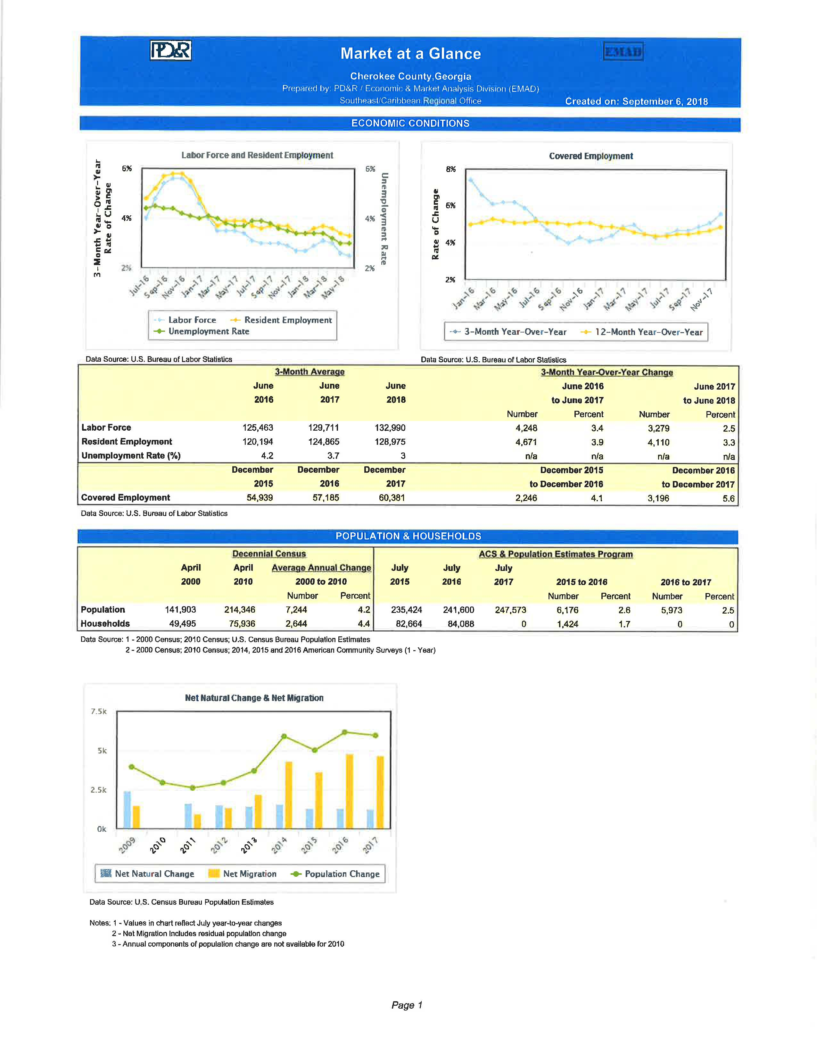
Market at a Glance (PDÿR) PG 1
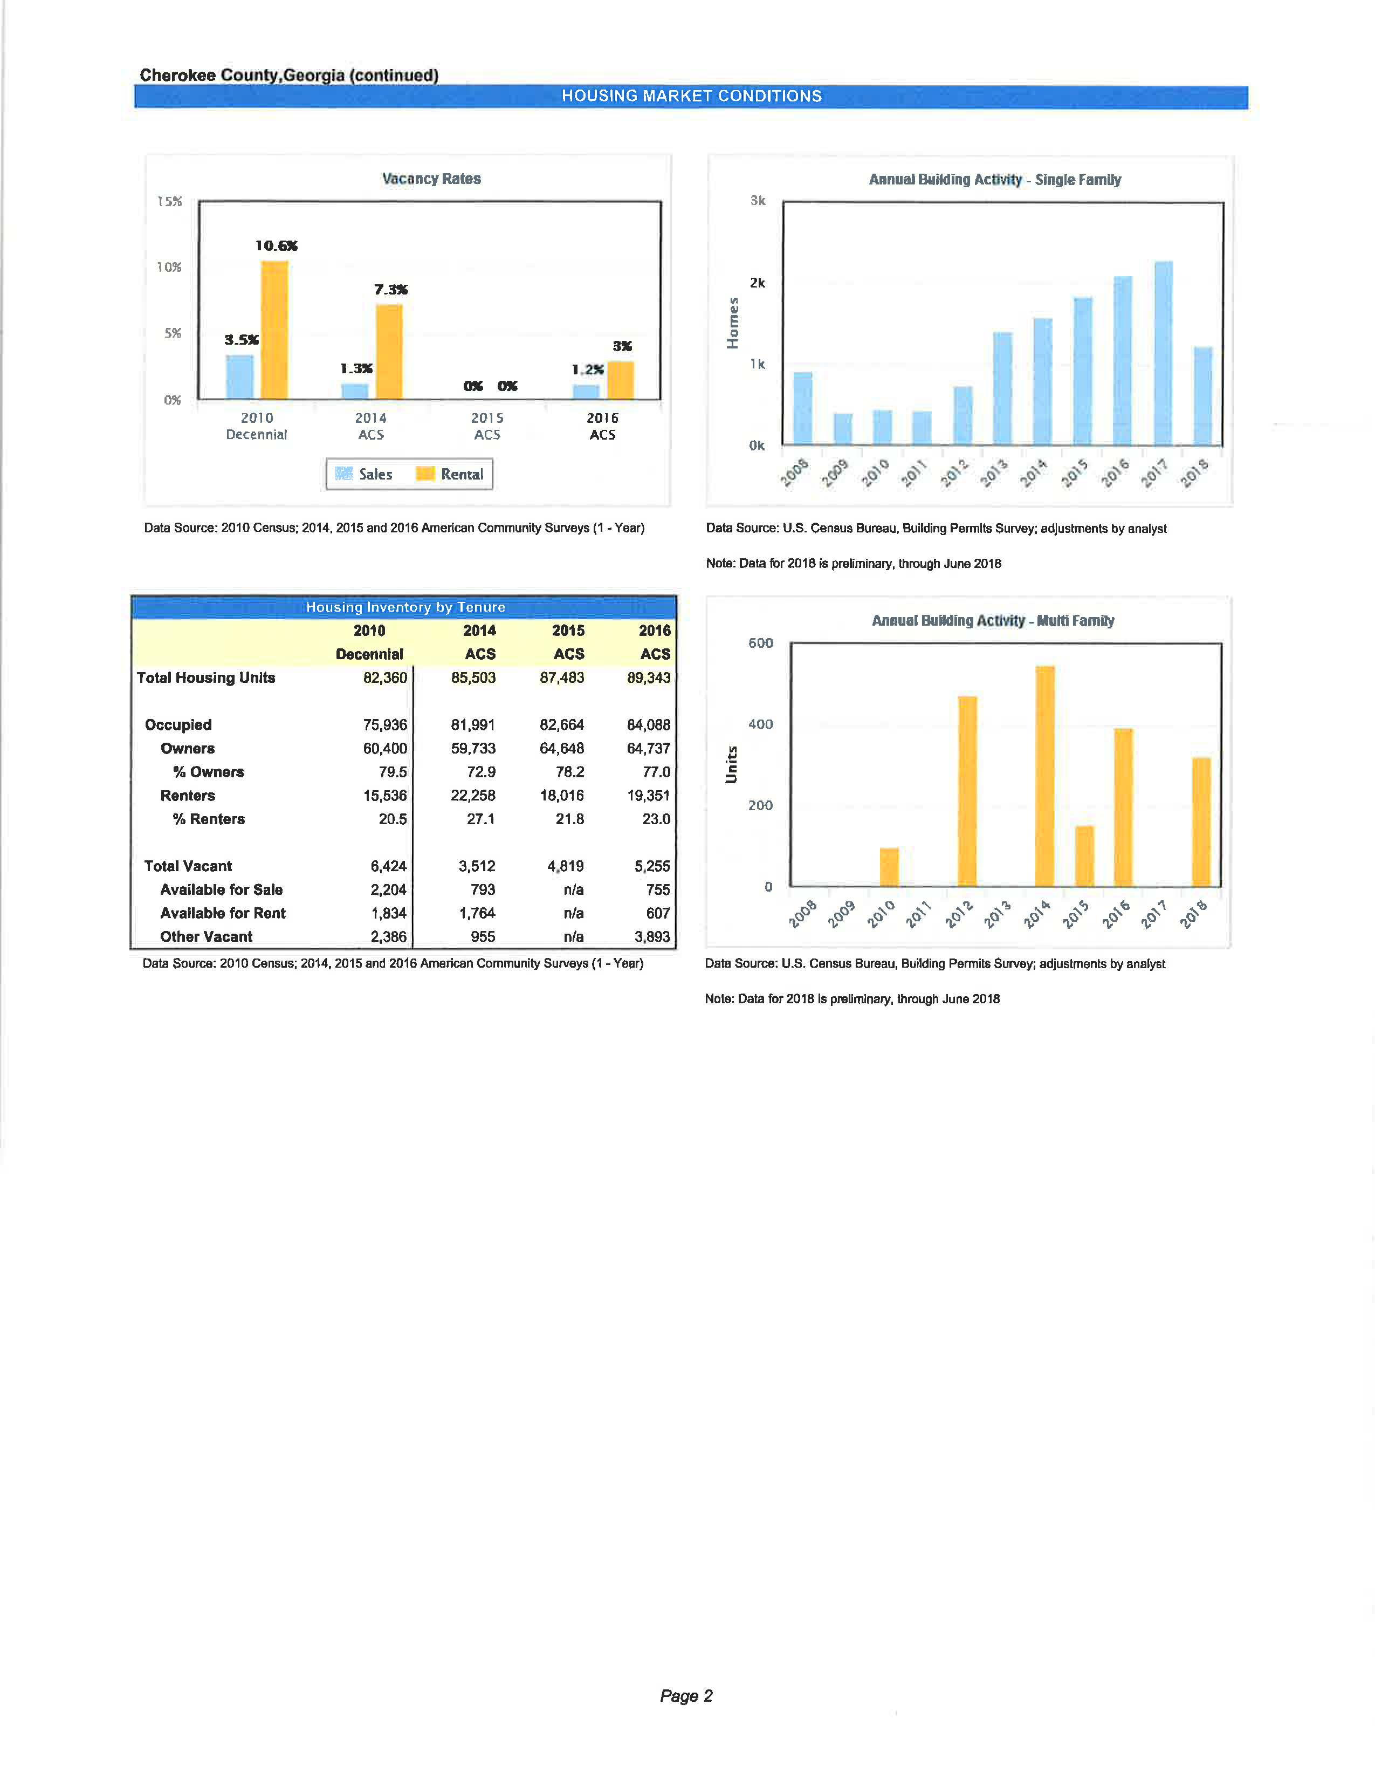
Market at a Glance (PDÿR) PG 2
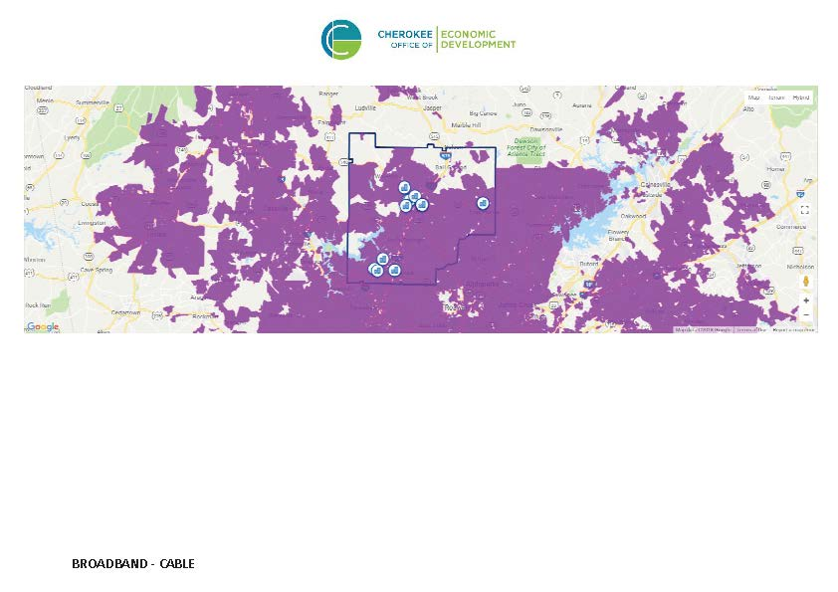
BROADBAND SERVICE AREA MAP-CABLE
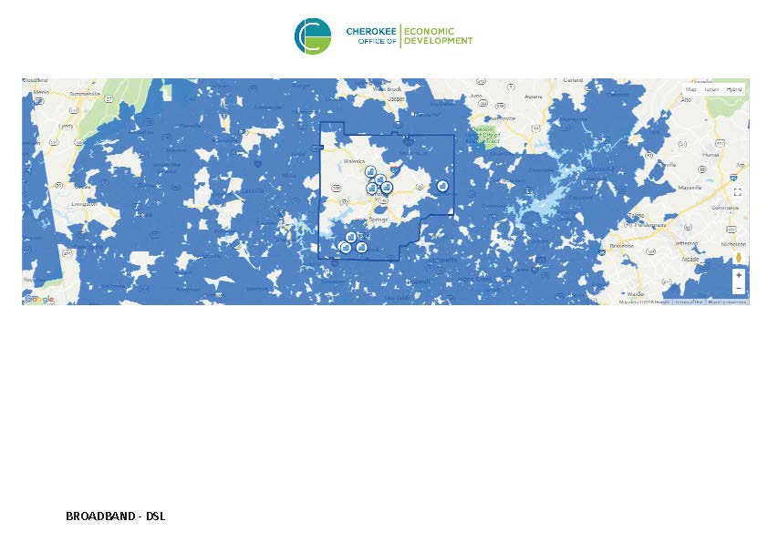
BROADBAND SERVICE AREA MAP-DSL
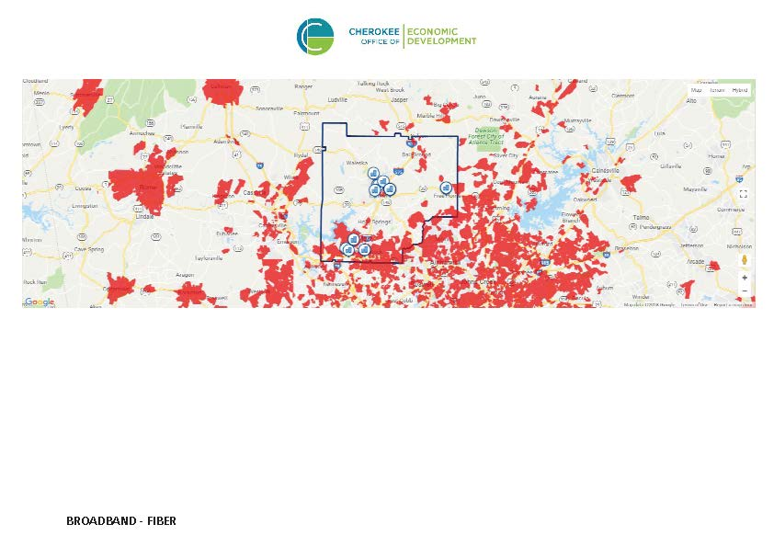
BROADBAND SERVICE AREA MAP-FIBER
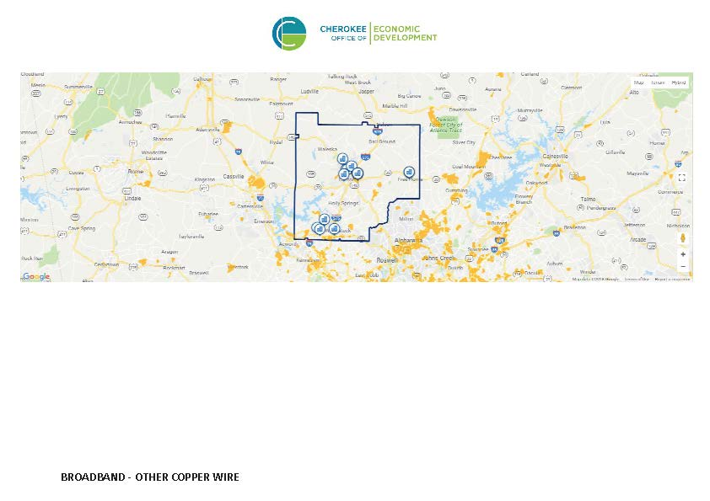
BROADBAND SERVICE AREA MAP-OTHER COPPER WIRE
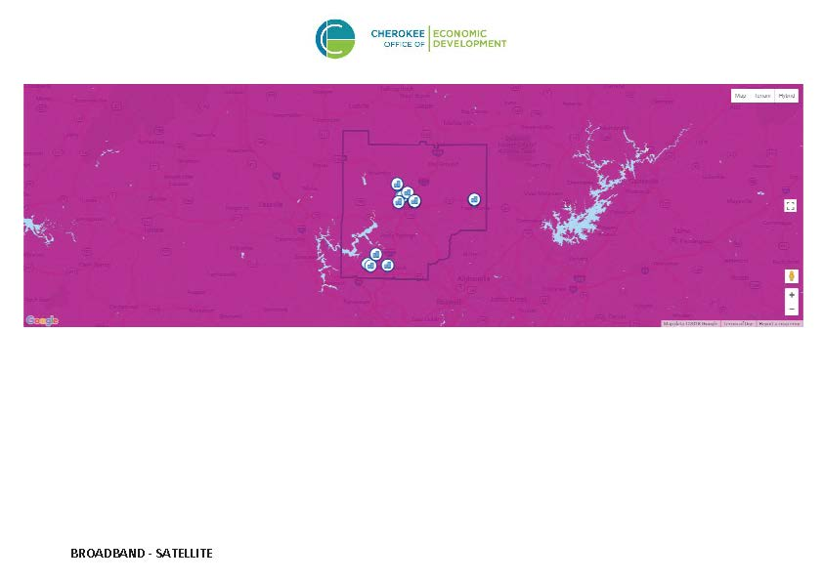
BROADBAND SERVICE AREA MAP-SATELLITE
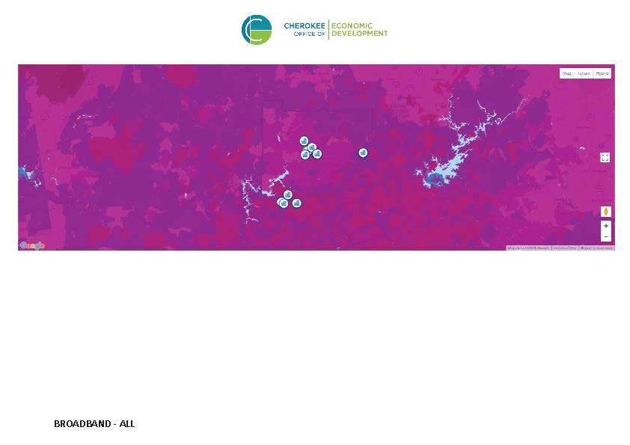
BROADBAND SERVICE AREA MAP-ALL BROADBAND
Resiliency Assessment
In addition, the County's Emergency Management Agency (EMA) was contacted to determine resiliency status for the County and its vulnerability to natural hazards. Cherokee County Water and Sewerage agency was contacted as well since one of its primary responsibilities is the management of water resources within the county. The EMA has a hazard mitigation plan that is reviewed annually and updated every five years. The mitigation plan contains input from several agencies, including public safety agencies, resources management agencies such as public utilities, major employers, nonprofit agencies who provide human services, and a local university, to name a few. The HMP was prepared in 2010 and is in compliance with the Federal Disaster Mitigation Act of 2000, which provides benchmarks and criteria for communities with the vision to implement practices in their communities. Natural hazards are given a risk assessment with empirical data, and mitigation plans for preparedness and response and recovery are updated based on the risk assessment and loss/damage to asset potential. New to the most recent mitigation plan update (2015, for the period 2016-2021) was the addition of man-made hazards such as technological hazard-terrorism, technological hazard-communications failure, technological hazard-transportation incidents, and technological hazard-hazardous materials. The CDBG Program Office will partner with the Emergency Management agency to determine where deficiencies exist in resources/funding for the County and participating cities in the implementation of the Hazard Mitigation Plan to accomplish the goals set forth.

MA-10 Number of Housing Units – 91.210(a)&(b)(2)
Introduction
In addition to the ACS Data 2009-2013 in the table below, American Fact Finder was used to obtain the report DP04 Selected Housing Characteristics: 2012-2016 American Community Survey 5-Year Estimates for a more recent picture of the housing stock in the County. The data provided by HUD shows that there were 83,158 residential units in Cherokee County through 2013. The housing mix consists of significant portion of single family units (over 83% of the total housing units), more so than condos/townhomes or multifamily properties. Most of the multifamily units were in larger complexes, 5 or more units, representing 82% of the multi-unit properties.
Manufactured/mobile homes are a notable component of the housing stock with an estimated 3,335 units, increasing over the last ACS Data (2006-2010), provided by HUD, for the previous ConPlan at 3,235, and even higher in the most recent 5-Year ACS Estimate (2012-2016) at 3,447. While there are many scattered locations, the condition of manufactured homes and the sites on which they are located vary. Often these units are on individual sites and provide modestly priced housing for residents.
The Unit Size by Tenure table estimates that 79% of the units were owner-occupied and 21% renter-occupied. Over 91% of owner units had 3 or more bedrooms. A majority of renter units are split between 2 bedrooms (39%) and 3 or more bedrooms (50%).
All residential properties by number of units
Property Type | Number | %
1-unit detached structure | 68,828 | 83%
1-unit, attached structure | 2,930 | 4%
2-4 units | 1,477 | 2%
5-19 units | 3,231 | 4%
20 or more units | 3,357 | 4%
Mobile Home, boat, RV, van, etc | 3,335 | 4%
Total | 83,158 | 100%
Table 31 – Residential Properties by Unit Number
Data Source: | 2009-2013 ACS

Unit Size by Tenure
 | Owners |  | Renters
 | Number | % | Number | %
No bedroom | 58 | 0% | 118 | 1%
1 bedroom | 259 | 0% | 1,632 | 10%
2 bedrooms | 4,895 | 8% | 6,297 | 39%
3 or more bedrooms | 55,194 | 91% | 7,918 | 50%
Total | 60,406 | 99% | 15,965 | 100%
Table 32 – Unit Size by Tenure
Data Source: | 2009-2013 ACS

Describe the number and targeting (income level/type of family served) of units assisted with federal, state, and local programs.
Public Housing in Cherokee County is provided by the Canton Housing Authority, which has 145 units on three campuses. Just over fifty of these units are family units, with the remainder serving the elderly, individuals, and handicapped persons. These units provide much-needed housing cost relief for low-to-moderate income households.
In addition to the safe and secure emergency shelter at Cherokee Family Violence Center (12 beds), the agency also operates a 72-unit gated apartment complex comprised of 2, 3 and 4-bedroom transitional housing for victims of domestic violence and their children living in Cherokee County. MUST Ministries, Inc. – Cherokee has 25 units of permanent supportive housing (total of 56 beds) to serve clients with disabling conditions that would prevent independent living. The program supports the most difficult to serve of the homeless population that include the chronically homeless, homeless, and veteran populations who suffer from addictions, mental illness, physical disabilities, or co-occurring disorders.
Provide an assessment of units expected to be lost from the affordable housing inventory for any reason, such as expiration of Section 8 contracts.
The Housing Authority in Canton does not handle Section 8 vouchers, but that is administered by the State. At some level, there were some units of affordable housing lost to development in Holly Springs where a trailer park forced residents out.
There is a population of seniors that have found affordable housing in manufactured/mobile homes that are in trailer parks, but one of the trailer parks, the one located in Holly Springs, is being sold to a developer and forcing residents to vacate. Senior Services regularly receives calls for assistance in finding affordable housing options, and some are assisted with deposits for an apartment or relocated to other jurisdictions.
Does the availability of housing units meet the needs of the population?
As in most communities, affordable housing is very limited especially housing for the lowest-income households (at or below 30% of AMI). The available housing stock is generally older and in need of rehabilitation. According to the 2012-2016 American Community Housing Survey 5-Year Estimates, specifically housing characteristics, approximately 33% of the housing units in the County are homes built over 20 years ago, and 4% represent homes 50+ years old. Homes built in the 90’s total 22,855, so the number of homes built 20 years ago could be closer to 50% (for homes built 1990-1997).
Households at or below 30% of AMI often require assistance with rent and/or utilities as well as other basic needs. People living on low, fixed incomes, such as Social Security as the sole retirement benefit, or disability benefits are not able to easily find suitable, affordable housing. According to the 2010 census, Cherokee County’s share of the state’s total population living in poverty (1,645,272) was at 1% (or 17,855). For the County, the percentage of the population living in poverty is at 8.4% of the households, and they need assistance for suitable housing.
Housing requirements change as the senior population continues to age. Many seniors are looking to downsize and are looking for units that meet future needs. While there are units in the County that offer amenities that allow for single floor living, handicap accessibility, and transportation, many of these units are not affordable to the seniors living on a fixed income. Many households require modifications for accessibility for the seniors who want to age in place, and the County addresses this with the Minor/Emergency Home Repair program to the extent modifications amount to only $5,000.
There is limited affordable housing for people with disabilities in general.
Describe the need for specific types of housing:
Housing prices in the County and its cities are considered affordable within the context of the Metro Atlanta Area region in which the County is located. A large proportion of the higher priced move-up homes and executive homes has been built within the last ten to fifteen years. The majority of new multi-family housing in the incorporated areas has occurred within the cities of Woodstock and Canton.
The economic slump from 2008, forward, weakened the construction of new owner and renter units in the County. The decline in permits from its high in 2005 continued through 2012 (1,213). By 2013, significant signs of recovery were noted, especially for unincorporated Cherokee County, but numbers haven't returned to the peaks seen between 2002-2006 for all of the Cities.
Much of the existing housing stock is older and many of these units are smaller making them affordable; however, there is concern about the condition of these homes. Rehabilitation of these older housing units brings concern about lead-based paint hazards and asbestos and ensuing requirements of abatement of such. Not all units are suitable for rehabilitation especially older manufactured homes. The County’s strategy includes preservation of affordable housing in existing communities when possible.
Entry level housing for working households making 50%-80% of AMI continues to be a challenge with the increase in construction costs. Several survey responses from human service providers as well as citizen responses have indicated a great need for affordable and available workforce housing.
Discussion

MA-15 Housing Market Analysis: Cost of Housing - 91.210(a)
Introduction
According to the 2017 American Community Survey 1-Year Estimate, the median home value for Cherokee County is $251,100. Despite this number being an estimate, it is $60,700 more than the ACS data in the table below. The median value for the 5-Year estimate from ACS data (2012-2016) ranks at $204,400, an increase of $14,000. The 5-Year estimate of contract rent (2012-2016) comes in at $860, a $51/month increase over the data in the table below. The high cost of housing and the lack of affordable inventory are barriers to many. Persons who are coming out of homelessness, those precariously-housed, veterans, and persons returning to the community from institutions face the challenge of finding suitable, affordable housing and finding resources to meet move-in costs.

Cost of Housing
 | Base Year: 2000 | Most Recent Year: 2013 | % Change
Median Home Value | 138,300 | 190,400 | 38%
Median Contract Rent | 622 | 809 | 30%
Table 33 – Cost of Housing

Data Source: | 2000 Census (Base Year), 2009-2013 ACS (Most Recent Year)

Rent Paid | Number | %
Less than $500 | 2,412 | 15.1%
$500-999 | 9,235 | 57.9%
$1,000-1,499 | 3,696 | 23.2%
$1,500-1,999 | 424 | 2.7%
$2,000 or more | 198 | 1.2%
Total | 15,965 | 100.0%
Table 34 - Rent Paid
Data Source: | 2009-2013 ACS

Housing Affordability
% Units affordable to Households earning | Renter | Owner
30% HAMFI | 478 | No Data
50% HAMFI | 3,190 | 2,354
80% HAMFI | 9,553 | 10,511
100% HAMFI | No Data | 16,964
Total | 13,221 | 29,829
Table 35 – Housing Affordability
Data Source: | 2009-2013 CHAS

Monthly Rent
Monthly Rent ($) | Efficiency (no bedroom) | 1 Bedroom | 2 Bedroom | 3 Bedroom | 4 Bedroom
Fair Market Rent | 764 | 820 | 949 | 1,253 | 1,532
High HOME Rent | 764 | 820 | 949 | 1,175 | 1,291
Low HOME Rent | 607 | 650 | 780 | 901 | 1,005
Table 36 – Monthly Rent

Data Source Comments: | FY 2016 FMR's and 2016 HOME Program Rents

Is there sufficient housing for households at all income levels?
The Housing Affordability table above estimates the number of units that are affordable for each of the HUD adjusted median family income levels (CHAS census data). Households with the lowest incomes – at or below 30% of AMI and those below 50% of AMI – lack affordable housing. The HUD data indicates there are 478 units with rents (including utilities) within the budgets of the households earning 30% or less of AMI and 3,190 (for renter households) and 2,354 (for owner households) for those households earning less than 50% of AMI. This data, as well as household data in the Housing Needs Assessment section (NA10), supports the need for suitable, affordable housing as there is an insufficient housing inventory to meet the needs of the lowest income renters and owners. Having a total number of household units at 83,158, a 31% affordability rate exists for the LMI households. It stands to reason that if the total number of units that are affordable at the specified income levels, above, is 43,050, and total housing units is 83,158 (52%), then there is not a sufficient amount of housing affordable to all income levels.
How is affordability of housing likely to change considering changes to home values and/or rents?
The housing market has seen a recovery and available inventory is tightening. According to the online magazine, PD&R Edge, the report of the Summary of US Housing Market Conditions: 1Q2018, all three major home price indices (Standard & Poor's Case-Shiller, Federal Housing Finance Agency, and CoreLogic) indicate that during the first quarter of 2018, home sales prices rose by about 7 percent relative to a year ago. Housing costs are not likely to decrease. New home construction costs are expected to continue to increase as well as fuel and transportation costs, factors influencing the cost of materials. Vacancy rates are on the decline, and the nation’s foreclosure rate continues to decline. More and more LMI households are finding themselves priced out of the new and existing homes market.
And, Fair Market Rent for an efficiency unit is $873. A person making the minimum wage of $7.25, working 40 hours per week would experience a severe cost burden (50%). If housing is available, households may have to opt for units in questionable condition. People with special needs, including those with disabilities may find themselves in units without accommodations and/or in locations that make it difficult to get to work and services.
The Analysis of Impediments to Fair Housing Choice, recently completed in April 2018, saw the County set as one of its fair housing goals the need to Increase Availability of Affordable Housing, and the County plans to promote LIHTC opportunities by contacting affordable housing developers working in the Atlanta area and support feasible LITC applications through letters of endorsement or investment of CDBG funds. There is no anticipated subsidized affordable housing in Cherokee County to alleviate the burden of housing for the low-income households, but the City of Woodstock is willing to partner with the County in efforts to get workforce housing constructed in the community.
How do HOME rents / Fair Market Rent compare to Area Median Rent? How might this impact your strategy to produce or preserve affordable housing?
The County no longer receives HOME funding, but Fair Market Rents, as well as High/Low HOME rents, were obtained from the HUD Economic and Market Analysis Division (HUD User) and the HUD Exchange. The area median rent, according to the 2012-2016 ASC estimates, is $860, slightly higher than the amount shown in the Housing Cost table, above, and compared to the Fair Market rent [FY 2016] of $949 for a 2-bedroom unit and $1,253 for a 3-bedroom unit, comes in below the data. While the area median rent is a 5-Year estimate (2012-2016), the 2017 ACS estimate is more representative of rents in the jurisdiction ($1,066). With median rent above the Fair Market rents for Efficiencies, 1-Bdrm, and 2-Bdrm units, production of additional units is needed to provide more affordable housing to increase the inventory of rental units.
Trend analysis from the online magazine and report referenced in the previous discussion concerning sufficient housing for households at all income levels indicates that apartment rents were up 4.4 nationally from a year ago (12-months ending March 31), with rents increasing in all regions.
Discussion
Considering there is not enough affordable housing in the County’s housing stock, rising costs of rent and home values contribute to the barriers for access to affordable housing for LMI households. Increasing the number of affordable units is a goal of the County’s.

MA-20 Housing Market Analysis: Condition of Housing – 91.210(a)
Introduction

Definitions
For the purpose of this Consolidated Plan, the County provides the following definitions for the terms “standard condition”, “substandard condition”, and “substandard but suitable for rehabilitation”. For units considered in “standard condition”, they must meet the HUD Section 8 housing quality standards. Substandard units are units that do not meet one or more of the HUD Section 8 housing quality standards. These units are likely to also have deferred maintenance, may have some structural damage such as leaking roofs or deteriorated interior surfaces. A unit is substandard if it is lacking the following: complete plumbing, complete kitchen facilities, and adequate heating systems.
Substandard but suitable for rehabilitation includes those units with some of the same features as substandard such as lacking complete plumbing, lacking complete kitchen facilities, and inadequate heating systems but has some infrastructure that can be improved upon.

Condition of Units
Condition of Units | Owner-Occupied |  | Renter-Occupied
 | Number | % | Number | %
With one selected Condition | 16,408 | 27% | 7,201 | 45%
With two selected Conditions | 285 | 0% | 539 | 3%
With three selected Conditions | 18 | 0% | 85 | 1%
With four selected Conditions | 0 | 0% | 0 | 0%
No selected Conditions | 43,695 | 72% | 8,140 | 51%
Total | 60,406 | 99% | 15,965 | 100%
Table 37 - Condition of Units
Data Source: | 2009-2013 ACS

Year Unit Built
Year Unit Built | Owner-Occupied |  | Renter-Occupied
 | Number | % | Number | %
2000 or later | 23,543 | 39% | 5,302 | 33%
1980-1999 | 28,041 | 46% | 6,832 | 43%
1950-1979 | 7,836 | 13% | 3,087 | 19%
Before 1950 | 986 | 2% | 744 | 5%
Total | 60,406 | 100% | 15,965 | 100%
Table 38 – Year Unit Built
Data Source: | 2009-2013 CHAS

Risk of Lead-Based Paint Hazard
Risk of Lead-Based Paint Hazard | Owner-Occupied |  | Renter-Occupied
 | Number | % | Number | %
Total Number of Units Built Before 1980 | 8,822 | 15% | 3,831 | 24%

Housing Units build before 1980 with children present | 13,389 | 22% | 10,349 | 65%
Table 39 – Risk of Lead-Based Paint
Data Source: | 2009-2013 ACS (Total Units) 2009-2013 CHAS (Units with Children present)

Vacant Units
 | Suitable for Rehabilitation | Not Suitable for Rehabilitation | Total
Vacant Units | 0 | 0 | 0
Abandoned Vacant Units | 0 | 0 | 0
REO Properties | 0 | 0 | 0
Abandoned REO Properties | 0 | 0 | 0
Table 40 - Vacant Units
Data Source: | 2005-2009 CHAS

Need for Owner and Rental Rehabilitation
Condition of Units, Table 33 above, summarizes the housing problems described in the earlier CHAS tables. Conditions include lack of complete kitchen or plumbing, overcrowding, and cost burden. In the earlier section of the plan, most of the housing problems are the results of cost burden. The ACS estimates that 16,408 (27%) of the owner households had at least one selected condition and only 303 had two or more selected problems. An estimated 6,666 (45%) renter households had at least one selected condition with 624 have two or more selected problems.
Growth of the population in the County has been noted since 1980. As the cost of housing rose in the surrounding counties of Cobb and Fulton, persons moved into Cherokee County for more affordable housing. The migration to Cherokee County resulted in a housing boom during the 1980-2000 period with 85% of the owner households built since 1980 and 76% of the rental units built after 1980.
Many of the older homes were constructed by the homeowner when the county did not have building codes. These homes were often built with scrap materials and substantial rehabilitation is required to bring these homes up to standards.
Estimated Number of Housing Units Occupied by Low or Moderate Income Families with LBP Hazards
Risk of Lead-Based Hazard – Table 35 above provides an estimate of housing where lead-based paint may be a hazard (housing built prior to 1980). Included in this table is 22,211 owner units/13,389 with children present and 14,180 rental units. It can be assumed that rental units would be more likely to have children present. Units built prior to 1980 with children present are at a greater risk for elevated blood levels.
Discussion
Risk of Lead-Based Hazard – Table 35 above provides an estimate of housing where lead-based paint may be a hazard (housing built prior to 1980). Included in this table is 22,211 owner units/13,389 with children present and 14,180 rental units. It can be assumed that rental units would be more likely to have children present. Units built prior to 1980 with children present are at a greater risk for elevated blood levels.

MA-25 Public and Assisted Housing – 91.210(b)
Introduction
Public housing in Cherokee County is provided through the Housing Authority of the City of Canton (HAC), an independent organization. The Housing Authority manages public housing units, but it does not handle Section 8 vouchers, which are administered by the Georgia Department of Community Affairs. The Housing Authority has 145 units of public housing on three campuses. Just over 50 of these are family units, with the remainder serving the elderly, individuals, and handicapped persons.
Totals Number of Units
Program Type
 | Certificate | Mod-Rehab | Public Housing | Vouchers
 |  |  |  | Total | Project -based | Tenant -based | Special Purpose Voucher
 |  |  |  |  |  |  | Veterans Affairs Supportive Housing | Family Unification Program | Disabled  *
# of units vouchers available |  |  | 145
# of accessible units

*includes Non-Elderly Disabled, Mainstream One-Year, Mainstream Five-year, and Nursing Home Transition
Table 41 – Total Number of Units by Program Type
Data Source: | PIC (PIH Information Center)

Describe the supply of public housing developments:
Describe the number and physical condition of public housing units in the jurisdiction, including those that are participating in an approved Public Housing Agency Plan:
The overall condition of the units is good, with the Authority receiving an inspection score of 26 out of 40 and currently are addressing deficiencies throughout the year. The Housing Authority is undergoing a Physical Needs Assessment where inspections of all systems are taking place to evaluate electrical systems, plumbing systems, HVAC, etc. to prepare for rehabilitation to all three campuses. Renovations to kitchens and bathrooms were completed, and recently letters were sent to residents to clean up front and back porches to coincide with common area cleanup. The properties need fencing, gutter work, and trees trimmed or taken down. The Executive Director will address those needs as funding allows.
While the Housing Authority meets a critical need for affordable housing for low-income residents, it has an insufficient number of units (145) and funds to meet the full need for affordable housing in the County. Given limited funding for public housing, this condition is not likely to change.
The current waiting lists vary by size of the units:
1 BR: 93 applicants (expected wait is 2-3 years)
2 BR: 49 families
3 BR: 11 families
4 BR: 1 applicant

Public Housing Condition
Public Housing Development | Average Inspection Score
Table 42 - Public Housing Condition

Describe the restoration and revitalization needs of public housing units in the jurisdiction:
The public housing units managed by the Canton Housing Authority recently received a 26 out of 40 inspection score, so the campuses are currently undergoing a Physical Needs Assessment to address deficiencies throughout the year. Inspections are being conducted on all of the systems to evaluate electrical, plumbing, HVAC, etc. to prepare for rehabilitation to all three campuses. Adjustments to the repair plan are made to respond to emergency problems encountered by residents.
Describe the public housing agency's strategy for improving the living environment of low- and moderate-income families residing in public housing:
As a result of unusual turnover in the Executive Director position, the current Executive Director is working to restore faith and trust in the management of the communities. Office hours for Housing Authority have been extended to include more hours in the day on more days of the week. The Board has been completely revamped, and more than improving the mission statement and objectives, the Director has taken steps to become more transparent than previous directors.
Residents are surveyed annually to obtain their input on needs, and this information is used in preparing the PHA 5-year plan, which includes strategies for improving the environment of Housing Authority units. Currently, residents are being asked to tidy up front and back porches, where applicable, in concert with common areas cleaned by the Housing Authority. As previously mentioned, the physical deficiencies are being addressed as funding allows.
Housing Authority staff members meet periodically with residents to discuss conditions and Authority operations and to secure input for improvements to the community.
Discussion:

MA-30 Homeless Facilities and Services – 91.210(c)
Introduction
There are limited housing facilities to meet the needs of homeless persons living in Cherokee County. Housing resources and services are generally provided by non-profit organizations and churches within the community. There is one 12-bed emergency shelter and a 72-unit transitional housing apartment community for victims of domestic violence and their families. MUST Ministries, Inc. – Cherokee has 18 Permanent Supportive Housing units that serve the homeless and near-homeless families, individuals, and veterans with verifiable disabilities.

Facilities and Housing Targeted to Homeless Households
 | Emergency Shelter Beds |  | Transitional Housing Beds | Permanent Supportive Housing Beds
 | Year Round Beds (Current & New) | Voucher / Seasonal / Overflow Beds | Current & New | Current & New | Under Development
Households with Adult(s) and Child(ren) | 0 | 0 | 0 | 0 | 0
Households with Only Adults | 0 | 0 | 0 | 0 | 0
Chronically Homeless Households | 0 | 0 | 0 | 0 | 0
Veterans | 0 | 0 | 0 | 0 | 0
Unaccompanied Youth | 0 | 0 | 0 | 0 | 0
Table 43 - Facilities and Housing Targeted to Homeless Households

Data Source Comments:

Describe mainstream services, such as health, mental health, and employment services to the extent those services are use to complement services targeted to homeless persons
Nonprofit agencies and churches are able to provide services and healthcare for homeless persons and persons at risk of homelessness. Bethesda Community Clinic partners with Cherokee Family Violence Center to provide health services to the women and children housed in emergency and transitional housing. Mental health counseling and services in the community are insufficient to meet the needs as there is a shortage of treatment beds for persons with mental disorders and substance abuse.
MUST Ministries, Inc.’s Permanent Supportive Housing program assigns a case manager to persons entering their program and assists them in obtaining mainstream services. Employment services are available in the community for homeless persons as well as those at risk of homelessness. MUST Ministries provides a computer lab and work-clothes closet for persons seeking employment.
List and describe services and facilities that meet the needs of homeless persons, particularly chronically homeless individuals and families, families with children, veterans and their families, and unaccompanied youth. If the services and facilities are listed on screen SP-40 Institutional Delivery Structure or screen MA-35 Special Needs Facilities and Services, describe how these facilities and services specifically address the needs of these populations.
The County does not have emergency shelter housing for the homeless. MUST Ministries, Inc. - Cobb operates the Elizabeth Inn in Cobb County and often has individuals from Cherokee referred to the Cobb Campus. Mass transit services are not available, and the County’s limited transit system does not travel beyond the bounds of the County. MUST Ministries, however, provides cab fare to the facility in Cobb County.
The Cherokee Family Violence Center, located in Canton, GA, provides emergency shelter (12 bed facility), crisis intervention, longer term transitional housing, case management services, transportation assistance, emergency financial assistance, support groups, children activities, and legal advocacy services to victims of domestic violence and their children living in Cherokee County. Due to the limited emergency shelter resources, victims are being referred outside of the County to facilities such as Peace Place, Inc. in Winder/Barrow County.
The Cherokee Family Violence Center established a Transitional Housing complex in 2005, comprised of 2, 3 and 4 bedroom units, where victims of domestic violence and their children can live for up to three years. It is one of the largest Transitional Housing programs of its kind in the United States. The rental structure is income based, with 80% of the units having Section 8 rental subsidies making it affordable for the families while rebuilding their lives.
Bethesda Community Clinic offers free acute and chronic medical care to residents of the County who lack access to medical care and whose income is equal to or less than 150% of the Federal Poverty Guidelines. Since medical expenses are a factor forcing many into homelessness, this clinic provides those most vulnerable the opportunity for health services. Bethesda also offers reduced cost to other uninsured or underinsured persons for a flat fee per visit.
Timothy House is located in Pickens County, north of Cherokee County, and it offers extensive programs for drug and alcohol recovery for both men and women. The programs are not residential and are offered for a fee of $1,200 which must be paid for up front. This fee makes it unaffordable for the homeless or near homeless populations.
Bethany Place is located in Cherokee County and it provides food and shelter for women up to 18 desiring to turn their lives around. The residents are not allowed to seek employment while participating in this program.
Hope Quest, in Woodstock, offers two programs geared toward men and women struggling with alcohol or substance abuse.
Serenade Heights, Inc., located in Cherokee County, is a restoration ministry that provides supportive transitional housing to single mother families. They provide support, resources, and coaching to mothers in the area. And, they provide workshops for local single moms as well. Assistance is given to clients in the program to help find secure housing.
Jubilee Church Restore, in Woodstock, operates a food pantry to serve those in the community who are struggling with issues around homelessness. Heritage Presbyterian Church, in Acworth, also operates a food pantry and partners with Atlanta Community Food Back to provide assistance in the southwest area of the County near the opportunity zone.

MA-35 Special Needs Facilities and Services – 91.210(d)
Introduction
The County, through its Senior Services and Minor/Emergency Home Repair program for seniors, veterans, and disabled persons, provides assistance to the elderly, frail elderly, and veterans populations to maximize the duration of an independent living situation. The Cherokee Day Training Center and Next Step Ministries, Inc. are the primary providers of services for the mentally and developmentally (respectively) disabled adults in Cherokee County.

Including the elderly, frail elderly, persons with disabilities (mental, physical, developmental), persons with alcohol or other drug addictions, persons with HIV/AIDS and their families, public housing residents and any other categories the jurisdiction may specify, and describe their supportive housing needs
Seniors and the frail elderly have special needs for accessible and affordable housing. As they age, they need assisted living facilities, health services, and nursing care. The elderly often need assistance, case management services, health education, and caregiver support. Cherokee Senior Services provides case management services. The case manager designs an individual service plan and coordinates services through Cherokee County Senior Services and other community agencies, as needed. The case managers assist with housing assistance, financial assistance, legal referrals, medical equipment, home-delivered meals, light housekeeping, etc.
The Cherokee County Senior Center, through a congregate program, provides nutritious meals in addition to activities designed to provide social, mental, and physical stimulation. For seniors finding it difficult to drive or get out of the home, home-delivered meals services, as well as light housekeeping, grocery shopping, or light meal preparation are provided to the elderly who might be nutritionally at risk or have mobility issues limiting their ability to perform cleaning tasks in the home. Senior Services also provides transportation services to and from the services offered at the Canton location. Vouchers are also available to assist seniors with essential travel needs (physician appointments, etc.).
MUST Ministries, Inc. – Cherokee has a permanent supportive housing program that serves clients with a verifiable disability, which may include drug or alcohol addictions, not just a physical challenge. The program has 18 units with case managers assigned to each individual/family.
Cherokee Day Training Center is a non-profit in Cherokee County that provides persons with developmental disabilities access to typical life experiences and offers the individualized support necessary for obtaining employment, for developing skills, and for implementing personal choices.
Next Step Ministries, Inc. serves developmentally disabled persons who have aged out of the school system and require round-the clock care. The Therapeutic Day program allows parents to work while their young adult is being cared for at the facility. Clients are provided a personalized plan based on cognitive levels and higher cognitive abilities go through a job training program. Lower cognitive ability clients are taught basic life skills to enable families to go out in public and enjoy basic activities like eating in a restaurant.
Persons with severe mental health issues require specialized case management services, mental health counseling and, in some cases supportive housing offered in group home settings.
Describe programs for ensuring that persons returning from mental and physical health institutions receive appropriate supportive housing
Currently there are not any programs for persons returning from mental and physical health institutions to receive appropriate supportive housing.
Specify the activities that the jurisdiction plans to undertake during the next year to address the housing and supportive services needs identified in accordance with 91.215(e) with respect to persons who are not homeless but have other special needs. Link to one-year goals. 91.315(e)
The activity that the County will support for next year to address the housing and supportive services needs is to provide staff support to MUST Ministries, Inc. – Cherokee for case managers in the agency’s permanent supportive housing program. In addition to this goal for next year, MUST has expressed a need for obtaining more supportive housing units.
As part of the Consolidated Planning and annual planning processes, the County participates in a forum – Housing and Services Forum. This group brings together organizations that provide assistance in housing and homelessness, the church community, other non-profit organizations, and even includes a formerly homeless individual. One of the goals of this forum is to define the housing needs in the community and develop a plan to address these needs. Agencies often network to share resources and information.
For entitlement/consortia grantees: Specify the activities that the jurisdiction plans to undertake during the next year to address the housing and supportive services needs identified in accordance with 91.215(e) with respect to persons who are not homeless but have other special needs. Link to one-year goals. (91.220(2))
While this Consolidated Plan addresses the County’s CDBG grant only, it is important to note the County no longer receives HOME funds as part of the Georgia Urban County Consortium, with Cobb County as Lead Agency.
The County partners with Habitat for Humanity to administer a Minor/Emergency Home Repair program to allow the elderly, frail elderly, and veterans populations to age in place as long as possible. Typically, with a limit of $5,000 for repairs, the program address one of the major systems of the home: electrical, plumbing, HVAC, or roofs, but modifications may be made for accessibility. This program allows the seniors, veterans, and the disabled to age in place in a safer environment.

MA-40 Barriers to Affordable Housing – 91.210(e)
Negative Effects of Public Policies on Affordable Housing and Residential Investment
The cost of housing and utilities is not affordable to many owner and renter households, especially those earning less than 50% of AMI. There is a shortage of affordable housing units, and construction costs continue to rise. Provision for infrastructure is expensive as development extends to the areas that are not currently developed. Revenue for nonprofit housing developers has declined as a result of cutbacks at the federal level.
The Cherokee County Analysis of Impediments to Fair Housing Choice, April 2018, indicated that zoning laws were seen as significant impediments to the availability of affordable housing. This was mentioned as a particular problem for organizations trying to develop group homes for persons with disabilities. The requirement that group home occupants be ambulatory is one the AI recommended the County review and clarify. Also, the AI produced a goal to eliminate the minimum spacing requirements for group homes. In addition, the reasonable accommodations process was criticized and it was suggested that an ordinance be passed to include specifics regarding the form that a request for accommodation should take, the time frame within which the reviewing authority must make a decision, the form that decision must take, and whether conditions may be attached, and how to appeal a decision. The strongest recent interest in subsidized affordable housing construction has been limited to the senior/elderly population.

MA-45 Non-Housing Community Development Assets – 91.215 (f)
Introduction
The County made use of the Cherokee Office of Economic Development data and information as well as Atlanta Regional Commission Economic Development information for assessing non-housing community development assets. In addition, information regarding non-housing community development assets was obtained from the County's 2018 update to the Comprehensive Plan.
Economic Development Market Analysis
Business Activity
Business by Sector | Number of Workers | Number of Jobs | Share of Workers  % | Share of Jobs  % | Jobs less workers  %
Agriculture, Mining, Oil & Gas Extraction | 230 | 135 | 0 | 0 | 0
Arts, Entertainment, Accommodations | 10,768 | 7,057 | 13 | 17 | 4
Construction | 5,470 | 3,821 | 7 | 9 | 2
Education and Health Care Services | 11,162 | 5,967 | 13 | 15 | 2
Finance, Insurance, and Real Estate | 6,746 | 2,194 | 8 | 5 | -3
Information | 3,773 | 719 | 5 | 2 | -3
Manufacturing | 6,973 | 4,127 | 8 | 10 | 2
Other Services | 2,841 | 1,804 | 3 | 4 | 1
Professional, Scientific, Management Services | 11,258 | 3,000 | 14 | 7 | -7
Public Administration | 0 | 0 | 0 | 0 | 0
Retail Trade | 12,715 | 8,778 | 15 | 22 | 7
Transportation and Warehousing | 3,074 | 456 | 4 | 1 | -3
Wholesale Trade | 7,696 | 2,625 | 9 | 6 | -3
Total | 82,706 | 40,683 | -- | -- | --
Table 45 - Business Activity
Data Source: | 2009-2013 ACS (Workers), 2013 Longitudinal Employer-Household Dynamics (Jobs)

Labor Force
Total Population in the Civilian Labor Force | 114,358
Civilian Employed Population 16 years and over | 105,162
Unemployment Rate | 8.04
Unemployment Rate for Ages 16-24 | 21.58
Unemployment Rate for Ages 25-65 | 5.40
Table 46 - Labor Force
Data Source: | 2009-2013 ACS

Occupations by Sector | Number of People
Management, business and financial | 28,765
Farming, fisheries and forestry occupations | 4,028
Service | 9,052
Sales and office | 30,520
Construction, extraction, maintenance and repair | 9,013
Production, transportation and material moving | 5,439
Table 47 – Occupations by Sector
Data Source: | 2009-2013 ACS

Travel Time
Travel Time | Number | Percentage
< 30 Minutes | 44,728 | 47%
30-59 Minutes | 35,862 | 38%
60 or More Minutes | 13,773 | 15%
Total | 94,363 | 100%
Table 48 - Travel Time
Data Source: | 2009-2013 ACS

Education:
Educational Attainment by Employment Status (Population 16 and Older)
Educational Attainment | In Labor Force
 | Civilian Employed | Unemployed | Not in Labor Force
Less than high school graduate | 7,123 | 770 | 3,826
High school graduate (includes equivalency) | 19,010 | 1,877 | 6,223
Some college or Associate's degree | 28,913 | 2,090 | 7,020
Bachelor's degree or higher | 35,000 | 1,760 | 6,775
Table 49 - Educational Attainment by Employment Status
Data Source: | 2009-2013 ACS

Educational Attainment by Age
 | Age
 | 18–24 yrs | 25–34 yrs | 35–44 yrs | 45–65 yrs | 65+ yrs
Less than 9th grade | 751 | 1,424 | 1,318 | 1,744 | 1,608
9th to 12th grade, no diploma | 2,979 | 1,865 | 1,604 | 3,764 | 2,590
High school graduate, GED, or alternative | 5,301 | 5,827 | 6,942 | 14,341 | 7,126
Some college, no degree | 6,805 | 6,606 | 8,818 | 13,602 | 4,358
Associate's degree | 449 | 1,743 | 2,596 | 4,686 | 1,132
Bachelor's degree | 1,009 | 7,570 | 9,870 | 13,799 | 3,209
Graduate or professional degree | 22 | 2,200 | 4,231 | 5,865 | 1,896
Table 50 - Educational Attainment by Age
Data Source: | 2009-2013 ACS

Educational Attainment – Median Earnings in the Past 12 Months
Educational Attainment | Median Earnings in the Past 12 Months
Less than high school graduate | 18,908
High school graduate (includes equivalency) | 29,931
Some college or Associate's degree | 38,623
Bachelor's degree | 56,183
Graduate or professional degree | 65,705
Table 51 – Median Earnings in the Past 12 Months
Data Source: | 2009-2013 ACS

Based on the Business Activity table above, what are the major employment sectors within your jurisdiction?
Cherokee County has four major employment sectors: 1) retail trade (22% of jobs as of the 2009-2013 ACS), 2) Arts, Entertainment, Accommodations (17% of jobs), 3) Education and Health Care Services (15% of jobs), and 4) Manufacturing (10% of jobs).
The Education and Health Care Services sector boasts the largest employer. Northside Hospital – Cherokee is the largest employer with 2,145 employees; Inalfa Roof Systems (advanced automobile roofing systems/advance manufacturing) employs 1,000 people; Pilgrim’s Pride (poultry processing) employs 760, Chart Industries, Inc. (stainless steel cylinders, biomedical), employs 715; Piolax Corporation (manufacturer of automobile parts) employs 615; Universal Alloy Corporation (aluminum extrusion/aerospace) employs 559; Belnick, Inc. (office furniture distribution) employs 490 people; Meyn America, Inc. employs 267 (manufacturing & distribution), and Roytec Industries employs 250 (electrical wire assemblies); Schoen Insulation Services, Inc. (machined, non-metallic parts); and Papa John’s Quality Control is a regional hub that employs 145 people. [Cherokee Office of Economic Development website, www.cherokeega.org]
Describe the workforce and infrastructure needs of the business community:
Data from the Business Activity table suggests that there are more workers than jobs by 42,000, and scrutiny of each sector bears witness to the mismatch of workers to skills and job capacity. There is an excess of workers in all sectors compared to jobs. The Brain Drain phenomenon might explain this gap with nearly 80% of the residents commuting outside the county for jobs. (COED, Collaborative Strategic Implementation Plan, Jan. 2017). Other factors to contribute may be explained by the economic downturn that occurred in 2008 and the County is still experiencing residual effects.
Table 41 indicates that unemployment in the County is at 8.04%; however, the County’s 2018 update to the Comprehensive Plan cites an unemployment rate of 3.4% for January 2018 (US Bureau of Labor Statistics), compared to the metro area unemployment rate of 4.3%.
Data obtained from COED indicates that nearly 44% of residents have a post-secondary degree making the county attractive to white collar employers to relocate to the area and recruit workforce. A Regional Snapshot released by the ARC (Atlanta Regional Commission) shows that Cherokee County leads the second highest quartile of metro counties in change in employment, or job growth, with a projected 52% increase, one percentage point below two counties at the bottom of the top quartile (53%) and nineteen percentage points below the projected leader, Paulding County, in growth in the number of jobs from 2015 to 2040 (Series 15 forecasts, ARC, 2015-2016).
In terms of infrastructure needs, the downtown area of Canton, the county seat, has a need for parking improvements, sidewalks, and street lights. In addition, the county operates a transit system with transit buses that operate on a limited schedule. There is one fixed route that operates a limited number of hours and the balance of the fleet of 20-passenger buses operates an on-demand service for citizens needing to be transported to doctor appointments, seniors to the Senior Center, and disabled adults to the Day Training Center. Aged or aging housing units in areas/neighborhoods do not have sufficient sidewalks, curbs, or drainage. And, some of the smaller cities within the County have aged and/or failing water and wastewater management systems.
Describe any major changes that may have an economic impact, such as planned local or regional public or private sector investments or initiatives that have affected or may affect job and business growth opportunities during the planning period. Describe any needs for workforce development, business support or infrastructure these changes may create.
The Cherokee Office of Economic Development, in partnership with the Carl Vinson Institute of Government, created a group that included leaders from business, economic development, education, workforce, and the community to listen to companies, analyze data, and prioritize issues. Cherokee Workforce Collaborative used the data and industry feedback to assess the County’s workforce with a SWOT analysis (strengths, weaknesses, opportunities, and threats). As a result of the collaboration and analysis, strategic goals and action items were developed to address the workforce challenges and talent gaps that were identified. The roadmap of strategies and goals was developed in 2017 in the Cherokee Workforce Collaborative Strategic Implementation Plan. Among the issues identified within the workforce climate were improved communication between industry, education, and other community partners, limited public transportation and infrastructure, brain drain (difficult to keep graduates in the area), lack of critical soft skills such as punctuality and customer service, differing expectations of younger workers regarding flexibility of work schedule and relaxed work environment; job hopping, and negative perceptions of certain jobs or industries by potential workers, current students, and parents. The collaborative developed four priorities to grow and retain local talent to meet current and emerging workforce needs: internships, innovative career preparation, business and education alliances, and sustaining the momentum and aligning resources. Each of the goals has action plan items and measures of success associated with them to ensure the workforce climate is improved through this implementation plan. Finally, the expected outcomes are: Cherokee County is more competitive, talent is developed locally, stronger partnerships between education and business are built, students graduate with a higher level of skills and work experience, and Cherokee County has the strongest workforce supply chain in Georgia. A robust pipeline of skilled workers and systematic support of business and industry will help attract companies seeking talent while also retaining skilled workers already within the county. Responsible parties include the Cherokee County School District, Chamber of Commerce, and the Development Authority.
A few major changes have occurred since the last ConPlan was developed. The major business sector, healthcare services, saw the opening of a newly-constructed Northside-Cherokee Hospital in May 2017 and subsequent expansion of the facility to add 13 medical/surgical beds and a second expansion to add two new floors, eight medical/surgical beds, and two shared operating rooms and modifications to the Women’s Center. The new building replaced a 245-bed facility located on Hospital Road in Canton that had inadequate Emergency Room services. Other recent commercial developments include Cabella’s (major sporting goods store), Inalfa, Adidas Speedfactory, Papa John’s Distribution, Campers Inn RV, and a phased shopping center development across from Canton Marketplace, with Phase I completed and most of the anchor stores in Phase II completed at the Canton Exchange. With the increase in jobs, improved and increased transportation options become an even more critical need for the County.
How do the skills and education of the current workforce correspond to employment opportunities in the jurisdiction?
Cherokee County’s residents make up a workforce that amounts to 42% having a post-secondary education according to COED. Cherokee County’s major sectors of business include retail trade; arts, entertainment, accommodations; education and healthcare services; and manufacturing, but all sectors fall short of supplying jobs for the workforce. The skill and education of the workforce are not well matched with employment opportunities. The number of workers outnumbers the amount of jobs by 42,023. This substantially explains the out commute rate of 80% (COED). COED remains optimistic about job growth as a recent Regional Snapshot released by the ARC (Atlanta Regional Commission) shows that Cherokee County is projected to have strong job growth, landing at the top of the second quartile of counties in the Atlanta region over the next 25 years (2015 – 2040) with a 52% rate and 19 percentage points below the leader, Paulding County.
Describe any current workforce training initiatives, including those supported by Workforce Investment Boards, community colleges and other organizations. Describe how these efforts will support the jurisdiction's Consolidated Plan.
Please see the comments regarding Cherokee Workforce Collaborative, above, for workforce development initiative.
The Cherokee Office of Economic Development drafted the county's economic development plan, Opportunity Cherokee, in 2015. The plan included interviews, surveys, and group discussions with 2,400 participants and highlighted the county's assets that make it an ideal employment center. The plan also included strategies for creating jobs and attracting people to live and work in Cherokee. Five target markets were identified as areas the County should focus on expansion: Advanced Manufacturing, Commercial Developers, Information Technology, Corporate Operations, and Film & Media. The plan expands on the County’s Comprehensive Plan, providing a more specific overview of existing industries and strategies to grow jobs in the target markets to keep residents from commuting outside the county. The economic development plan emphasizes the importance of education and job training programs to promote a strong workforce and the importance of entrepreneurial programs that will cater to potential and current business owners. Key initiatives
- Enhance COED’s organizational capacity;
- Advance marketing and communication endeavors;
- Continue to expand business retention and recruitment activities;
- Create a culture for entrepreneurs; and
- Establish dynamic quality of place.
Cherokee County participates in a work ready program known as Georgia Work Ready. Be Work Ready is a one-of-a-kind initiative providing unemployed Georgians a monetary incentive for earning a Work Ready Certificate and/or improving their skills through free, online Work Ready skills gap training. The incentive, in the form of a pre-paid card, is to be used to offset job search expenses. In order for disadvantaged and low-to-moderate income persons to improve their economic status, job training and educational opportunities must prepare them for more competitively-compensated jobs.
Does your jurisdiction participate in a Comprehensive Economic Development Strategy (CEDS)?
No
If so, what economic development initiatives are you undertaking that may be coordinated with the Consolidated Plan? If not, describe other local/regional plans or initiatives that impact economic growth.
Cherokee County does not participate in a Comprehensive Economic Development Strategy. There are two economic development offices within the county that develop plans and initiatives to impact economic growth. See major changes that may have a significant economic impact (above). COED hired a Workforce Program Manager in 2017 to help implement the strategies and goals of the Cherokee Workforce Collaborative Strategic Implementation Plan.
Discussion

MA-50 Needs and Market Analysis Discussion
Are there areas where households with multiple housing problems are concentrated? (include a definition of "concentration")
Concentration, in the context of housing problems, indicates there is a prevalence of occurrences in a particular census tract at a rate of significance. Here, that rate is 40%. The County's AI (April 2018) revealed two census tracts in Canton and one census tract in Woodstock where more than 40% of households have a housing need. The Canton tracts encompass the northern part of the city (tract 904.00), where 48.16% of households have a housing need, and the southwest portion, where 42.06% of households do. In Woodstock, the tract lying bounded by I-575, the Little River, Main Street, and the county line has a housing need rate of 43.85%.
Several of these census tracts are more racially diverse than the county as a whole. In Canton, the block groups comprising the census tracts with high housing need rates have Latino populations that range from 9% to 70%. In contrast, Latinos make up about 10% of the county residents. African Americans also make up higher shares of the population in two Canton block groups (about 9%), compared to 5% throughout the county. Black and Latino residents also make up higher shares of Woodstock census tract with a high rate of housing need when compared to their population shares countywide.
In Canton, Mexican and Guatemalan immigrants are more likely to reside in the tracts with high rates of housing need, while Mexican and Columbian immigrants are more likely to live in the Woodstock tract.
In general, the needs assessment indicated that cost burden was the largest problem especially with renters below 50% of the AMI and owners up to 80% of AMI. Older housing with multiple housing problems are located throughout the County as is evidenced by the applicants to the Minor/Emergency Home repair program. Although the program typically addresses one of the major systems in the home, an assessment of repair needs in the home is performed by Habitat for Humanity.
Are there any areas in the jurisdiction where racial or ethnic minorities or low-income families are concentrated? (include a definition of "concentration")
HUD developed a methodology that combines demographic and economic indicators to identify areas it classifies as racially and ethnically concentrated areas of poverty (R/ECAPs). HUD defines a R/ECAP as a census tract that has an individual poverty rate of 40% or more (or an individual poverty rate that is at least 4 times that of the tract average for the metropolitan area, whichever is lower) and a non-white population.
There are no census tracts in Cherokee County that meet HUD’s R/ECAP definition.
The most integrated areas in Cherokee County are along the county’s southwestern border. In the three census tracts in that area, the predominant groups living there include white (62-70% of total tract population), African-Americans (9-13%), and Latinos (16-24%). Black/African Americans account for 6.5% of the population profile according to ACS Data 5-Year Estimates for 2012-2016. Three tracts in Canton are also relatively diverse, with white populations ranging from 66-72%, Black from 5-9%, and Latinos from 18-23%. Overall the Hispanic population accounts for 9.9% of the population profile noted in the ACS Data 5-Year Estimates for 2012-2016.
Cherokee County qualifies under HUD’s exception rule for LMI qualification (44.2%). This exception takes into account the lack of concentration of LMI populations. However, the majority of the LMI census tracks are located around the Cities.
What are the characteristics of the market in these areas/neighborhoods?
Generally, the areas in Cherokee County where rental housing is most common are also areas that are among the most integrated in the county. The highest share of renters is in northern Canton, where 57.42% of households rent their homes; this tract also has a population that is 23% Latino, 9% African American, and over 15% foreign-born. Rental housing in also common in a Woodstock tract (53%) where African Americans make up 13% of the population and Latinos constitute 11%. Other diverse areas with high shares of rental households include southwest Canton where 42.46% of households rent and a census tract in southwest Cherokee County where 48.88% of households do.
The housing in these areas is generally older and considered affordable but lack sidewalks and lighting. The infrastructure (water, sewer) is aging and in need of upgrade and/or replacement. Retail and fast food establishments surround these communities.
Are there any community assets in these areas/neighborhoods?
A fixed route bus is available for limited hours through the City of Canton providing services for the residents to have access to needed services (doctors, shopping, human services service providers). The recent openings of a shopping center in the City of Canton, a regional hospital in Canton, and manufacturing facilities in the southwest portion of the county (an opportunity zone) will provide additional employment opportunities.
Are there other strategic opportunities in any of these areas?
To maximize the update to the County’s Comprehensive Plan, the Planning & Zoning Department sought to incorporate other major plans and initiatives, which cover transportation, green space, and economic development. Two plans/initiatives that might benefit these areas, not excluding the 5-year economic development plan for the county [Opportunity Cherokee 2015], are the Bells Ferry LCI plan and SW Cherokee Redevelopment Plan. The Bells Ferry LCI plan was born out of a Livable Centers Initiative (LCI) grant received from the ARC to study land use and transportation in the Bells Ferry Corridor, a three-mile stretch of Bells Ferry Road starting near the Cobb County line (in 2005). A major priority of this plan is to develop “greyfield” commercial areas and to create a gateway to Cherokee County that provides shopping, basic needs, and housing. The plan for Bells Ferry, an area designated as its own character area, developed guidelines within the following categories: Community Character, Transportation, Land Use, and Economic Development. Key initiatives include: create a “sense of place” and a unique identity for the community; improve traffic flow and vehicular circulation through the area; promote mixed-use development that offers live/work/play environments; and attract additional businesses and employers to the area that provide diverse jobs and enhanced tax base. The Bells Ferry Corridor separates unincorporated Woodstock from unincorporated Acworth in the south/southwest area of the county.
The SW Cherokee Redevelopment Plan was drafted in 2009 to address the needs of the area that has in it the Southwest Cherokee Opportunity Zone, the boundaries of which are Cobb County, Bartow County, and the intersection of Highway 92 and Woodstock Road. It is a state-designated Opportunity Zone that provides tax relief to employers and property owners who establish businesses within the boundaries to spur job growth. The plan highlights issues that this area faces such as the underutilization of developable land, deteriorating commercial buildings, the overall lack of tax revenue generation, and high demand for services to address disinvestment and blight.

Strategic Plan

SP-05 Overview
Strategic Plan Overview
Cherokee County conducted a needs assessment through a survey mailing to community stakeholders and provided surveys to citizens and participants through public meetings. And, a market analysis was conducted as part of the process to develop the County's needs. Hearings, interviews, consultations with the Community Housing Conversation group, and survey responses helped to establish the priority needs and to develop long term goals and strategies. Through this process, an overall focus for CDBG activities will be of assistance to the most vulnerable populations - households with incomes at and below 80% of the AMI, persons with disabilities, veterans, and the elderly.
The following goals and strategies were established for the five-year Strategic Plan to guide the County's allocation of CDBG funds for 2019-2023.
Increase the Capacity of Public Facilities and Infrastructure
- Improve residential neighborhood safety and livability by expanding/improving public facilities and infrastructure
- Increase services for low to moderate income persons by expanding/improving public facilities
Increase the Capacity of Public Services and Economic Opportunities
- Provide critical services for low income persons, homeless persons, and other persons with special needs to assist them toward increased stability
Preserve and Expand Affordable Housing
- Improve sustainability of homeownership and address substandard housing through a minor/emergency home repair program
- Expand the supply of affordable housing
- Expand the supply of affordable rental housing
- Reduce lead-based paint hazard
- Encourage fair housing opportunities

SP-10 Geographic Priorities – 91.215 (a)(1)
Geographic Area
Table 52 - Geographic Priority Areas
1 | Area Name: | Countywide LMI persons/households
 | Area Type: | Projects serving persons meeting LMI criteria
 | Other Target Area Description: | Projects serving persons meeting LMI criteria
 | HUD Approval Date:
 | % of Low/ Mod:
 | Revital Type:
 | Other Revital Description:
 | Identify the neighborhood boundaries for this target area.
 | Include specific housing and commercial characteristics of this target area.
 | How did your consultation and citizen participation process help you to identify this neighborhood as a target area?
 | Identify the needs in this target area.
 | What are the opportunities for improvement in this target area?
 | Are there barriers to improvement in this target area?
2 | Area Name: | The City of Woodstock
 | Area Type: | Infrastructure LMI neighborhoods
 | Other Target Area Description: | Infrastructure LMI neighborhoods
 | HUD Approval Date:
 | % of Low/ Mod:
 | Revital Type:
 | Other Revital Description:
 | Identify the neighborhood boundaries for this target area.
 | Include specific housing and commercial characteristics of this target area.
 | How did your consultation and citizen participation process help you to identify this neighborhood as a target area?
 | Identify the needs in this target area.
 | What are the opportunities for improvement in this target area?
 | Are there barriers to improvement in this target area?
3 | Area Name: | The City of Nelson
 | Area Type: | Other
 | Other Target Area Description: | Other
 | HUD Approval Date:
 | % of Low/ Mod:
 | Revital Type:
 | Other Revital Description:
 | Identify the neighborhood boundaries for this target area.
 | Include specific housing and commercial characteristics of this target area.
 | How did your consultation and citizen participation process help you to identify this neighborhood as a target area?
 | Identify the needs in this target area.
 | What are the opportunities for improvement in this target area?
 | Are there barriers to improvement in this target area?
4 | Area Name: | The City of Ball Ground
 | Area Type: | Infrastructure in LMI communities
 | Other Target Area Description: | Infrastructure in LMI communities
 | HUD Approval Date:
 | % of Low/ Mod:
 | Revital Type:
 | Other Revital Description:
 | Identify the neighborhood boundaries for this target area.
 | Include specific housing and commercial characteristics of this target area.
 | How did your consultation and citizen participation process help you to identify this neighborhood as a target area?
 | Identify the needs in this target area.
 | What are the opportunities for improvement in this target area?
 | Are there barriers to improvement in this target area?
5 | Area Name: | The City of Canton
 | Area Type: | Infrastructure in LMI neighborhoods
 | Other Target Area Description: | Infrastructure in LMI neighborhoods
 | HUD Approval Date:
 | % of Low/ Mod:
 | Revital Type:
 | Other Revital Description:
 | Identify the neighborhood boundaries for this target area.
 | Include specific housing and commercial characteristics of this target area.
 | How did your consultation and citizen participation process help you to identify this neighborhood as a target area?
 | Identify the needs in this target area.
 | What are the opportunities for improvement in this target area?
 | Are there barriers to improvement in this target area?

General Allocation Priorities
Describe the basis for allocating investments geographically within the jurisdiction (or within the EMSA for HOPWA)
Cherokee County does not intend to designate or target specific areas for allocation of funds as part of its strategic use of CDBG funds. There are opportunities through the cooperating cities to provide benefit to low and moderate income neighborhoods, and any base for allocation of funding would be an unfair meting of funds. Instead, Cities are asked to bring their shovel-ready projects to the County's grant application process. Allocations will support efforts to improve neighborhoods through public improvements to the infrastructure of the Cities.
There is a good collaboration of services with the non-profits in the County. There is little overlap on the services provided to the most vulnerable of the County's population and therefore each serves the geographical boundaries of the County.

SP-25 Priority Needs - 91.215(a)(2)
Priority Needs
Table 53 – Priority Needs Summary
1 | Priority Need Name | Affordable Housing
 | Priority Level | High
 | Population | Extremely Low  Low  Moderate  Large Families  Families with Children  Elderly  Elderly  Frail Elderly  Persons with Physical Disabilities
 | Geographic Areas Affected | Projects serving persons meeting LMI criteria
 | Associated Goals | Eliminate Substandard Housing  Access to Affordable Housing  Planning & Administration
 | Description | Affordable Housing, especially households who are cost burdened, was identified as a need through the Needs Assessment section and through the intentional direct-mail surveys to stakeholders. Cherokee County will utilize 20% of funds for the acquisition of lots to develop affordable housing and partner with Habitat for Humanity to administer a minor/emergency home repair program. Seniors, veterans, and disabled persons are targeted beneficiaries for the repair program. Homes that are rehabbed, will be abated for lead and asbestos as required. Modifications may be made to the home for accessibility improvements. A secondary benefit of this program is after the senior no longer resides in the home, the home remains part of the affordable housing inventory and is safe for families with children or persons with physical disabilities.
 | Basis for Relative Priority | In addition to the Analysis of Impediments to Fair Housing Choice (April 2018), the Needs Assessment section of the Consolidated Plan, the intentional direct-mail surveys to community stakeholders and the subsequent responses, regular meetings with the group "Housing and Services and Forum", non-profit organizations’ input, and the needs assessment survey responses from citizens all identified the need for affordable housing.
2 | Priority Need Name | Non-housing Community Development- Public Facility
 | Priority Level | High
 | Population | Extremely Low  Low  Moderate  Large Families  Families with Children  Elderly  Families with Children  veterans  Unaccompanied Youth  Elderly  Frail Elderly  Persons with Mental Disabilities  Persons with Physical Disabilities  Persons with Developmental Disabilities  Persons with Alcohol or Other Addictions  Victims of Domestic Violence  Non-housing Community Development  Other
 | Geographic Areas Affected | Projects serving persons meeting LMI criteria
 | Associated Goals | Increase Capacity of Public Facilities  Planning & Administration
 | Description | Increase the Capacity of Public Facilities. The County has a need to provide expanded/or rehabilitated space for organizations that serve the most vulnerable of the County's population. This plan will seek to address the identified needs of organizations that serve abused/neglected children and the most vulnerable populations. Youth Centers, Child Care Centers, Senior Centers, Health Care Centers, and Community Centers were identified as needs within the County. The County anticipates allocating about 40% of the funding to address these facilities that will serve the LMI residents.
 | Basis for Relative Priority | Public facility needs were identified through meetings, interviews, and funding requests from the cities and nonprofit agencies in the county. Non-profit service providers played an integral role in identifying the needs of the LMI residents they interact with on a daily basis. An on-going needs assessment survey is available for public input on the County's website as well as at public meetings and responses were tabulated for identification of needs. In addition, an intentional mailing to nonprofit agencies and cities solicited input for unmet needs in the county.
3 | Priority Need Name | Increase Capacity of Public Services
 | Priority Level | High
 | Population | Extremely Low  Low  Moderate  Large Families  Families with Children  Elderly  Chronic Homelessness  Individuals  Families with Children  Mentally Ill  Chronic Substance Abuse  veterans  Victims of Domestic Violence  Unaccompanied Youth  Elderly  Frail Elderly  Persons with Mental Disabilities  Persons with Physical Disabilities  Persons with Developmental Disabilities  Persons with Alcohol or Other Addictions  Victims of Domestic Violence  Other
 | Geographic Areas Affected | Projects serving persons meeting LMI criteria
 | Associated Goals | Increase Capacity of Public Services  Planning & Administration
 | Description | Public services provide critical services for the LMI persons, persons with special needs, and homeless persons to obtain stable and sustainable living environments. Transportation was identified as a major need for almost all segments of the LMI population including youth centers, health services, group homes for long term foster care, senior services, supportive housing program participants, and developmentally disabled adults. The County anticipates using the full extent of the public service cap (15%) to address needs of the low-to-moderate income population in the county.
 | Basis for Relative Priority | Public services needs were identified through meetings, interviews, and funding requests. Non-profit service providers played an integral role in identifying the needs of the LMI residents they interact with on a daily basis. An on-going needs assessment survey is available for public input on the County's website as well as at public meetings and responses were tabulated for identification of needs. In addition, an intentional mailing to nonprofit agencies and cities solicited input for unmet needs in the county.
4 | Priority Need Name | Non-housing Community Development - Infrastructure
 | Priority Level | High
 | Population | Extremely Low  Low  Moderate  Large Families  Families with Children  Elderly  Elderly  Frail Elderly  Persons with Physical Disabilities  Non-housing Community Development
 | Geographic Areas Affected | Projects serving persons meeting LMI criteria
 | Associated Goals | Increase Capacity of Public Improvements  Planning & Administration
 | Description | Improve residential neighborhood safety and livability by expanding/improving infrastructure. Affordable housing tends to be in the older sections of the cities and the county where the infrastructure is aging, failing, or not available. In order to maintain a safe and healthy environment for these LMI homeowners, projects to include storm water infrastructure improvements, street improvements, and sidewalk installation projects have been identified as community needs. The County estimates that 10% of the CDBG funding will address infrastructure improvements.
 | Basis for Relative Priority | Public improvements through infrastructure needs were identified through meetings, interviews, and funding requests from the cities in the County. Non-profit service providers played an integral role in identifying the needs of the LMI residents they interact with on a daily basis. An on-going needs assessment survey is available for public input on the County's website as well as at public meetings and responses were tabulated for identification of needs. In addition, an intentional mailing to nonprofit agencies and cities solicited input for unmet needs in the county.

Narrative (Optional)
The County considers all four of these needs significant priorities for improving the community. Transportation and affordable housing, by far, are the most reported survey responses obtained through citizen and stakeholder input. While the economic landscape has been improving in recent years, the affordable housing stock is dwindling and creating cost-of-living challenges for the workforce. The transportation system operated within the county does not meet the needs of persons needing transportation to work, services, and community amenities. The County will employ strategies to meet these critical needs within the jurisdiction.

SP-30 Influence of Market Conditions – 91.215 (b)
Influence of Market Conditions
Affordable Housing Type | Market Characteristics that will influence  the use of funds available for housing type
Tenant Based Rental Assistance (TBRA) | The County does not receive HOME funds.
TBRA for Non-Homeless Special Needs | The County does not receive HOME funds.
New Unit Production | The County's Analysis of Impediments to Fair Housing Choice produced a goal for addressing affordable housing. That goal is to contact affordable developers working in the Atlanta area to promote LIHTC opportunities in the County and provide letters of support for developers' applications or CDBG investment of funds.
Rehabilitation | Aging housing stock and scarce affordable housing units will impact the use of funds for minor/emergency repairs owned by seniors, veterans, and disabled persons.
Acquisition, including preservation | Scarce affordable housing units allow the County to fund the acquisition of lots for development of affordable housing by a housing partner. Recent new housing developments in the County are priced way beyond the resources of LMI households.
Table 54 – Influence of Market Conditions

SP-35 Anticipated Resources - 91.215(a)(4), 91.220(c)(1,2)
Introduction
The activities included in the plan do not generate program income and therefore the County does not expect to receive program income.
The County does not receive HOME Program funding, so affordable housing needs will be addressed with the use of CDBG funds. Approximately $230,000 to $300,000 will be allocated each program year to address affordable housing needs.
The same assumptions were used for the available resources for the Action Plan. The activities included in the plan do not generate program income and therefore the County does not expect to receive program income.
Because the HOME consortium that the County was part of during some of the last Con Plan period disbanded, HOME funds are no longer available to the County. Instead, affordable housing needs are addressed through a Minor/Emergency Home Repair program and the acquisition of lots to develop affordable housing. The repair program is administered by Habitat for Humanity – North Central Georgia and it receives an annual allotment of $100,000. Funding for lot acquisitions is based on available funds remaining from other agencies’ requests for funding of public services and capital projects and a prioritization of needs.
Anticipated Resources
Program | Source of Funds | Uses of Funds | Expected Amount Available Year 1 |  |  |  | Expected Amount Available Remainder of ConPlan  $ | Narrative Description
 |  |  | Annual Allocation: $ | Program Income: $ | Prior Year Resources: $ | Total:  $
CDBG | public - federal | Acquisition  Admin and Planning  Economic Development  Housing  Public Improvements  Public Services | 1,254,884 | 0 | 1,605,384 | 2,860,268 | 4,800,000 | Expected amount available remainder of the Con Plan assumes an allocation of $1.2 M for each of the next four years. Prior year resources are the result of committed funds for projects not yet finished by the end of the program year ($891,861) and uncommitted funds from prior year projects not yet begun ($713,523).
Table 55 - Anticipated Resources

Explain how federal funds will leverage those additional resources (private, state and local funds), including a description of how matching requirements will be satisfied
CDBG funds do not require a match, but the County does require that subrecipients provide a minimum of 10% of the activity cost from non-federal sources. i.e., private donations and fund-raising activities. Funding for infrastructure activities is often leveraged with local and state funds.
If appropriate, describe publically owned land or property located within the jurisdiction that may be used to address the needs identified in the plan
The County's Senior Services Center is publicly-owned, and it will continue to serve the needs of the senior citizens of Cherokee County. An expansion project funded with prior year resources was begun in program year 2018, and the expansion will allow the facility to expand services to reach more clients ranging for home-delivered meal recipients to seniors under the care of a case manager.
In addition, the County will fund the acquisition of property used to benefit homeless and near-homeless persons who enter the supportive housing program with MUST Ministries to reach stability and gain mainstream benefits. Other property to be acquired will be a building for the Cherokee County Historical Society to improve the neighborhood amenities for a low-income area and offer educational and culturally-significant programs and services to LMI youth.
Discussion
At the beginning of the first program year in this strategic plan, the County had $1.6 M in unexpended funds for prior years’ projects. Three public facility projects from prior years had begun ($592,492.49, funded and $125,315.03 expended), but they were not completed by the end of the program year. All three projects will be completed in PY 2019. In addition, of the $193,346 awarded for public service projects in 2018, $105,399.71 had been expended, leaving $87,946.29 to be completed in 2019. Funds, awarded for the home repair program in prior years and available for the program year 2019, amounted to $134,699, and funds awarded, in prior years, for the acquisition of lots for development of affordable housing totaled $142,131.

SP-40 Institutional Delivery Structure – 91.215(k)
Explain the institutional structure through which the jurisdiction will carry out its consolidated plan including private industry, non-profit organizations, and public institutions.
Responsible Entity | Responsible Entity Type | Role | Geographic Area Served
CHEROKEE COUNTY | Government | Economic Development  Non-homeless special needs  Planning  neighborhood improvements  public facilities  public services | Jurisdiction
North Central Georgia Habitat for Humanity | Subrecipient | Non-homeless special needs  Ownership | Jurisdiction
City of Ball Ground | Government | Non-homeless special needs  neighborhood improvements  public facilities | Jurisdiction
Canton, GA | Government | neighborhood improvements  public facilities | Jurisdiction
City of Holly Springs | Government | neighborhood improvements  public facilities | Jurisdiction
City of Nelson | Government | neighborhood improvements  public facilities | Jurisdiction
City of Woodstock, GA | Government | neighborhood improvements  public facilities | Jurisdiction
MUST Ministries | Subrecipient | Homelessness  Rental  public services | Jurisdiction
Table 56 - Institutional Delivery Structure
Assess of Strengths and Gaps in the Institutional Delivery System
As the lead agency, Cherokee County will work through the local city governments and non-profit organizations and subrecipients to implement the program activities. Through the development of the Consolidated Plan, opportunities exist to develop additional partnerships with the Housing and Services Forum – hosted by Cherokee FOCUS (a group addressing the housing needs and services for LMI persons, homeless persons, and persons with addictions). This group is composed of non-profits, former homeless persons, and community leaders. Given the increase in children in foster care with the pervasive opioid crisis and increasing scarcity of affordable housing, it is increasingly critical for organizations and the County to collaborate to leverage limited resources to meet the growing community needs. The County began participating in a housing collaborative to meet the housing needs of seniors, veterans, and disabled populations after losing HOME funds in 2015.
One serious gap in the institutional delivery system is the huge need for mental health treatment facilities within the jurisdiction. Highland Rivers Health provides comprehensive treatment and support services for adult, children, and families affected by mental health disorders intellectual developmental disabilities, and addictive disease. They are a regional provider that serves 12 counties in the Northwest Georgia area. They have 8 outpatient Recovery and Wellness Centers, 3 crisis stabilization /detox units (not located in Cherokee), men’s and women’s residential treatment programs, adolescent clubhouses and a variety of services delivered in community locations including schools and individuals’ homes. More providers are needed within the community with options for low-mod persons.
Availability of services targeted to homeless persons and persons with HIV and mainstream services
Homelessness Prevention Services | Available in the Community | Targeted to Homeless | Targeted to People with HIV
Homelessness Prevention Services
Counseling/Advocacy | X | X
Legal Assistance | X
Mortgage Assistance
Rental Assistance | X
Utilities Assistance | X

Street Outreach Services
Law Enforcement
Mobile Clinics
Other Street Outreach Services

Supportive Services
Alcohol & Drug Abuse | X | X | X
Child Care
Education | X
Employment and Employment Training | X | X
Healthcare | X | X
HIV/AIDS
Life Skills | X | X
Mental Health Counseling | X | X | X
Transportation | X

Other
Table 57 - Homeless Prevention Services Summary
Describe how the service delivery system including, but not limited to, the services listed above meet the needs of homeless persons (particularly chronically homeless individuals and families, families with children, veterans and their families, and unaccompanied youth)
Cherokee County has limited services targeted toward the homeless population. Bethesda Health Clinic offers free or low cost health care to individuals many who are homeless or precariously housed. The assistance with these services allows the person/family to have more resources available to cover housing costs and other needs. MUST Ministries, Inc. – Cherokee’s Supportive Housing program provides stable housing and case managers to assist clients in obtaining mainstream benefits not offered by MUST. Cherokee FOCUS works with unaccompanied youth in finding housing, GED achievement, job training, and transportation to jobs.
Describe the strengths and gaps of the service delivery system for special needs population and persons experiencing homelessness, including, but not limited to, the services listed above
Cherokee County, historically, has not had a large homeless population. During the past several years with the economic downturn, there has been a growth in this population reaching the second highest number of homeless persons in the balance of state continuum of care (encompasses 152 counties). Service organizations and the faith community have been resourceful in meeting the needs of these populations with little overlap in services offered. The Housing and Services Forum that is hosted by Cherokee FOCUS provides a monthly forum to address the needs of homeless and precariously-housed individuals, not just with housing but also with the many services that will put an end to the homeless cycle that they encounter. The collaborative group meets to share ideas and to put plans together to utilize the limited resources available to each group. The primary gap is the limited resources available.
Provide a summary of the strategy for overcoming gaps in the institutional structure and service delivery system for carrying out a strategy to address priority needs

SP-45 Goals Summary – 91.215(a)(4)
Goals Summary Information
Sort Order | Goal Name | Start Year | End Year | Category | Geographic Area | Needs Addressed | Funding | Goal Outcome Indicator
1 | Increase Capacity of Public Facilities | 2019 | 2023 | Non-Housing Community Development | Countywide LMI persons/households | Non-housing Community Development- Public Facility | CDBG: $3,621,909 | Public Facility or Infrastructure Activities other than Low/Moderate Income Housing Benefit:  5000 Persons Assisted
2 | Increase Capacity of Public Improvements | 2019 | 2023 | Affordable Housing  Non-Housing Community Development | The City of Ball Ground  The City of Canton  The City of Woodstock  The City of Nelson | Non-housing Community Development - Infrastructure | CDBG: $766,027 | Public Facility or Infrastructure Activities other than Low/Moderate Income Housing Benefit:  800 Persons Assisted
3 | Increase Capacity of Public Services | 2019 | 2023 | Homeless  Non-Homeless Special Needs  Non-Housing Community Development | Countywide LMI persons/households | Increase Capacity of Public Services | CDBG: $991,178 | Public service activities other than Low/Moderate Income Housing Benefit:  7000 Persons Assisted
4 | Eliminate Substandard Housing | 2019 | 2023 | Affordable Housing | Countywide LMI persons/households | Affordable Housing | CDBG: $634,699 | Homeowner Housing Rehabilitated:  60 Household Housing Unit
5 | Access to Affordable Housing | 2019 | 2023 | Affordable Housing | Countywide LMI persons/households | Affordable Housing | CDBG: $897,355 | Homeowner Housing Added:  15 Household Housing Unit  Housing for Homeless added:  1 Household Housing Unit
6 | Planning & Administration | 2019 | 2023 | Planning & Administration | Countywide LMI persons/households | Non-housing Community Development- Public Facility  Non-housing Community Development - Infrastructure  Increase Capacity of Public Services  Affordable Housing | CDBG: $749,100 | Other:  1 Other
Table 58 – Goals Summary

Goal Descriptions

1 | Goal Name | Increase Capacity of Public Facilities
 | Goal Description | Improve services for LMI persons by expanding/improving public facilities.
2 | Goal Name | Increase Capacity of Public Improvements
 | Goal Description | Improve the residential neighborhood safety and livability by expanding/improving public facilities and infrastructure
3 | Goal Name | Increase Capacity of Public Services
 | Goal Description | Provide critical services for low-to-moderate income persons, persons with special needs, and homeless persons.
4 | Goal Name | Eliminate Substandard Housing
 | Goal Description | Provide Minor/Emergency Home Repair assistance to LMI seniors, veterans, and disabled persons.
5 | Goal Name | Access to Affordable Housing
 | Goal Description | Provide assistance to LMI persons seeking home ownership and stable housing for persons/families in Supportive Housing
6 | Goal Name | Planning & Administration
 | Goal Description | Planning & Administration
Estimate the number of extremely low-income, low-income, and moderate-income families to whom the jurisdiction will provide affordable housing as defined by HOME 91.315(b)(2)
The County does not receive HOME funds. Through the funding of lot acquisitions by Habitat for Humanity, it is estimated that 15 affordable housing units will be developed from affordable lots acquired with CDBG funds over the next five years with an anticipated 5 units for low income households and 10 units for moderate income households.

SP-50 Public Housing Accessibility and Involvement – 91.215(c)
Need to Increase the Number of Accessible Units (if Required by a Section 504 Voluntary Compliance Agreement)
Since, the Housing Authority of Canton is an independent organization, Cherokee County does not directly control public housing policies and actions. The Housing Authority meets the Section 504 need for accessible housing but still has a wait list of 2-4 years for an accessible unit. When possible the Authority retrofits the units to meet accessibility needs such as grab bars, egress showers, etc.
Activities to Increase Resident Involvements
Residents are surveyed annually to obtain their input on needs and this information is used in preparing the Authority's five-year plan, including strategies for improving the environment of the units.
Housing Authority staff members meet periodically with residents to discuss conditions and Housing Authority operations and to secure input from residents for improvements to the community.
Is the public housing agency designated as troubled under 24 CFR part 902?
No
Plan to remove the ‘troubled’ designation
The housing authority is not designated as troubled.

SP-55 Barriers to affordable housing – 91.215(h)
Barriers to Affordable Housing
The cost of housing and utilities is not affordable to many owner and renter households, especially those earning less than 50% of AMI. There is a shortage of affordable housing units, and construction costs continue to rise. Provision for infrastructure is expensive as development extends to the areas that are not currently developed. Revenue for nonprofit housing developers has declined as a result of cutbacks at the federal level.
The Cherokee County Analysis of Impediments to Fair Housing Choice, April 2018, indicated that zoning laws were seen as significant impediments to the availability of affordable housing. This was mentioned as a particular problem for organizations trying to develop group homes for persons with disabilities. The requirement that group home occupants be ambulatory is one the AI recommended the County review and clarify. Also, the AI produced a goal to eliminate the minimum spacing requirements for group homes. In addition, the reasonable accommodations process was criticized and it was suggested that an ordinance be passed to include specifics regarding the form that a request for accommodation should take, the time frame within which the reviewing authority must make a decision, the form that decision must take, and whether conditions may be attached, and how to appeal a decision. The strongest recent interest in subsidized affordable housing construction has been limited to the senior/elderly population.
Strategy to Remove or Ameliorate the Barriers to Affordable Housing
Cherokee County will implement the following strategies to remove or ameliorate the Barriers to Affordable Housing:
- Provide funding to participating cities for sidewalks, curb cuts, and infrastructure improvements;
- Provide funding to participating cities for street/streetscape improvements;
- Continue to fund the Minor/Emergency Home Repair program to allow seniors, veterans, and disabled persons to age in place;
- Continue to support the acquisition of lots to develop affordable homes for low-to-moderate income persons in the County;
- Support feasible Low Income Housing Tax Credit applications through letters of endorsement or investment of CDBG funds;
- Conduct outreach to encourage private sector landlords, including those in high opportunity areas, and accessible via CATS (transportation system), to participate in the HCV program;
- Continue to work with Habitat for Humanity and other community partners to increase homeownership opportunities and downpayment assistance for qualified households; and
- Explore opportunities to fund a Tenant-Based Rental Assistance (TBRA) program to assist low income households in securing housing.

SP-60 Homelessness Strategy – 91.215(d)
Reaching out to homeless persons (especially unsheltered persons) and assessing their individual needs
The homeless population is the second highest number in the Balance of State Continuum of Care (of 152 counties) in the state. The County will continue to work with organizations that provide services to the homeless population. The County has previously provided funding to MUST Ministries, Inc. to acquire and renovate a building in order to expand the number of individuals they are able to help, though a job training program that provides a computer lab, an expanded food pantry, an expanded clothes closet that includes work attire for job interviews, and an expanded administration facility for assessing the needs of the clients they serve. In addition, the County has partially funded staff support for case managers in MUST’s Supportive Housing program to reach persons experiencing physical disabilities, mental health issues, addictions, or co-occurring issues. Through case managers, MUST's SHP creates an individualized service plan to obtain health services, mainstream benefits, and employment. The County supported MUST Ministries’ program in reaching homeless and near homeless persons and families, the only supportive housing program in Cherokee (in 2017 and 2018), and will continue to support the program in 2019 to expand services. MUST refers Cherokee County homeless persons to its Cobb County homeless shelter for immediate needs.
North Georgia Angel House and Goshen Valley Boys Ranch are long term homes for youth and teens in the foster care system. Without the support of family, youth aging out of the foster care system are vulnerable to becoming homeless. Both organizations working with these groups are looking for solutions to this problem and will be seeking assistance to meet these needs.
Addressing the emergency and transitional housing needs of homeless persons
Cherokee Family Violence Center is the only permanent emergency shelter in Cherokee County. While in the emergency shelter individuals are assessed and provided assistance in the court system and a plan is developed for them while in transitional housing. The County will continue to support programs for its residents in the transitional housing program.
While the Strategic Plan does not specifically address emergency shelter, the County will work with organizations seeking funding through the State's Emergency Shelter Grants programs.
Helping homeless persons (especially chronically homeless individuals and families, families with children, veterans and their families, and unaccompanied youth) make the transition to permanent housing and independent living, including shortening the period of time that individuals and families experience homelessness, facilitating access for homeless individuals and families to affordable housing units, and preventing individuals and families who were recently homeless from becoming homeless again.
The County will work with the organizations that serve homeless individuals and families and near-homeless individuals and families with transportation services, counseling services, and job training programs. In addition, the County will support plans to provide shelter. The County will work with Bethesda Community Health Clinic to expand its facilities in order to provide both health and dental services to homeless persons freeing up household resources to meet housing needs. Cherokee FOCUS assists unaccompanied youth obtain GED’s, job training, and transportation to jobs to help achieve stable housing, and the County will continue to support programs that assist these at-risk youths.

Help low-income individuals and families avoid becoming homeless, especially extremely low-income individuals and families who are likely to become homeless after being discharged from a publicly funded institution or system of care, or who are receiving assistance from public and private agencies that address housing, health, social services, employment, education or youth needs
The County does not have a discharge plan for individuals being released from publicly funded institutions or systems of care or who are receiving assistance from public and private agencies that address different human needs. The County will partner with healthcare providers and agencies that are part of the Balance of State Continuum of Care programs for direction on developing a discharge plan. Guidance will be sought from area jurisdictions, as well, to obtain best practices and solid solutions to reach individuals and families that might be facing homelessness after being discharged from publicly-funded institutions or systems of care or who are receiving assistance from public and private agencies that address housing, health, social services, employment, education or youth needs. The collaboration should inform the County as to the best approach, whether it be through dissemination of information or creating a partnership with human services providers, healthcare facilities, and public safety agencies. Roles and responsibilities must be established with the discharge plan to effectively reach this vulnerable population.

SP-65 Lead based paint Hazards – 91.215(i)
Actions to address LBP hazards and increase access to housing without LBP hazards
The Cherokee County Minor/Emergency Home Repair Program follows HUD’s guidelines for reducing exposure to lead based paint hazards. Homes belonging to homeowners that are built prior to 1978, will have lead based paint hazards abated if such paint is disturbed as a result of the minor or emergency repair performed in the home.
How are the actions listed above related to the extent of lead poisoning and hazards?
The above actions will ensure that when lead based paint hazards are identified, the appropriate abatement steps are taken.
How are the actions listed above integrated into housing policies and procedures?
The County’s Minor/Emergency Home Repair program currently includes policies and procedures that are followed in the event lead based paint hazards are detected and determined that the intended repair will disturb such paint. Lead based paint hazards are abated to remove the exposure to lead poisoning and provide safe homes that may be occupied by children in the future.

SP-70 Anti-Poverty Strategy – 91.215(j)
Jurisdiction Goals, Programs and Policies for reducing the number of Poverty-Level Families
The County has seen an increase in poverty from the 2000 decennial census to the 2010 decennial census (about three percentage points). The County employs strategies to reduce the number of families and individuals who fall under the poverty level and these include improving job skills/increasing employment opportunities and reducing the cost of living for low-income families, particularly those with disabilities or limitations.
Upgrading Job Skills/Increasing Employment
- Cherokee County will support public and private service organizations and private sector businesses who are working to stimulate increased employment among people in poverty;
- The County will support organizations such as The Cherokee Day Training Center, MUST Ministries, Inc., Next Step Ministries, Inc., Goshen Valley Boys Ranch, North Georgia Angel House, and Cherokee Focus, organizations that provide training for individuals in poverty, those at risk of entering poverty, and individuals who have disabilities; and
- The County’s Section 3 policy encourages businesses to incorporate job-training for individuals as part of their organizations.
Reduce the Cost of Living
- The County will support efforts of agencies, public and private, that coordinate assistance provided to families in poverty;
- The County will strengthen its efforts to assist families in poverty by directly funding service agencies that help low and moderate income households and persons with disabilities;
- The County will help agencies access federal, state, and private resources which can provide critically-needed services – such as food, shelter, health services, and clothing and will encourage community leveraging of resources; and
- The County will work to increase the availability of affordable housing for low-income families through rehabilitation of deteriorated homes, support of low-income tax credit projects, and increase the availability of housing for first-time homebuyers.
How are the Jurisdiction poverty reducing goals, programs, and policies coordinated with this affordable housing plan
Cherokee County will work with local human services providers, such as Cherokee FOCUS, MUST Ministries, Inc., Bethesda Community Clinic, Cherokee Family Violence Center, and the Canton Housing Authority to ensure that low and moderate income families who are assisted through the housing component of the Consolidated Plan receive information and counseling on other services that may assist them with education and job development and other types of financial assistance to reduce the negative impact of their low incomes. The County takes advantage of the networking meeting with service providers at the housing and services collaborative hosted by Cherokee FOCUS.

SP-80 Monitoring – 91.230
Describe the standards and procedures that the jurisdiction will use to monitor activities carried out in furtherance of the plan and will use to ensure long-term compliance with requirements of the programs involved, including minority business outreach and the comprehensive planning requirements

Expected Resources

AP-15 Expected Resources – 91.220(c)(1,2)
Introduction
The activities included in the plan do not generate program income and therefore the County does not expect to receive program income.
The County does not receive HOME Program funding, so affordable housing needs will be addressed with the use of CDBG funds. Approximately $230,000 to $300,000 will be allocated each program year to address affordable housing needs.
The same assumptions were used for the available resources for the Action Plan. The activities included in the plan do not generate program income and therefore the County does not expect to receive program income.
Because the HOME consortium that the County was part of during some of the last Con Plan period disbanded, HOME funds are no longer available to the County. Instead, affordable housing needs are addressed through a Minor/Emergency Home Repair program and the acquisition of lots to develop affordable housing. The repair program is administered by Habitat for Humanity – North Central Georgia and it receives an annual allotment of $100,000. Funding for lot acquisitions is based on available funds remaining from other agencies’ requests for funding of public services and capital projects and a prioritization of needs.
Anticipated Resources
Program | Source of Funds | Uses of Funds | Expected Amount Available Year 1 |  |  |  | Expected Amount Available Remainder of ConPlan  $ | Narrative Description
 |  |  | Annual Allocation: $ | Program Income: $ | Prior Year Resources: $ | Total:  $
CDBG | public - federal | Acquisition  Admin and Planning  Economic Development  Housing  Public Improvements  Public Services | 1,254,884 | 0 | 1,605,384 | 2,860,268 | 4,800,000 | Expected amount available remainder of the Con Plan assumes an allocation of $1.2 M for each of the next four years. Prior year resources are the result of committed funds for projects not yet finished by the end of the program year ($891,861) and uncommitted funds from prior year projects not yet begun ($713,523).
Table 59 - Expected Resources – Priority Table

Explain how federal funds will leverage those additional resources (private, state and local funds), including a description of how matching requirements will be satisfied
CDBG funds do not require a match, but the County does require that subrecipients provide a minimum of 10% of the activity cost from non-federal sources. i.e., private donations and fund-raising activities. Funding for infrastructure activities is often leveraged with local and state funds.

If appropriate, describe publically owned land or property located within the jurisdiction that may be used to address the needs identified in the plan
The County's Senior Services Center is publicly-owned, and it will continue to serve the needs of the senior citizens of Cherokee County. An expansion project funded with prior year resources was begun in program year 2018, and the expansion will allow the facility to expand services to reach more clients ranging for home-delivered meal recipients to seniors under the care of a case manager.
In addition, the County will fund the acquisition of property used to benefit homeless and near-homeless persons who enter the supportive housing program with MUST Ministries to reach stability and gain mainstream benefits. Other property to be acquired will be a building for the Cherokee County Historical Society to improve the neighborhood amenities for a low-income area and offer educational and culturally-significant programs and services to LMI youth.
Discussion
At the beginning of the first program year in this strategic plan, the County had $1.6 M in unexpended funds for prior years’ projects. Three public facility projects from prior years had begun ($592,492.49, funded and $125,315.03 expended), but they were not completed by the end of the program year. All three projects will be completed in PY 2019. In addition, of the $193,346 awarded for public service projects in 2018, $105,399.71 had been expended, leaving $87,946.29 to be completed in 2019. Funds, awarded for the home repair program in prior years and available for the program year 2019, amounted to $134,699, and funds awarded, in prior years, for the acquisition of lots for development of affordable housing totaled $142,131.

Annual Goals and Objectives

AP-20 Annual Goals and Objectives
Goals Summary Information
Sort Order | Goal Name | Start Year | End Year | Category | Geographic Area | Needs Addressed | Funding | Goal Outcome Indicator
1 | Increase Capacity of Public Facilities | 2019 | 2023 | Non-Housing Community Development | Countywide LMI persons/households | Non-housing Community Development- Public Facility | CDBG: $1,306,909 | Public Facility or Infrastructure Activities other than Low/Moderate Income Housing Benefit: 450 Persons Assisted
2 | Increase Capacity of Public Services | 2019 | 2023 | Homeless  Non-Homeless Special Needs  Non-Housing Community Development | Countywide LMI persons/households | Increase Capacity of Public Services | CDBG: $271,178 | Public service activities other than Low/Moderate Income Housing Benefit: 2705 Persons Assisted
3 | Eliminate Substandard Housing | 2019 | 2023 | Affordable Housing | Countywide LMI persons/households | Affordable Housing | CDBG: $234,699 | Homeowner Housing Rehabilitated: 12 Household Housing Unit
4 | Access to Affordable Housing | 2019 | 2023 | Affordable Housing | Countywide LMI persons/households | Affordable Housing | CDBG: $467,131 | Homeowner Housing Added: 6 Household Housing Unit  Housing for Homeless added: 1 Household Housing Unit
Table 60 – Goals Summary

Goal Descriptions

1 | Goal Name | Increase Capacity of Public Facilities
 | Goal Description | Capital project applications submitted for the 2019 program year were limited and agencies are being asked to obtain fundraising to enable projects to move forward in 2019. The County anticipates having $845,870 in unexpended funds from prior program years as available resources for program year 2019 to finish projects started but not completed in 2018. In addition to the funds from prior year projects, the funding to be awarded in 2019 amounts to $461,039. Funds will be used to help acquire a building for an agency that provides educational services to youth. Prior year funds will be used to finish up a project that will add space at a group home setting for boys in foster care and finish the project to expand the facility at the County’s Senior Center.
2 | Goal Name | Increase Capacity of Public Services
 | Goal Description | The County anticipates having $87,946 in unexpended funds from program year 2018 designated for public services in addition to the funds to be awarded for public service projects in 2019 of $183,232. Projects for the first year of the action plan will fund various activities ranging from staff support, transportation, and a summer camp for youth development.
3 | Goal Name | Eliminate Substandard Housing
 | Goal Description | The County anticipates having $134,699 in prior year funds to continue support of the Minor/Emergency Home Repair program to address substandard housing in the County. The program will continue to be funded in 2019.
4 | Goal Name | Access to Affordable Housing
 | Goal Description | The County anticipates having $142,131 in prior year funds as available resources to fund the acquisition of lots for which affordable homes will be developed on in addition to $175,000 of the 2019 allocation expended for acquisition of lots for the development of affordable housing.  The County also anticipates funding the acquisition of housing for a supportive housing program with an allocation of $150,000.

Projects

AP-35 Projects – 91.220(d)
Introduction
During the application review process, several projects were flagged as potential funded projects with caveats attached to them. The agencies were asked to have their fundraising efforts accomplished by the time HUD announced the allocation for 2019. Agencies who had their fundraising were awarded funding for their projects. A small amount represents potential funding to those projects is designated as “To Be Determined”.
Among the public service projects selected, the County intends to address transportation needs by funding the acquisition of a vehicle for MUST Ministries, Inc. – Cherokee to transport their supportive housing clients.

Projects
# | Project Name
1 | Mimms Boys & Girls Club
2 | Cherokee Child Advocacy Council [Anna Crawford Children's Center]
3 | MUST Ministries, Inc.
4 | MUST Ministries, Inc.
5 | Bethesda Community Clinic
6 | YMCA Scholarship Program
7 | Mimms Boys & Girls Club
9 | Habitat for Humanity Acquisition
10 | MUST Ministries, Inc.
11 | Habitat for Humanity-Repair Program
12 | Cherokee County Historical Society - Acquisition
13 | Projects to Be Determined
14 | Planning & Administration
Table 61 – Project Information

Describe the reasons for allocation priorities and any obstacles to addressing underserved needs
With the limited CDBG resources, the County looks at projects that bring leveraged resources and the capacity to make the most impact to meet underserved needs within the community. Responsibilities for some public facility projects for cities will be handled by the cities requiring less County oversight. The projects have a high and lasting impact on community needs and help LMI persons/households with access to much needed services. Certainly, projects addressing affordable housing will be given high priority as well.

AP-38 Project Summary
Project Summary Information

1 | Project Name | Mimms Boys & Girls Club
 | Target Area | Countywide LMI persons/households
 | Goals Supported | Increase Capacity of Public Facilities
 | Needs Addressed | Increase Capacity of Public Services
 | Funding | CDBG: $24,219
 | Description | Transportation program that picks up children from area schools for after-school club programs and summer programs.
 | Target Date | 12/31/2019
 | Estimate the number and type of families that will benefit from the proposed activities | The number of youth expected to benefit from the transportation service is 297 low-to-moderate income members. Members who are not LMI and parents of all children increase the total number of persons to benefit to 743.
 | Location Description | The program will benefit youth scattered throughout the County.
 | Planned Activities | The activity will partially fund the salaries of two drivers and related fuel and insurance costs for the two vehicles.
2 | Project Name | Cherokee Child Advocacy Council [Anna Crawford Children's Center]
 | Target Area | Countywide LMI persons/households
 | Goals Supported | Increase Capacity of Public Services
 | Needs Addressed | Increase Capacity of Public Services
 | Funding | CDBG: $25,057
 | Description | The program provides staff support of two bi-lingual counselors and forensic interviewers for victim children of abuse and/or neglect.
 | Target Date | 12/31/2019
 | Estimate the number and type of families that will benefit from the proposed activities | The expected number of abused children that will benefit from the program is 157. Non-offending caregivers add to the total of persons to benefit and bring that estimate to 265.
 | Location Description | The Children's Center is located at 9870 Highway 92, Suite 200, Woodstock, GA. The facility is equipped with child-friendly and child-scaled interview rooms with hidden video equipment to record the interviews.
 | Planned Activities | The program will receive funding to partially support the salaries of two bilingual counselors/forensic interviewers who serve victim children of abuse and/or neglect.
3 | Project Name | MUST Ministries, Inc.
 | Target Area | Countywide LMI persons/households
 | Goals Supported | Increase Capacity of Public Services
 | Needs Addressed | Increase Capacity of Public Services
 | Funding | CDBG: $23,166
 | Description | The Supportive Housing Program uses case managers to address the needs of homeless clients with disabling conditions and enter them in the supportive housing program. First, stable housing is obtained and case managers then assist clients, who suffer from addiction, mental illness, physical disabilities, or co-occurring disorders, obtain mainstream benefits.
 | Target Date | 12/31/2019
 | Estimate the number and type of families that will benefit from the proposed activities | The estimated number of clients to benefit from the services is 70 homeless persons who suffer from disabling conditions that do not allow them to live independently.
 | Location Description | Supportive housing units are located on scattered sites throughout the county.
 | Planned Activities | The activity will be the staff support of case managers who serve the clients in the supportive housing program.
4 | Project Name | MUST Ministries, Inc.
 | Target Area | Countywide LMI persons/households
 | Goals Supported | Increase Capacity of Public Services
 | Needs Addressed | Increase Capacity of Public Services
 | Funding | CDBG: $40,013
 | Description | The Supportive Housing program provides transportation services to the clients in the supportive housing program.
 | Target Date | 12/31/2019
 | Estimate the number and type of families that will benefit from the proposed activities | The estimated number of persons to benefit from the transportation program is 70 clients.
 | Location Description | The supportive housing units are located on scattered sites in Canton.
 | Planned Activities | The activity will partially fund the acquisition of a vehicle to transport clients in the supportive housing program.
5 | Project Name | Bethesda Community Clinic
 | Target Area | Countywide LMI persons/households
 | Goals Supported | Increase Capacity of Public Services
 | Needs Addressed | Increase Capacity of Public Services
 | Funding | CDBG: $38,134
 | Description | The Care Coordinator, staffed by a Registered Nurse, to advocate for the needs of patients who have been disadvantaged by socio-economics and injustices, thereby improving health care equity. The position will coordinate all aspects of care for patients with chronic diseases and those needing specialized referrals and/or surgeries, post-hospitalization, post ER visits, and transitional care and oversee the appropriation of resources (human, material, financial) as needed.
 | Target Date | 12/31/2019
 | Estimate the number and type of families that will benefit from the proposed activities | It is estimated that 1,600 uninsured or underinsured low-to-moderate income individuals will benefit from the services of a Care Coordinator.
 | Location Description | The clinic is located a 111 Mountain Brook Drive, Suite 100, Canton, but it serves clients who live all over Cherokee County.
 | Planned Activities | The planned activity is to partially fund the salary for the care coordinator for the clinic to expand the capacity to provide health care services and improve the level of services to clients who use the clinic.
6 | Project Name | YMCA Scholarship Program
 | Target Area | Countywide LMI persons/households
 | Goals Supported | Increase Capacity of Public Services
 | Needs Addressed | Increase Capacity of Public Services
 | Funding | CDBG: $18,954
 | Description | The YMCA provides an outdoor summer camp on Lake Allatoona that provides youth development in which programs offered provide opportunities for teens to shadow a YMCA staff person, for service projects, and for cultural field trips all of which promote social growth, self-confidence, and interpersonal skills.
 | Target Date | 12/31/2019
 | Estimate the number and type of families that will benefit from the proposed activities | The estimated number of LMI youth to benefit from the program is 450.
 | Location Description | The YMCA is located at 151 Waleska Street in Canton, but the day camp is held at Lake Allatoona, 201 East Bells Ferry Road, Woodstock. The YMCA will provide transportation to the summer camp that is essentially a 227-acre outdoor facility.
 | Planned Activities | The program will fund scholarships to LMI youth on a sliding scaled based on household income and the level assistance ranges from 20% to 100%, but a greater portion of scholarships are expected to cover 50% of the fee for the week.
7 | Project Name | Mimms Boys & Girls Club
 | Target Area | Countywide LMI persons/households
 | Goals Supported | Increase Capacity of Public Services
 | Needs Addressed | Increase Capacity of Public Services
 | Funding | CDBG: $13,689
 | Description | The program will offer teens an opportunity to participate in a mentoring/apprenticeship program to develop soft/work skills for all career paths graduating seniors face, whether continuing to college or technical school, the military, or directly into wage-earning jobs.
 | Target Date | 12/31/2019
 | Estimate the number and type of families that will benefit from the proposed activities | The program targets 13-18 year old club members and expects to benefit 61 teens.
 | Location Description | The Mimms Boys & Girls Club is located at 1082 Univeter Road, Canton, GA.
 | Planned Activities | The planned activity will be partial staff support for the staff responsible for the workforce development program aimed at providing training to LMI teens to prepare them for further education toward careers, entry into the military, or entry into wage-earning careers after high school.
8 | Project Name | Habitat for Humanity Acquisition
 | Target Area | Countywide LMI persons/households
 | Goals Supported | Access to Affordable Housing
 | Needs Addressed | Affordable Housing
 | Funding | CDBG: $175,000
 | Description | Project acquires lots for development of affordable housing.
 | Target Date | 12/31/2019
 | Estimate the number and type of families that will benefit from the proposed activities | It is estimated that 6 affordable homes (six households/families) will be developed from the acquisition of lots.
 | Location Description | Lots selected for acquisition are undetermined at the time of this plan but will likely be scattered sites throughout the county.
 | Planned Activities | The activity will partially fund the acquisition of lots for the development of affordable housing. Families who qualify for the affordable home is required to provide sweat equity and time spent on other Habitat builds. Clients also complete a household budgeting and managing household finances training as part of the program.
9 | Project Name | MUST Ministries, Inc.
 | Target Area | Countywide LMI persons/households
 | Goals Supported | Access to Affordable Housing
 | Needs Addressed | Affordable Housing
 | Funding | CDBG: $150,000
 | Description | The project allows for the acquisition of housing for MUST's supportive housing program to provide homeless clients stable housing.
 | Target Date | 12/31/2019
 | Estimate the number and type of families that will benefit from the proposed activities | It is estimated that 6 homeless families will benefit from the acquisition of a supportive housing unit.
 | Location Description | The site for the supportive housing unit has not been determined.
 | Planned Activities | The activity will partially fund the acquisition of supportive housing for the most difficult portion of the homeless population, persons who suffer from physical or mental disabilities, from addictions, or co-occurring disorders that prevent independent living.
10 | Project Name | Habitat for Humanity-Repair Program
 | Target Area | Countywide LMI persons/households
 | Goals Supported | Eliminate Substandard Housing
 | Needs Addressed | Affordable Housing
 | Funding | CDBG: $100,000
 | Description | Cherokee County partners with Habitat for Humanity - North Central Georgia and funds the administration of the Minor/Emergency Home Repair Program.
 | Target Date | 12/31/2019
 | Estimate the number and type of families that will benefit from the proposed activities | It is estimated that twelve households will benefit from the minor/emergency home repair program.
 | Location Description | The location of the repair sites are scattered throughout the county.
 | Planned Activities | The activity will allow $100,000 to be allocated to Habitat for Humanity to administer the minor/emergency home repair program designed to help seniors, veterans, and disabled persons to age in place and maintain the affordable housing stock in the county.
11 | Project Name | Cherokee County Historical Society - Acquisition
 | Target Area | Countywide LMI persons/households  The City of Canton
 | Goals Supported | Increase Capacity of Public Facilities
 | Needs Addressed | Non-housing Community Development- Public Facility
 | Funding | CDBG: $400,000
 | Description | Acquisition of a building for Cherokee County Historical Society's Museum, educational services for LMI youth, and administrative offices for preserving historical monuments in the County
 | Target Date | 12/31/2019
 | Estimate the number and type of families that will benefit from the proposed activities | It is estimated that 175 LMI youth will benefit from the program and services offered by the historical society.
 | Location Description | The location of the building to be acquired is located in Downtown Canton, a low income area that lacks amenities and services of cultural significance and educational benefit. The proposed site is located at 221 East Marietta Street.
 | Planned Activities | The activity will fund the acquisition of a building to house the Cherokee County Historical Society that will have museum space, offer educational and cultural services to LMI youth, and house administrative offices of the agency.
12 | Project Name | Projects to Be Determined
 | Target Area | Countywide LMI persons/households
 | Goals Supported | Increase Capacity of Public Facilities
 | Needs Addressed | Non-housing Community Development- Public Facility
 | Funding | CDBG: $61,039
 | Description | The 2019 application process yielded applications for capital projects that were not yet fully supported with expected fundraising required to move forward. Projects represented by the total allocation will move forward on the basis of having the fundraising by the time HUD announced the 2019 allocation.
 | Target Date | 12/31/2019
 | Estimate the number and type of families that will benefit from the proposed activities | Until projects are identified, an estimate cannot be made for the number and type of families that will benefit.
 | Location Description | The sites for these potential projects are scattered throughout the county.
 | Planned Activities | The 2019 application process yielded applications for capital projects that were not yet fully supported with expected fundraising required to move forward. Projects represented by the total allocation will move forward on the basis of having the fundraising by the time HUD announced the 2019 allocation. Potential projects are the construction of additional space for developmentally disabled adults and sidewalk and stormwater infrastructure improvements in the City of Nelson.
13 | Project Name | Planning & Administration
 | Target Area | Countywide LMI persons/households
 | Goals Supported | Increase Capacity of Public Facilities  Increase Capacity of Public Services  Eliminate Substandard Housing  Access to Affordable Housing
 | Needs Addressed | Affordable Housing  Non-housing Community Development- Public Facility  Increase Capacity of Public Services  Non-housing Community Development - Infrastructure
 | Funding | CDBG: $185,613
 | Description | The County uses a portion of grant funds to conduct planning and administer the program.
 | Target Date | 12/31/2019
 | Estimate the number and type of families that will benefit from the proposed activities | All households and individuals served through CDBG-funded activities will benefit from the use of planning & admin monies.
 | Location Description | Cherokee County, GA
 | Planned Activities | The County expects to use less than the 20% maximum allowed to plan and administer the CDBG program.

AP-50 Geographic Distribution – 91.220(f)
Description of the geographic areas of the entitlement (including areas of low-income and minority concentration) where assistance will be directed
The County does not intend to direct allocations toward specific targeted neighborhoods which is optional within the Consolidated Plan. However, geographic distributions are available in IDIS for the Consolidated Plan suite and the following are estimates of the use of funds in Target Areas. The County seeks equitable distribution of funds but requires the cities to have shovel-ready projects when applying for funding.
Geographic Distribution
Target Area | Percentage of Funds
Countywide LMI persons/households | 100
The City of Ball Ground | 0
The City of Canton | 0
The City of Woodstock | 0
The City of Nelson | 0
Table 62 - Geographic Distribution

Rationale for the priorities for allocating investments geographically
Each of the Cities was consulted regarding the needs over the five-year period. None of the participating Cities submitted requests for funding for the program year, so no distributions will be made for the first year for the Consolidated Plan. Rather the agencies that provide human services and the public facilities that will benefit from awards will serve low-to-moderate income persons throughout the County.
Discussion

Affordable Housing

AP-55 Affordable Housing – 91.220(g)
Introduction
The County has identified two program/activities for which affordable housing will addressed. As a result of the County no longer receiving HOME funds through the Georgia Urban County Consortium (with Cobb County as the lead agency), a program was developed in 2015 to provide repairs to the homes of seniors, veterans, and disabled persons. This Minor/Emergency Home Repair program can provide repairs to major systems in the home such as HVAC, roofing, plumbing, electrical, and accessibility modifications. The Minor/Emergency Home Repair program anticipates providing, through partnership with Habitat for Humanity who administers the program, repairs to 12 low income households.
The other activities for which the County anticipates to support is the acquisition of lots for affordable housing development. The acquisition of lots will result in the development of approximately six affordable housing units. The result of these actions is preserving affordable housing and providing a safe and sustainable environment for the seniors, veterans, and disabled persons to age in place. All homes built prior to 1978 receive lead based paint abatement if it is present. In addition, the County intends to fund the acquisition of a supportive housing unit for MUST Ministries.
One Year Goals for the Number of Households to be Supported
Homeless | 1
Non-Homeless | 18
Special-Needs | 0
Total | 19
Table 64 - One Year Goals for Affordable Housing by Support Requirement

One Year Goals for the Number of Households Supported Through
Rental Assistance | 0
The Production of New Units | 6
Rehab of Existing Units | 12
Acquisition of Existing Units | 1
Total | 19
Table 65 - One Year Goals for Affordable Housing by Support Type
Discussion
In addition, the County will be funding transportation programs for the Boys & Girls Club and MUST Ministries, Inc. – Cherokee to meet the needs of accessibility to services for the LMI community.
The repair program helps to preserve the affordable housing stock while allowing seniors, veterans, and disabled persons to continue to live in homes that would otherwise not be safe. The acquisition of lots for affordable housing development increases access to affordable housing for LMI individuals and families in the County.
And, the County remains committed to the implementation of the strategies to remove or ameliorate the barriers to affordable housing as outlined in SP-55.

AP-60 Public Housing – 91.220(h)
Introduction
Public housing in Cherokee County is available through the Housing Authority of the City of Canton, an independent organization. The Housing Authority provides public housing units, but does not handle Section 8 vouchers. Vouchers are handled by the Georgia Department of Community Affairs.
The Housing Authority has 145 units of public housing on three campuses.
Actions planned during the next year to address the needs to public housing
The Canton Housing Authority is addressing deficiencies determined from the most recent inspection. Major systems are being evaluated through a physical needs assessment to prepare for rehabilitation to all three campuses (electrical, plumbing, HVAC, etc.). The properties also need fencing, gutter work, and trees trimmed or taken down. Those needs will be addressed as funding allows.
Actions to encourage public housing residents to become more involved in management and participate in homeownership
Staff and residents meet together several times each year to discuss needs and give feedback on planned improvements to the properties.
The community center at the Shipp Street campus previously provided child care, but the contract ended about mid-year 2018. Plans are underway to complete rehab of the facility to allow for a computer lab and space to host job fairs, workshops, and homeownership workshops. Habitat for Humanity conducts an annual application workshop for residents to encourage homeownership.
If the PHA is designated as troubled, describe the manner in which financial assistance will be provided or other assistance
The Housing Authority of Canton is not designated as troubled.
Discussion

AP-65 Homeless and Other Special Needs Activities – 91.220(i)
Introduction
It is estimated that 219 persons were sheltered homeless persons (Emergency Shelter and Transitional Housing) in 2018. The 2017 unsheltered persons (predictive model and counts) totaled 69. Homelessness is a difficult population to count and it should be assumed that the actual numbers would be higher than those reported. The County supports organizations that provide services to the homeless and near homeless population of individuals and families.
Describe the jurisdictions one-year goals and actions for reducing and ending homelessness including
Reaching out to homeless persons (especially unsheltered persons) and assessing their individual needs
The one year goals include funding for staff support of the case managers that are part of the Supportive Housing Program at MUST Ministries, Inc. – Cherokee. MUST Ministries is part of the Balance of State Continuum of Care that receives ESG funds to address the needs of homeless persons. The County does not have an overnight emergency shelter, but MUST provides transportation to individuals who may be referred to their shelter in Cobb County. The following actions are also included as part of this plan:
- CDBG Staff will participate with the Housing and Services Forum in the development of a plan to leverage resources and address the needs of the homeless population.
- CDBG Staff will participate in the development of a Community Provider booklet.
Addressing the emergency shelter and transitional housing needs of homeless persons
The County will continue to support organizations providing emergency shelter and/or transitional housing through the Certifications of Consistency required for ESG funding.
The County has previously supported Cherokee Family Violence Center through funding for staff support. This staff person assessed the needs of those entering the emergency shelter and developed plans for the victims and families of domestic violence while they are in the transitional housing. In addition to that activity, the County supported the staff responsible for the children’s program that assisted victim children of domestic violence. The agency chose not to apply for funding in 2018 and 2019, but the County will keep regular contact with the agency to determine the needs and opportunities for financial support.
Helping homeless persons (especially chronically homeless individuals and families, families with children, veterans and their families, and unaccompanied youth) make the transition to permanent housing and independent living, including shortening the period of time that individuals and families experience homelessness, facilitating access for homeless individuals and families to affordable housing units, and preventing individuals and families who were recently homeless from becoming homeless again
Habitat for Humanity - North Central Georgia reaches out to the families in public housing during the application cycles each year. As part of the application process individuals receive counselling on homeownership, credit repair, and stable job environments. When a resident successfully participates with Habitat for Humanity, the Housing Authority is able to free up a unit from its waiting list.
The County continues to support the Boys & Girls Club with funding for the transportation of LMI youth for the afterschool programs and summer programs. Through this program parents are able to have safe/affordable child care while they work or seek employment.
CDBG staff will continue the dialogue with North Georgia Angel House and Goshen Valley Boys Ranch to locate housing for its residents aging out of the foster system. In addition, Cherokee FOCUS assists drop-out youth in obtaining GED’s and provides training and transportation to jobs for youth to help obtain stable housing and avoid being precariously housed. And, although the agency did not apply for funding in 2019, the County will remain a participant in the Housing and Services forum hosted by Cherokee FOCUS.
Helping low-income individuals and families avoid becoming homeless, especially extremely low-income individuals and families and those who are: being discharged from publicly funded institutions and systems of care (such as health care facilities, mental health facilities, foster care and other youth facilities, and corrections programs and institutions); or, receiving assistance from public or private agencies that address housing, health, social services, employment, education, or youth needs
The County does not have a discharge plan for individuals being released from publicly funded institutions or systems of care or who are receiving assistance from public and private agencies that address different human needs. The County will partner with healthcare providers and agencies that are part of the Balance of State Continuum of Care programs for direction on developing a discharge plan. Guidance will be sought from area jurisdictions, as well, to obtain best practices and solid solutions to reach individuals (or families) that might be facing homelessness after being discharged from publicly-funded institutions or systems of care or who are receiving assistance from public and private agencies that address housing, health, social services, employment, education or youth needs. The collaboration should inform the County as to the best approach, whether it be through dissemination of information or creating a partnership with human services providers, healthcare facilities, and public safety agencies. Roles and responsibilities must be established with the discharge plan to effectively reach this vulnerable population.
Discussion

AP-75 Barriers to affordable housing – 91.220(j)
Introduction:
The cost of housing and utilities is not affordable to many owner and renter households, especially those earning less than 50% of AMI, and there is a shortage of affordable housing units. Construction costs continue to rise. Provision for infrastructure is expensive as development extends to the areas that are not currently developed.
The Cherokee County Analysis of Impediments to Fair Housing Choice, April 2018, indicated that zoning laws were seen as significant impediments to the availability of affordable housing. This was mentioned as a particular problem for organizations trying to develop group homes for persons with disabilities. The requirement that group home occupants be ambulatory is one the AI recommended the County review and clarify. Also, the AI produced a goal to eliminate the minimum spacing requirements for group homes. In addition, the reasonable accommodations process was criticized, and it was suggested that an ordinance be passed to include specifics regarding the form that a request for accommodation should take, the time frame within which the reviewing authority must make a decision, the form that decision must take, and whether conditions may be attached; and how to appeal a decision. The strongest recent interest in subsidized affordable housing construction has been limited to the senior/elderly population.
The AI indicated respondents felt that much of the affordable housing in the County is located in neighborhoods with high concentrations of minority residents. These neighborhoods often lack facilities and services, i.e., sidewalks, curb cuts for accessibility, access to better schools, retail, and medical services.
Actions it planned to remove or ameliorate the negative effects of public policies that serve as barriers to affordable housing such as land use controls, tax policies affecting land, zoning ordinances, building codes, fees and charges, growth limitations, and policies affecting the return on residential investment
The County will continue to fund the acquisition of lots to develop affordable housing ($175,000). In addition to that, the County will support funding requests to improve infrastructure and sidewalks in low-to-moderate income areas of participating cities.
Goals were set in the AI to address the negative effects of zoning ordinances, and the CDBG Program Office will open the conversation to explore opportunities to address the negative impact on persons with disabilities as a result of spacing and ambulatory requirements for group home residents.
Discussion:
The County's Planning & Zoning Department has engaged in the exploration of the feasibility of an affordable housing project with the City of Woodstock targeted toward the population that is workforce persons that often find that they must live outside the county where more affordable housing is located and have long commutes to jobs within the county. The CDBG Program office will support this effort in any way possible.

AP-85 Other Actions – 91.220(k)
Introduction:

Actions planned to address obstacles to meeting underserved needs
- A primary focus will be to expand the capacity to serve LMI persons through the expansion of public facilities and support of public service activities serving LMI persons and vulnerable populations in the community.
- Work with non-profit organizations to address transportation needs.
Actions planned to foster and maintain affordable housing
- Use funds to acquire lots to develop new affordable housing units.
- Use funds to repair homes of seniors, veterans, and disabled persons to preserve the affordable housing stock.
- Reach out to and support developers seeking LITC for the development of affordable housing communities.
Actions planned to reduce lead-based paint hazards
- All homes built prior to 1978 that are repaired will receive a risk assessment and abatement if required.
- Homes with asbestos will have the hazard abated as part of the repair.
Actions planned to reduce the number of poverty-level families
The Housing and Services Forum, a group of housing organizations, service providers, and religious organizations, facilitates the sharing of resources and best practices for leveraging limited funds to address the needs of poverty-level families and the most vulnerable of the community. Stakeholders at the forum are made aware of available funding to support the efforts to reduce the number of persons in poverty. The County will continue to support the Transportation Program and Education Program at the Boys & Girls Club to allow working parents to have access to affordable child care after school and during the summer. LMI youth benefit from club services to improve literacy, job skills, and life skills that will prepare them for success after completing high school.
Actions planned to develop institutional structure
The Planning process also provided the County with the opportunity to be more involved in the Balance of State Continuum of Care process. MUST Ministries, Inc. – Cherokee is also the organization that takes the lead role in the PIT count and CDBG staff participates in some capacity to assist with care packages or counts at other agencies where homeless or precariously housed individuals may seek services. The County will coordinate actions with MUST Ministries, Inc. – Cherokee, FOCUS and DCA to address needs for the Balance of State Continuum of Care.
County staff also participates in a Housing Collaborative that includes the Volunteer Aging Council, Habitat for Humanity – North Central Georgia, Senior Services, and the nonprofit agency Homeless Veterans of Cherokee County. This group addresses the housing needs of low-to-moderate income persons, veterans, and disabled persons. The County will continue to participate in this collaborative group to help in providing repairs for the target population.
Actions planned to enhance coordination between public and private housing and social service agencies
The County will encourage coordination between Habitat for Humanity - North Central Georgia and the Housing Authority of Canton to foster first-time ownership for public housing residents. In addition, the County will support affordable housing developers seeking LITC projects in the county.
Discussion:

Program Specific Requirements
AP-90 Program Specific Requirements – 91.220(l)(1,2,4)
Introduction:
Projects planned with CDBG funds expected to be available during the year are identified in the Projects Table. The County does not have program income available at the beginning of this program year.
Community Development Block Grant Program (CDBG)
Reference 24 CFR 91.220(l)(1)
Projects planned with all CDBG funds expected to be available during the year are identified in the Projects Table. The following identifies program income that is available for use that is included in projects to be carried out.

1. The total amount of program income that will have been received before the start of the next program year and that has not yet been reprogrammed | 0
2. The amount of proceeds from section 108 loan guarantees that will be used during the year to address the priority needs and specific objectives identified in the grantee's strategic plan. | 0
3. The amount of surplus funds from urban renewal settlements | 0
4. The amount of any grant funds returned to the line of credit for which the planned use has not been included in a prior statement or plan | 0
5. The amount of income from float-funded activities | 0
Total Program Income: | 0

Other CDBG Requirements
1. The amount of urgent need activities | 0

2. The estimated percentage of CDBG funds that will be used for activities that benefit persons of low and moderate income. Overall Benefit - A consecutive period of one, two or three years may be used to determine that a minimum overall benefit of 70% of CDBG funds is used to benefit persons of low and moderate income. Specify the years covered that include this Annual Action Plan. | 90.00%

The overall benefit of 70% of CDBG funds used to serve low and moderate income persons is expected to be met each program year.
Attachments

Grantee SF-424's and Certification(s)
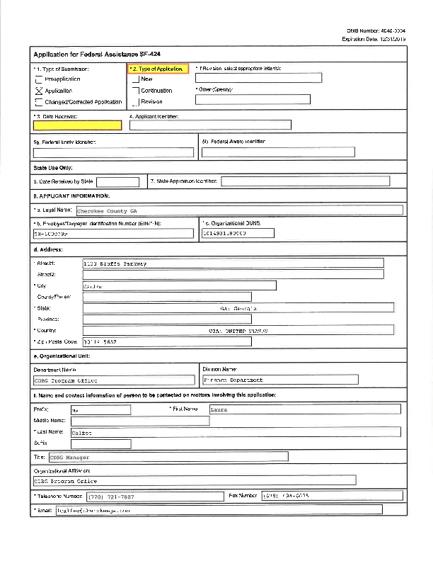
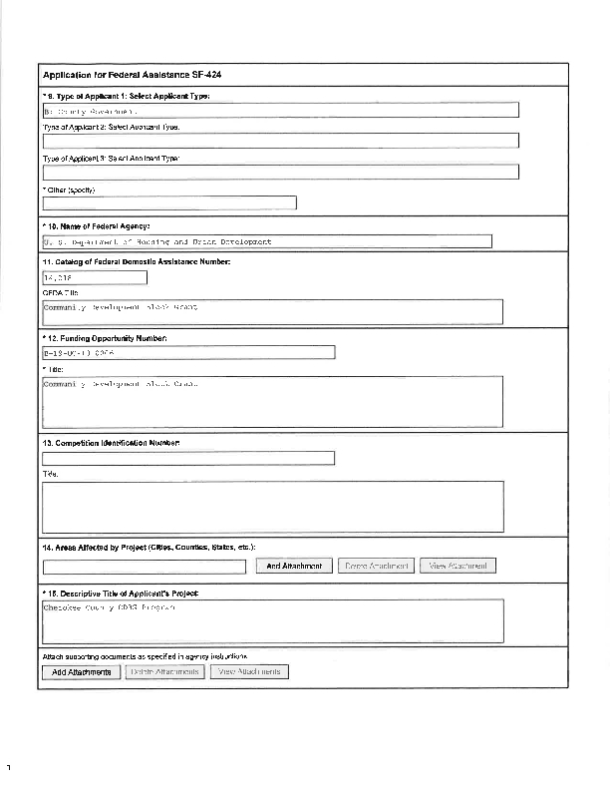
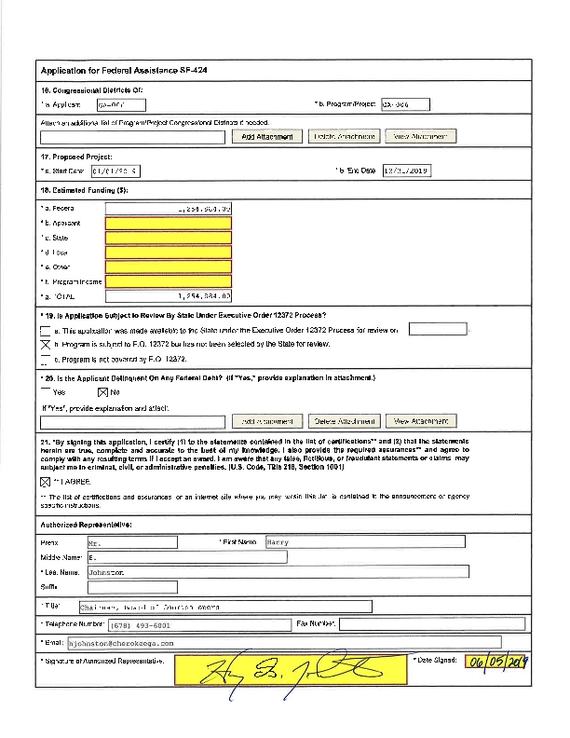
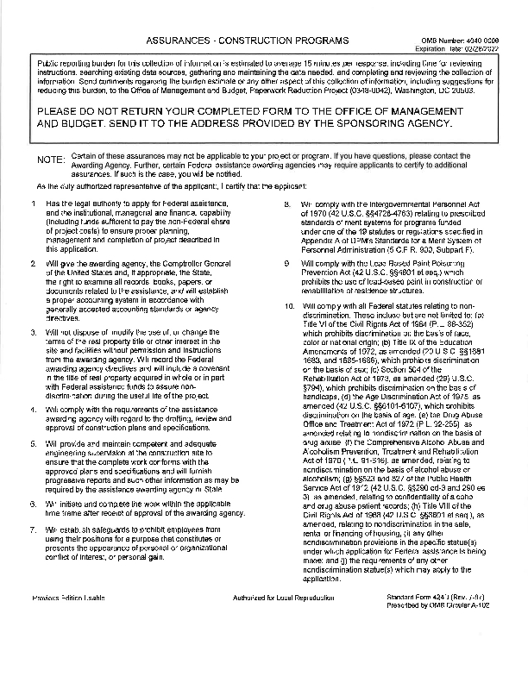
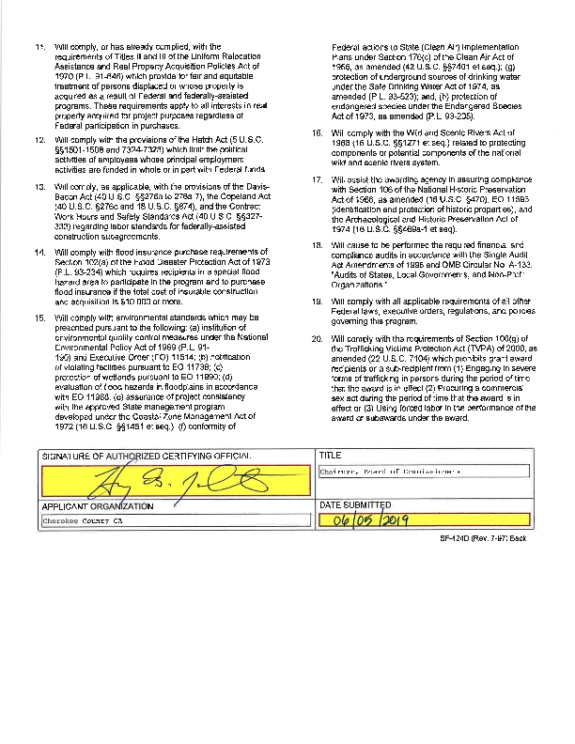
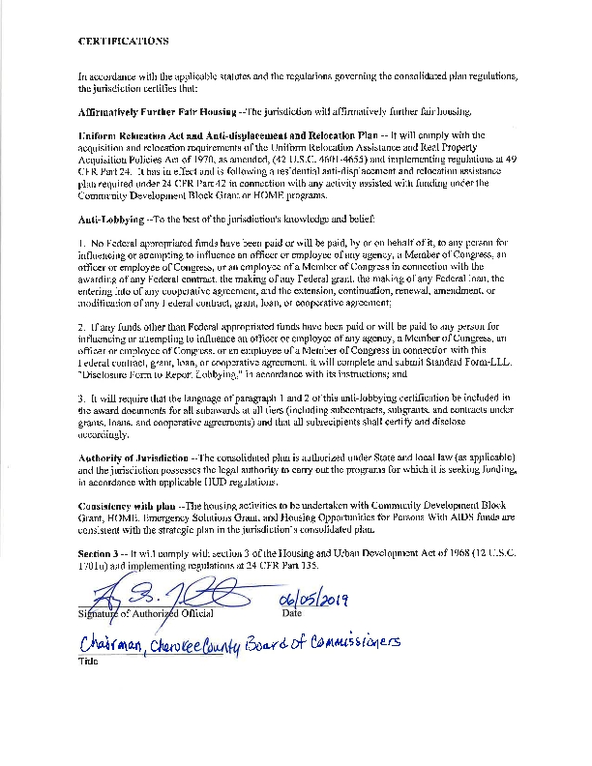
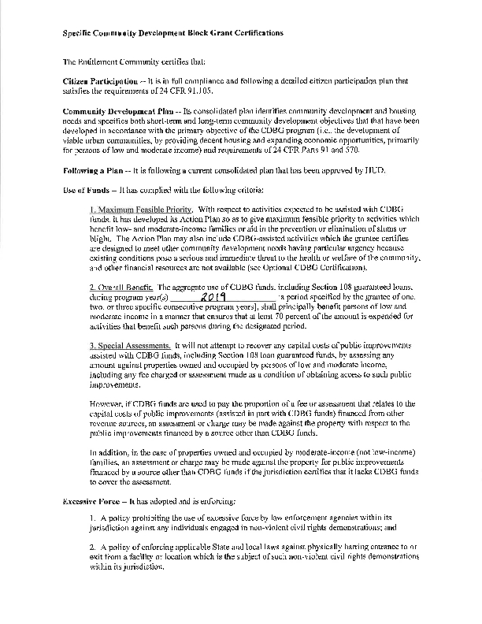
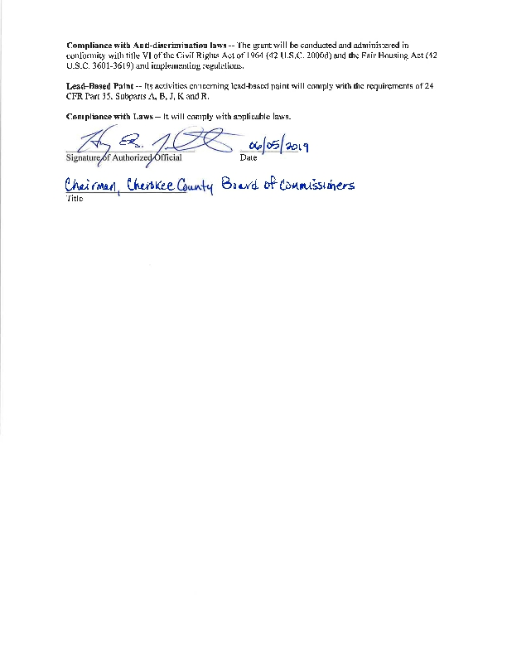
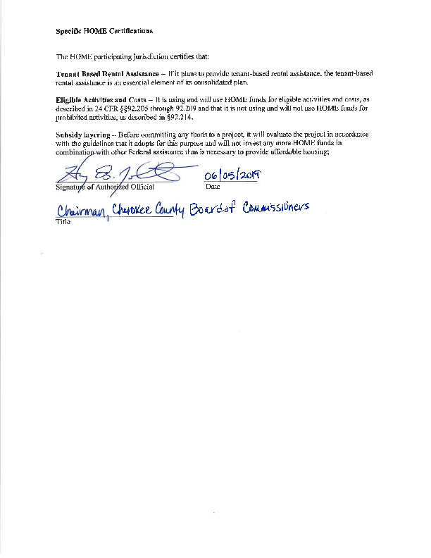
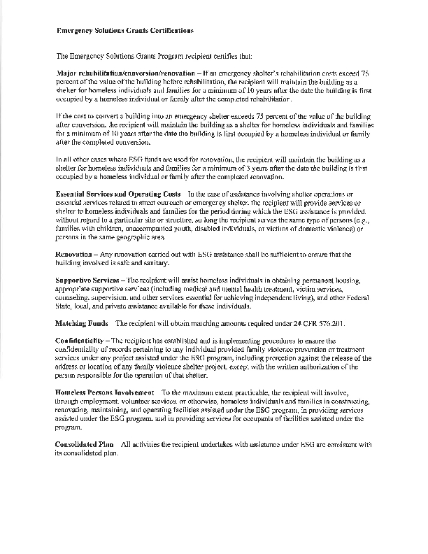
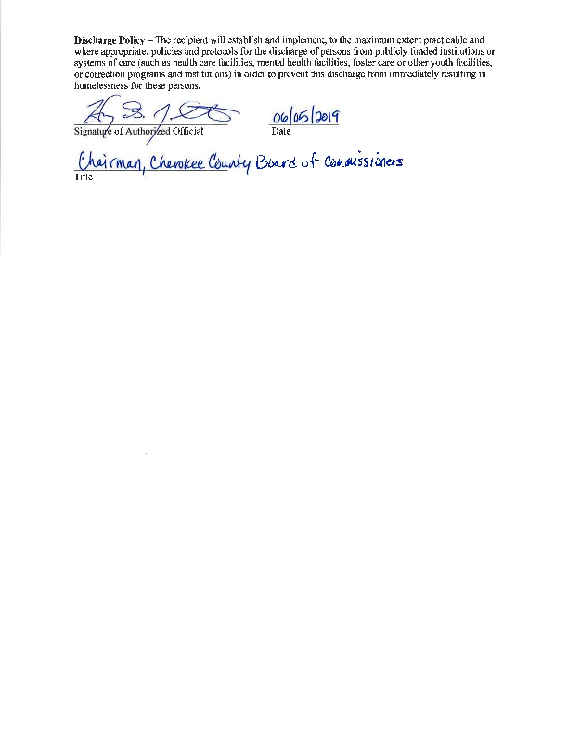
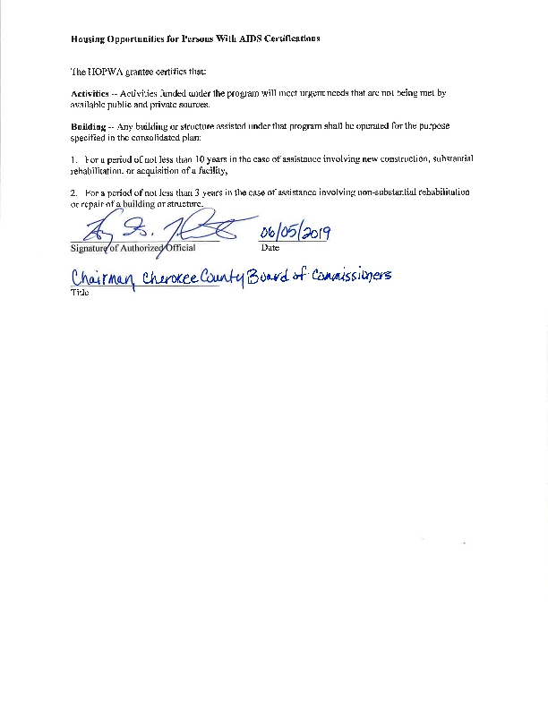
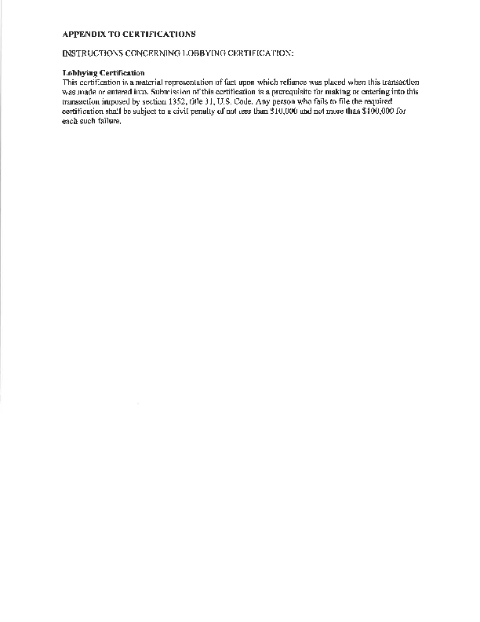

Appendix - Alternate/Local Data Sources

1 | Data Source Name  QuickFacts from the US Census Bureau
 | List the name of the organization or individual who originated the data set.
Provide a brief summary of the data set.
Quickfacts.census.gov, Cherokee County. Provides median household income 2007-2011
What was the purpose for developing this data set?
To have current median household income
 | Provide the year (and optionally month, or month and day) for when the data was collected.
 | Briefly describe the methodology for the data collection.
 | Describe the total population from which the sample was taken.
 | Describe the demographics of the respondents or characteristics of the unit of measure, and the number of respondents or units surveyed.

